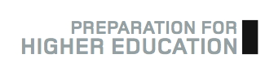
How to use Preparation for Higher Education materials

As the title suggests, the ‘Preparation for Higher Education’ materials are designed to give you the information, insight and skills you will need to succeed at college or university. SWAP is a programme for adults and you are expected to take responsibility for this section of the programme. You will need to take the time to read each section on your own and complete the exercises that are provided.

You will find a timeline on the SWAP web site that will let you know approximately when to complete each exercise. You can complete the exercises at your own pace, but it is important that you do complete each section, as doing so will enhance your studies at college and give you the support you need as you progress on to an HN or degree course next year.

Visit the SWAP web site: www.scottishwideraccess.org

If you have any questions at all, please feel free to contact the SWAPWest team on 0141 553 2471 or by email at swapwest@scottishwideraccess.org

