

SCOTTISH WIDER ACCESS PROGRAMME (SWAPWEST)

Study Skills Supplement - Access to Nursing

Proofreading

Proofreading

It’s a good idea to get into the habit of proofreading every piece of work you submit as you don’t want to let yourself down with avoidable errors. When you’re working as a nurse and writing in patients’ notes or writing letters you will need this skill. The following passage includes twenty mistakes. Can you identify them all?
Student Nurse Blog: What I love about nursing

Published: Nursing Times, 08 January 2009 17:34 Author: Katrina Michelle Rowan
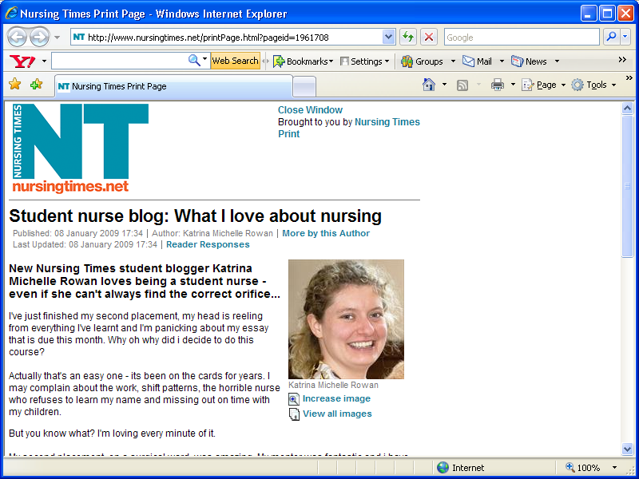

New Nursing Times student blogger Katrina Michelle Rowan loves being a student nurse – even if she can't always find the correct orifice...

Ive just finished my second placement, my head is reeling from everything I've learned and I'm panicking about my essay that is due this month . Why oh why did I decide to do this course?

Actually that's an easy one – it’s been on the cards for years, I may complain about the work, shift patterns the horrible nurse who refuses to learn my name and missing out on time with my children. But you know what? I'm loving every minute of it.

My second placement, on a surgical ward, was amazing. My mentor was fantastic I have learned so much. I feel overwelmed by how much I don’t know; I'm still frightened about the anatomy side of things – (I haven’t studied biology in 15 years); and don’t even get me started on the drug’s round.
But there are so many things I love: the staf nurses who don't mind being bombarded with questions and who are happy to show me again what they showed me seven times yesterday; the ones who dont laugh when your trying to catheterise a patient and can't find the right orifice; the oneswho give me feedback and tell me I'm doing well. But most of all I love the patience and the opportunity I've been given to broaden my knowledge base and challenge myself to learn things that frighten me.

I love the fict that I take the jab home with me, that I have phoning the ward at
2 a.m. as I'd forgotten to do something – much to the amusement of the poor staff nurse who answered my call and took ten minutes to figure out what on earth I was waffling on about. I also love the people I meat that make me laugh and cry.And most importantly all of them – every single one – help me lean.

I cant wait to qualify, even though its a distant two and a half years away, and I would love to take you on this journey with me.

Proofreading Test: Original document

Student Nurse Blog: What I love about nursing

Published: Nursing Times
08 January 2009 17:34
Author: Katrina Michelle Rowan

New Nursing Times student blogger Katrina Michelle Rowan loves being a student nurse - even if she can't always find the correct orifice...

I've just finished my second placement, my head is reeling from everything I've learned and I'm panicking about my essay that is due this month. Why oh why did I decide to do this course?

Actually that's an easy one – it’s been on the cards for years. I may complain about the work, shift patterns, the horrible nurse who refuses to learn my name and missing out on time with my children. But you know what? I'm loving every minute of it.

My second placement, on a surgical ward, was amazing. My mentor was fantastic and I have learned so much. I feel overwhelmed by how much I don’t know; I'm still frightened about the anatomy side of things – (I haven’t studied biology in 15 years); and don’t even get me started on the drugs round.
Space here as it’s a new paragraph
But there are so many things I love: the staff nurses who don't mind being bombarded with questions and who are happy to show me again what they showed me seven times yesterday; the ones who don’t laugh when you're trying to catheterise a patient and can't find the right orifice; the ones who give me feedback and tell me I'm doing well. But most of all I love the patients and the opportunity I've been given to broaden my knowledge base and challenge myself to learn things that frighten me.

I love the fact that I take the job home with me, that I have phoned the ward at
2 a.m. as I'd forgotten to do something – much to the amusement of the poor staff nurse who answered my call and took ten minutes to figure out what on earth I was waffling on about. I also love the people I meet that make me laugh and cry. And most importantly all of them – every single one – helps me learn.

I can't wait to qualify, even though it's a distant two and a half years away, and I would love to take you on this journey with me.

http://www.nursingtimes.net/students/2009/01/student_nurse_blog_what_i_love_about_nursing.html

Corrections:

I’ve:
The apostrophe is needed because it tells us that some letters have been intentionally missed out. I’ve = I have. We therefore need the apostrophe to replace the ‘h’ and ‘a’.

Month.
This is an easy mistake to make when typing your work. There is an unnecessary space between the end of the word and the full stop. Always check that your punctuation is in the right place.

For years. I may complain . . .
Here, a full stop is needed instead of a comma. Think about the two sentences as separate thoughts which need a full stop to divide them. Notice that the subjects of the sentences are different: ‘it’s been on the cards’ and ‘I may complain about the work . . .’ Commas are generally used in lists. These sentences do not form part of a list.

Shift patterns,
Here ‘shift patterns’ is one item in a list of things that the student nurse may complain about. A comma is needed to separate it from the ‘horrible nurse’.

My mentor was fantastic and I have learned so much
Here a full stop or a word is needed to separate or link the two ideas.

Overwhelmed
Your spellchecker will pick up misspellings but not all of them – and what if you’re writing by hand?

Drugs round
Here is another mistake that’s easy to make with an apostrophe. Here, drugs is used an adjective (a describing word). The round is a drugs round. If you put in an apostrophe it means that the drug possesses something – the drug’s addictive quality or the drug’s turn to buy a round of drinks.

Space between paragraphs
Keep your style consistent and watch for things like this.

Staff
Check for typos.

Don’t
Same rule as for ‘I’ve’

You’re

This is a common mistake to make. Think back to the rule for ‘I have’ then think about whether you want to say ‘you are’ – as in ‘you are going to make a great nurse’ – or ‘your’ – as in ‘your progress has been excellent this year’. ‘You’re’ is short for ‘you are’ whilst ‘your’ relates to possession – ‘your handbag’, ‘your car’, ‘your ambitions’.

Ones who
Again, this is a style and formatting thing. Don’t be let down by clumsy formatting.

Patients
Spellchecker won’t pick up this kind of spelling error as the word ‘patience’ is correctly spelled – just not the right word for this context.

Fact:
A simple typo.

Job
Again, spellchecker or grammar check won’t pick up this spelling mistake as ‘jab’ could well apply in this, albeit unusual, context.

I have phoned the ward
Check your grammar. Sometimes when you’re rushing to get your thoughts on the page you begin a sentence in one way and end in another. When you’re checking your work make sure you check your grammar.

Meet
Another case where spellchecker may not pick up on an incorrect word.

Cry. And
Another formatting error.

Learn
Another typo.

I can’t wait to qualify and it’s a distant two and a half years:
The rule as explained for ‘I have’ applies here. The apostrophe is needed because it tells us that some letters have been intentionally missed out. Can’t = Cannot. We therefore need the apostrophe to replace the second ‘n’ and the ‘o’. The same with it is = is.
Top Tip: If you go to the BBC Skillswise website you will find online quizzes and games to help you with all aspects of your written work – from use of the comma to tips on remembering spellings. www.bbc.co.uk/skillswise/

