

UCAS Online applications for
SWAPWest Access students

Guidelines for applicants

For detailed information, please refer to UCAS handbook
‘How to apply’ and ‘Applying online’ or speak with your college tutor.
Introduction

All of the instructions and advice given below are important. Read carefully.

SWAPWest students must apply to university via UCAS online. Payment is required and you must pay by credit or debit card – this can be yours or someone else’s card. If this poses a problem please speak to your college tutor.

Web address: www.ucas.com/apply

SWAPWest has its own “exam centre” number – 78792

Deadlines are:

15 October - for applications for Medical, Dental and Veterinary Schools

15th January - for all other applicants

If you are applying for Primary Education, see your tutor for further guidance.

Please check the Progression Routes for up-to-date deadlines (available from your college tutor and the SWAPWest office in late October/early November).

Registration

When you begin the registration process, you’ll encounter the question “How are you applying?” Select “Through my school/college.”

- The buzzword is swapwest 2016 (no spaces). Enter the buzzword when prompted.

- You are then asked to identify your Application Group. This should be the name of the college that you are attending. Select your college, campus and programme name from the drop-down list.

- Upon successful registration, you’ll reach the Welcome screen on which will be displayed your UCAS Personal ID number. Make a note of this number and keep it somewhere safe. (Top Tip: text or email it to yourself so it cannot be lost; you will need it again)

- Next, you will complete the application by working your way through the links on the left-hand side of the UCAS application page.

Responsibility

It is your responsibility to ensure that your application form is completed correctly.

Pay particular attention to the guidelines below, identifying you as a SWAP Access student. If you make a mistake and fail to identify yourself as a SWAP student, you will be considered a normal student applicant and so any special arrangements that would be available to you as a SWAP student will not apply.

Should you make a mistake and require it to be rectified, seek advice from your tutor and if you need SWAP to make a change, we must receive a written instruction before we can do so.

Completing the application

“Choices” page:
Your “Choices” are the institutions and courses that you wish to apply to.

You can list as many courses as you like, up to a maximum of five. You can choose any combination of degree courses. We strongly advise you to use all 5 choices and to apply for more than one partner institution (university).

Your position will depend upon the SWAP Student Agreement you signed at the beginning of the year (for example, if you are applying for a specific programme such as Nursing). Refer to your Student Agreement for details. If you have not signed an agreement or do not have it to hand, please contact the SWAPWest office for a copy: swapwest@scottishwideraccess.org

If you want to apply for more than one course at the same university you must use a separate line for each choice. However, remember that some universities operate a “faculty entry” system whereby the entry requirements are the same for all courses within a faculty, so one course choice per university may be sufficient.

You may enter your courses in any order; they will automatically be arranged alphabetically. The fee is £23.00 for more than one choice (2015-16).

Do your research into your choices thoroughly and check carefully that you have given the correct course and university codes. Use the worksheet on the next page to gather all of your choices before you begin. When you’re ready to enter your choices, click on “Add a choice”.

My 1st choice:
University name and code: ……………………………………………………………...
Course Name and code:…………………………………………………………………
Entry requirements:………………………………………………………………………
This is listed among the SWAP progression routes available to me: Yes No

My 2nd choice:
University name and code: ……………………………………………………………...
Course Name and code:…………………………………………………………………
Entry requirements:………………………………………………………………………
This is listed among the SWAP progression routes available to me: Yes No

My 3rd choice:
University name and code: ……………………………………………………………...
Course Name and code:…………………………………………………………………
Entry requirements:………………………………………………………………………
This is listed among the SWAP progression routes available to me: Yes No

My 4th choice:
University name and code: ……………………………………………………………...
Course Name and code:…………………………………………………………………
Entry requirements:………………………………………………………………………
This is listed among the SWAP progression routes available to me: Yes No

My 5th choice:
University name and code: ……………………………………………………………...
Course Name and code:…………………………………………………………………
Entry requirements:………………………………………………………………………
This is listed among the SWAP progression routes available to me: Yes No

“Education” page:

Highest Level of Qualification:
You will be asked to indicate the highest level of qualification you expect to have before the start of your course. If you are applying to university on the basis of your SWAP qualification, you should select “Below honours degree level qualifications” here.

How to identify yourself as a SWAP student:
It is important to identify yourself as a SWAP student. Failure to do so will result in your application being treated as if from an ordinary applicant rather than as a SWAP applicant, which can have implications for your progression to university.

- When you first land on the Education screen, the School/College/Centre space will be greyed out.
- Click the “Find” button and a pop-up window will appear.
- In the pop-up window, type in “Scottish Wider Access Programme.”
- You’ll then see the result: “0 matches found”.
- Click the link below that reads: “My school/centre is not listed here”.

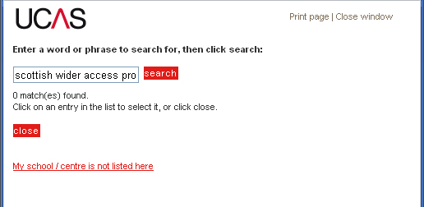
You will then be able to type in your school/college/centre name. Type: Scottish Wider Access Programme (see image on next page)
- Enter the exam centre number: 78792
- Start and end dates for your SWAP course are provided by your college (usually Aug-Jun)
- Indicate that you have been full-time and that you will receive a formal qualification at the end

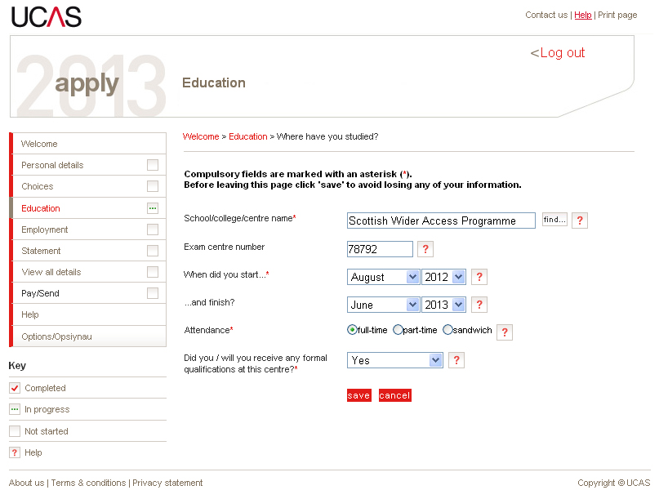
After completing this form, click on Save to return to the main Education page. You will then be able to add your qualifications (the National Units you have been studying at college) to your application.

Education qualifications
- Click ‘Add a qualification’
- Then click ‘National Units – Scotland’

Add the units of your programme (your college tutor can provide you with a list of units and their levels). The qualification date will be the end of your SWAP programme (usually June) and the awarding body is SQA. Click on ‘save and add similar’ to add another unit. Click ‘save’ after you have entered all units to be returned to the main Education page. You may also include any other qualifications you hold, if you wish (e.g. from school or previous study). When you have completed all education information, you can mark the section completed by ticking the box.

You will be reminded to input a Scottish Candidate Number (SCN) for Scottish Qualifications. This number is either from your previous Scottish certificates or will be issued to you by your college.

“Employment” page:

Follow the prompts to add employers and details of any previous work experience you may have. You are not required to include employment information if it is not relevant to your application or if you have not worked. However, you must mark the section as complete (by ticking the box) before your application can be considered complete.

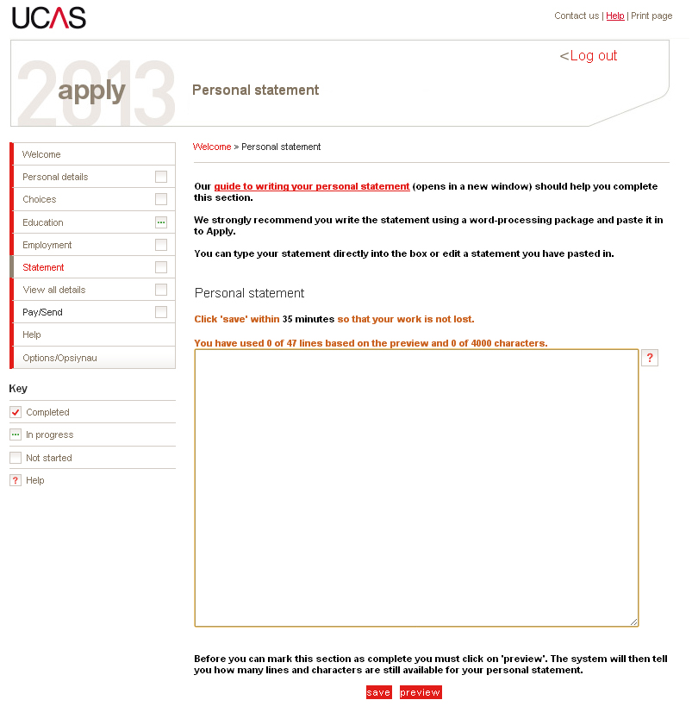
“Statement” page:

Your personal statement is your best opportunity to tell the universities and colleges about your motivation, commitment and suitability for your chosen courses. It should include relevant practical experience, transferable skills or qualifications not mentioned elsewhere.

A good personal statement is important; it could help to persuade an admissions officer to offer you a place. The statement should be clear and concise with correct punctuation and spelling.

Long paragraphs of unbroken text can be difficult to read so use headings and/or shorter paragraphs. You do not have to fill the entire space, and you must not use more than 4000 characters.

The Personal Statement field has a timer attached to it which, when it expires, will “refresh” the window and cause you to lose all of the information you have typed unless you continually click Save as you are working. For that reason (among others), it is a good idea to prepare your statement offline.

Create your Personal Statement in a Word document and paste it into your online application after it is complete. Please read through the Personal Statement section in the Preparation for Higher Education folder and take advantage of the guidance provided by UCAS on how to write a good personal statement.

Criminal convictions
Universities ask applicants to state on the application form if they have a relevant criminal conviction. If you have any criminal convictions, read the advice given by UCAS. You may also contact the SWAP office to discuss. You must disclose all criminal convictions, including traffic violations. Failure to do so, even if the offence was minor or a long time ago will mean that any offer made by a university will be retracted for non-disclosure.

Declaration
You must confirm that the information provided on your application is complete and accurate. You must also confirm your agreement to UCAS’ conditions by entering a tick in a box. If you do not provide this confirmation, UCAS cannot process the application.

Submission of application
Your application is not formally submitted until the reference has been attached and the application approved by your tutor. Your college will provide you with dates that you must strictly adhere to for completion of your application. These dates are normally around the beginning of December. Please continue to check your status, as you cannot be certain your application has been received until you receive acknowledgement from UCAS. Please check with your tutor if you have not received acknowledgement and it is approaching the 15th January.

Decisions
When UCAS receive your application they will send you an applicant number so that you can track your application online (Log in to UCAS and click on Track). They will also send you a booklet entitled ‘Advice for Applicants’ which explains how to respond to offers. You do not have to make a final decision until you have heard from all your choices.

An offer may be either conditional or unconditional (most SWAP students will receive a conditional offer) and the offer letter will tell you the year and month that the course starts.

Conditional offer (C)
This means that the university or college has made you an offer that depends
on certain conditions; usually that you must satisfactorily complete all units of your Access Programme and obtain appropriate grades in your profile.

Accepting or replying to offers
When your chosen institutions have decided whether or not to offer you a place, UCAS will send you a Statement of Decisions letter and a reply slip. You must reply to each offer in one of the following ways.
- Firm acceptance (F)
- Insurance acceptance (I)
- Decline (D)

You may not want to wait for all your choices to make their decisions (see UCAS application guide “When to Reply”). But you should think carefully before you decide which offers to accept because once you accept an offer, including an insurance offer; you are committed to that course. You should feel satisfied that both the course and the college or university are right for you because you will be spending the next three or four years there. We recommend that, where possible, you attend open days or visits before you make your decision. You can delay your replies to UCAS until after your visits, as long as you reply by the date given in your Statement of Decisions letter.

If you change your mind after accepting an offer, you can withdraw but you will not be able to apply for other courses or go through Clearing in the same year.

Firm acceptance (F)
You can only accept one offer firmly. If you firmly accept an unconditional offer (UF), you commit yourself to that course. You must turn down all other offers through UCAS and then you won’t deal with UCAS again. Afterwards, you will just be directly in contact with your chosen university or college.

If you firmly accept a conditional offer (CF), you will be guaranteed a place on that course provided you achieve the grades that are needed or meet any other conditions. If you meet all of the conditions of your ‘Conditional Firm’ offer, you are then committed to the course and you will not be able to go elsewhere.

Insurance acceptance (I)
If you receive two or more offers, and you firmly accept a conditional offer, you must also decide whether to accept a second offer as insurance. This could be either an unconditional offer (UI) or another conditional offer (CI). If you choose
a conditional offer as your insurance, the grades needed for this place should be lower than the grades needed for your firm choice. This will give you a safer ‘fall-back’ option in case you don’t achieve the grades required for your Firm choice.

Why have an Insurance choice?
If you do not meet the conditions of your firm choice, but you do meet the conditions of your insurance choice, you are guaranteed a place on your insurance choice. You are committed to the course and you will not be able to go elsewhere.

Decline (D)
When you have decided on your firm acceptance and insurance acceptance, you must decline (D) all other offers through UCAS. If you want, you can decline all the offers. You will then be able to apply to other universities and colleges either through UCAS Extra or Clearing depending on the time of year.

Examples of ways you can accept offers

UF Firmly accepted unconditional offer.
You cannot have an insurance choice.

CF Firmly accepted conditional offer.

CF + CI Firmly accepted conditional offer plus a
conditional offer that you have accepted
as an insurance.

CF + UI Firmly accepted conditional offer plus an
unconditional offer that you have accepted
as an insurance.

Finally

Your college is asked to retain your student UCAS number (the UCAS number starts with year of entry e.g. 16) on file. This information is required for your Student Profile and is written on your offer letter(s). Please make sure that you give your student UCAS number to your tutor – it is very important.

