
Preparation for Higher Education – Using Mahara

Using Mahara to evidence completion of PHE

Mahara is ‘e-portfolio’ software. Some have described it as a digital version of a three-ring binder. Others say it’s a little like Facebook, but strictly for academic work.

Basically, Mahara e-portfolio provides a private online space (i.e. a personal web site) where you can collect various bits of work that you have completed, things that interest you or that may enhance your assignments. For example, you could collect newspaper or magazine articles, documents you have created for assignments, images you have downloaded or scanned, photos you have taken at Open Days or Study Skills Days, links to videos you have found online -- or indeed film clips or audio clips that you have created yourself. You may also include information about the universities and courses that you are considering and your thoughts about those choices. Later on, Mahara enables you to quickly and easily create a private web page featuring selected items from your collection.

Mahara lends itself to the completion of PHE; you can use its ‘journal’ feature as your PHE ‘Study Diary’ and you can upload electronic versions of completed PHE exercises to your Mahara web pages. At the end of the academic year, you can create a web page showcasing all of these items and share that page with your college tutor to show that you have completed the PHE unit.

If you wish to complete your PHE online using Mahara, follow the steps outlined on the following pages. If you have questions, please contact the SWAPWest team on 0141 564 7206 and ask for Amy Angus, or by email: swapwest@scottishwideraccess.org
Step 1: Find Mahara on the SWAPWest web site and register as a new user.

- Visit the web site www.scottishwideraccess.org and click on West, then Prep for HE, then SWAP Mahara as shown below:
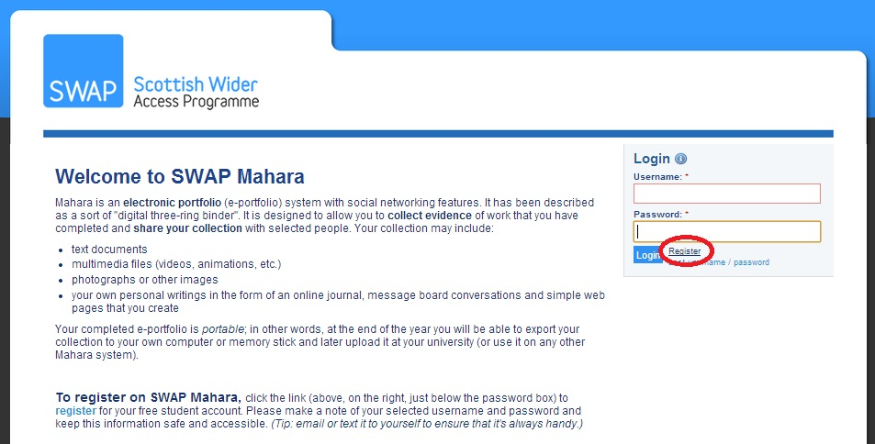
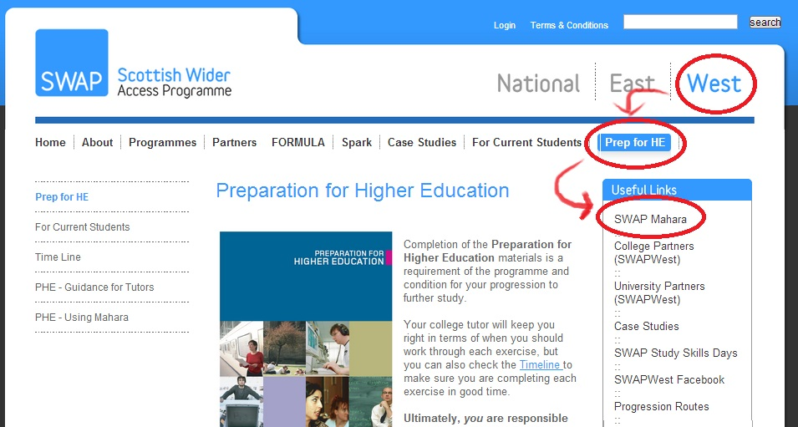
- Click on the link ‘Register,’ as shown below:

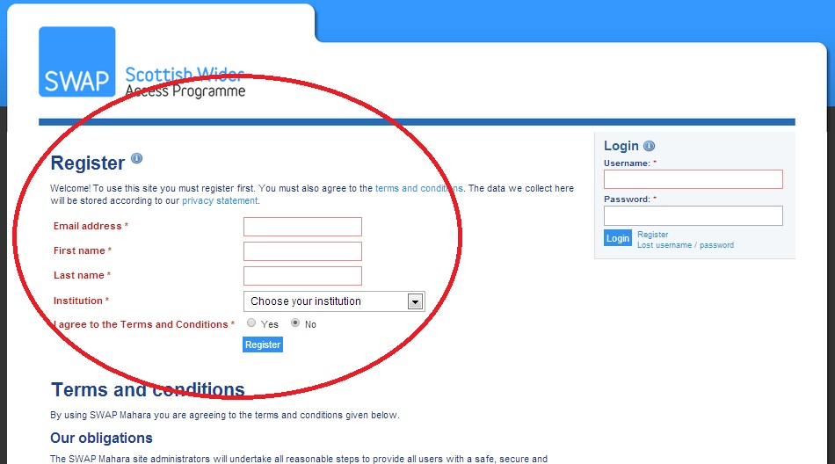
- Fill in the short registration form. Be sure to select your college name from the drop-down menu next to ‘Institution’. You may use any email address you wish but be sure to use one that you have easy access to, as it will be required in order to complete registration.

- When asked to give your reason for registering, give the name of your SWAP ‘Prep for HE’ tutor.

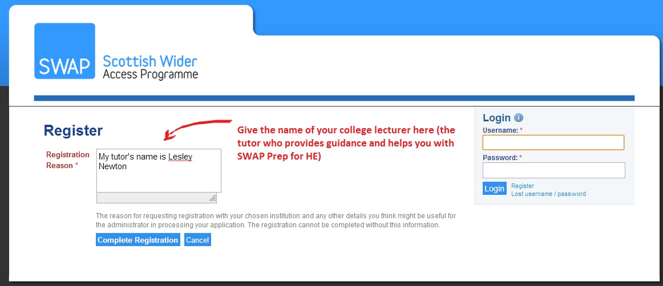
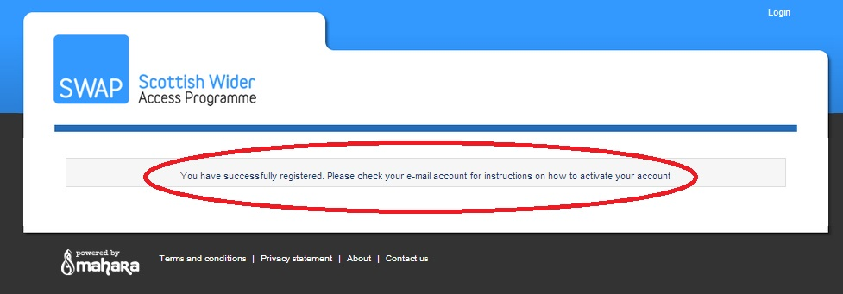
- You will see a confirmation if you have registered successfully. Now you must check your email for instructions on activating your account.

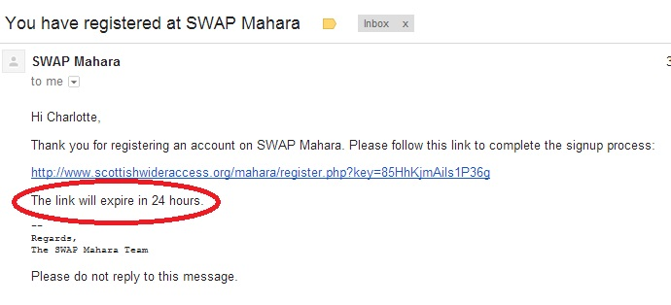
- You have 24 hours to check your email, click the link and confirm your registration. If you fail to confirm within this time period, your registration request will expire and you will have to start over from the beginning.

- Finally, choose your username and password. Be sure to email or text this information to yourself so that you cannot lose it.
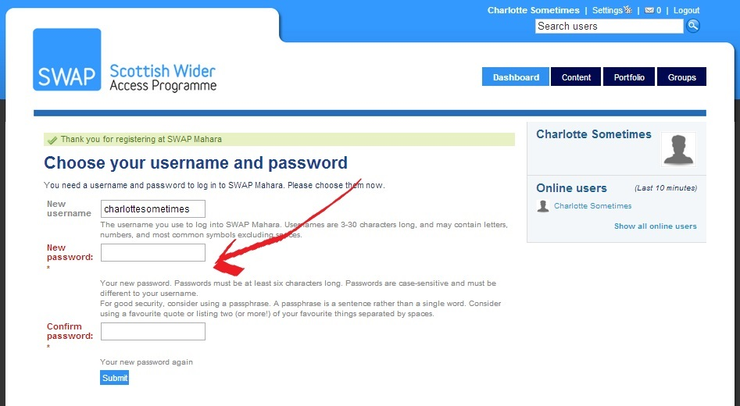

Congratulations! You have registered successfully!

Step 2: Become familiar with the main features of Mahara. Set up your profile. Join groups.

- Read the ‘Welcome to the SWAP Mahara’ information.
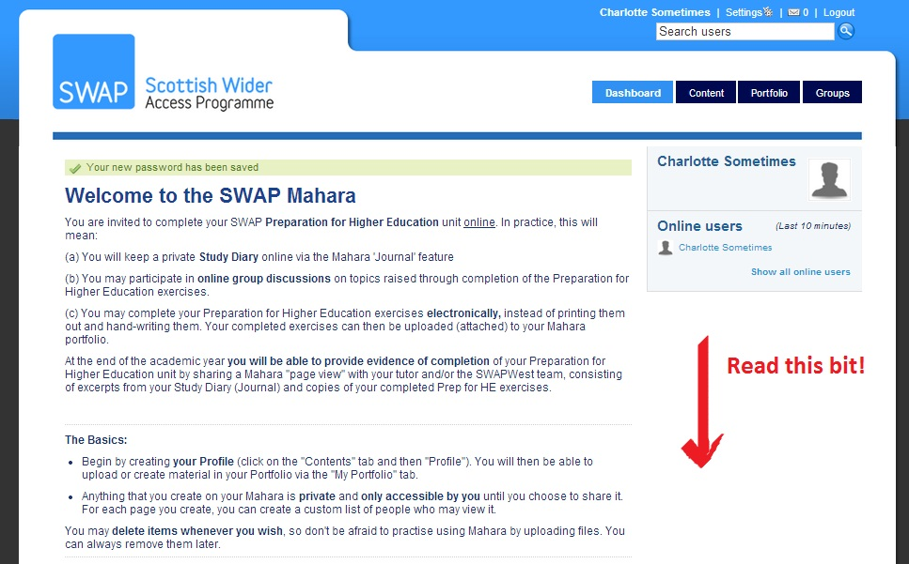
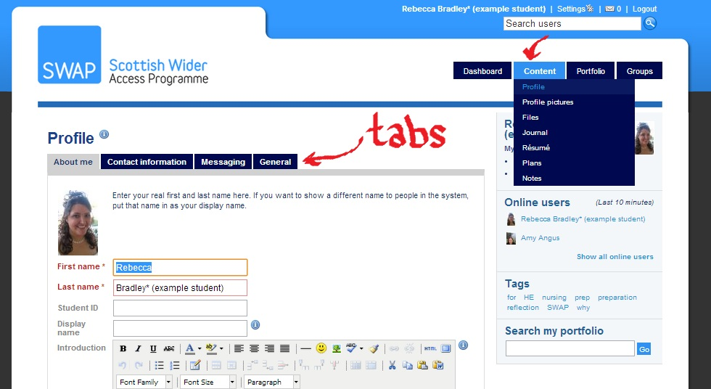
- Set up your profile by filling in the information under each tab, as below:

- Join Groups. Join your own college (class) group (e.g. New College Lanarkshire – Cumbernauld Campus – Humanities). You should also join the Curriculum Group (e.g. SWAP Curriculum Group – Humanities)
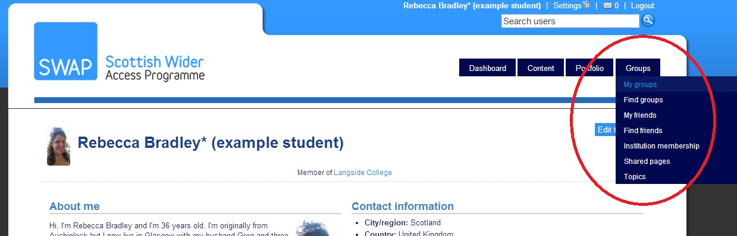
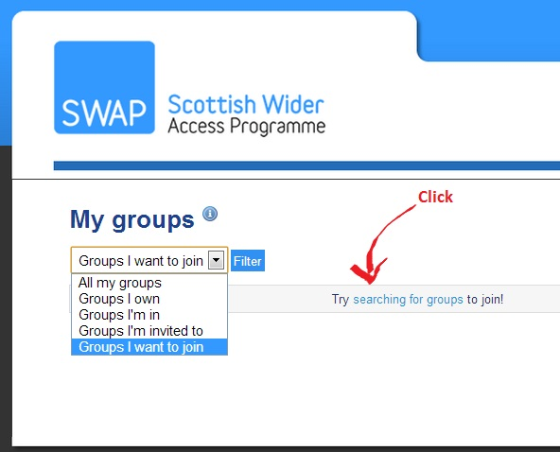

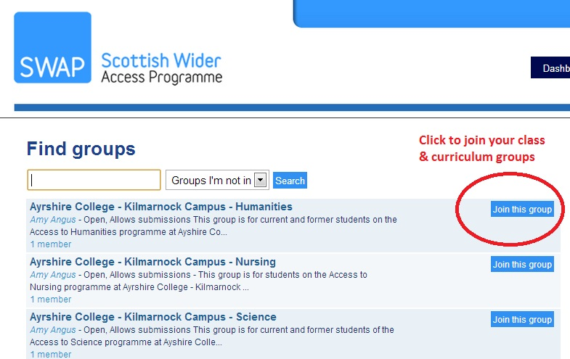

Step 3: Create a page entitled ‘Preparation for Higher Education’, as below:

- Click on ‘Create Page’
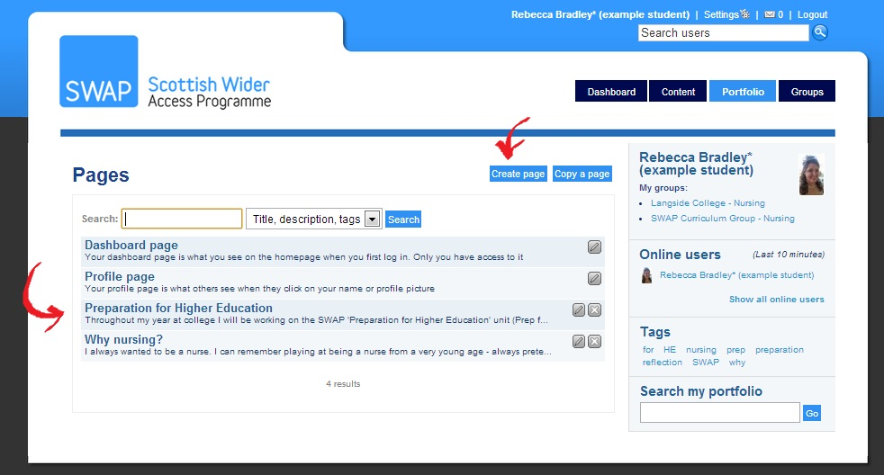

- Title the page. Click the tabs along the top to edit the layout and content.

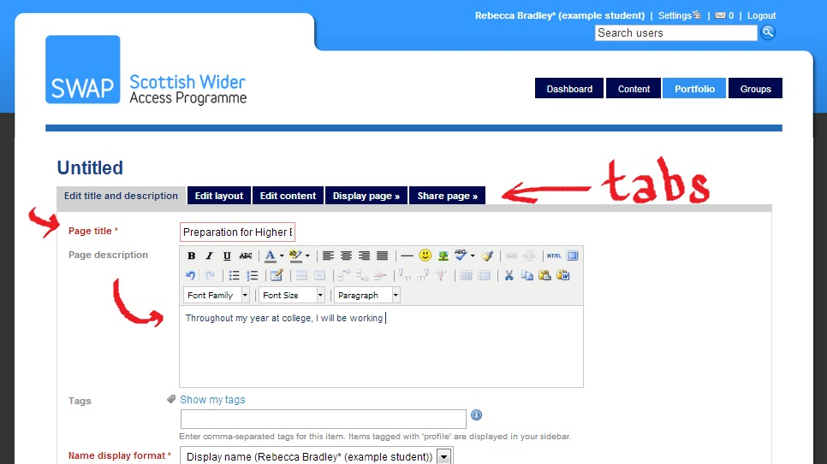

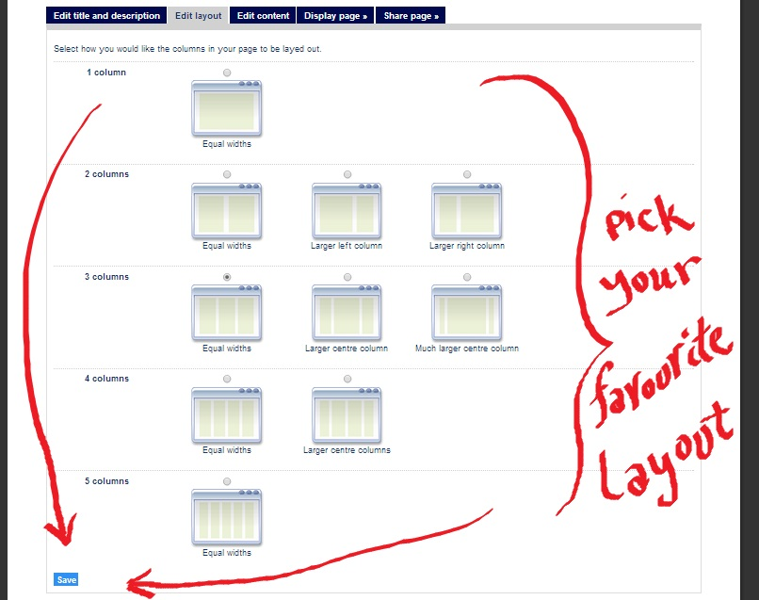

- Drag-and-drop content types to create your page. You can include files (e.g. Word documents, PDF documents, etc.), images and even multimedia content (videos, etc.)
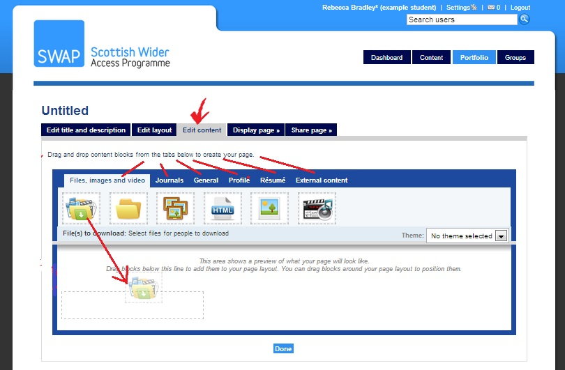

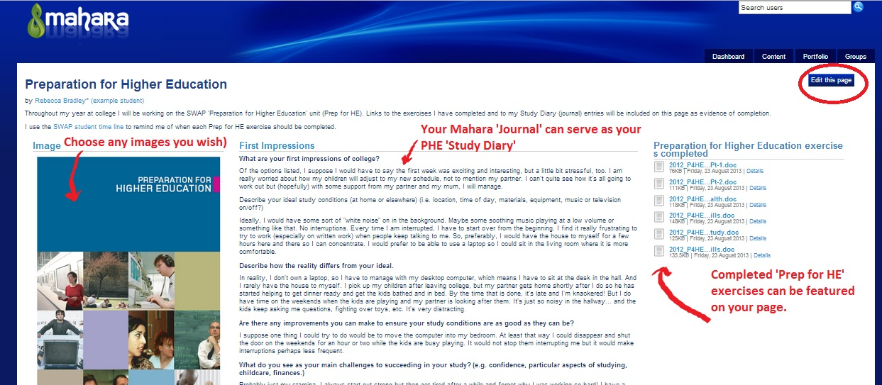
- You can view your completed page as you create it. If you don’t like the way it looks, click on ‘Edit this page’ and change it.

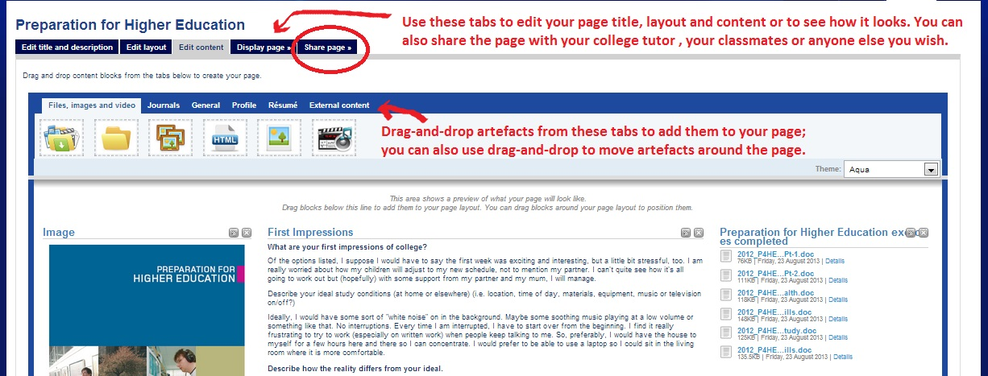

NB: You can download blank copies of the Preparation for Higher Education exercises from the SWAPWest web site, complete them electronically and then upload them to Mahara to be included on your page:

www.scottishwideraccess.org/west/phe

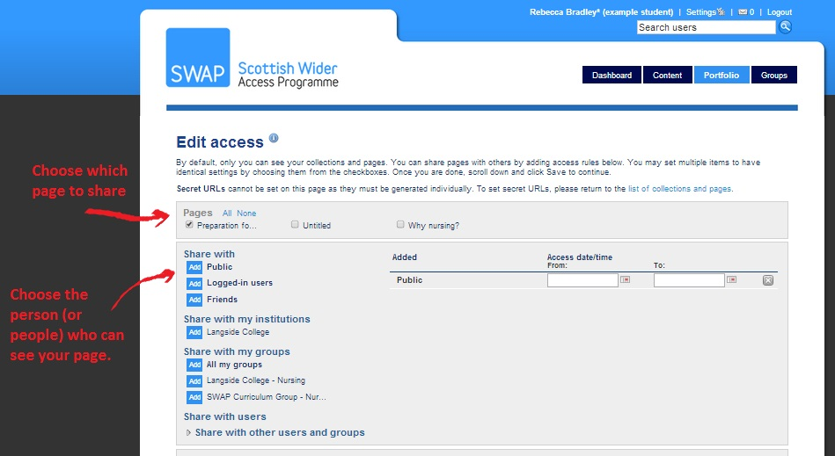
- When you are ready to show your page to others, click on the ‘Share page’ tab and select the person (or people) who will have permission to view it. By default, your pages are set to ‘private’ (only you can see them) until you change these settings.

- One person you definitely want to ‘share’ your PHE page with is your tutor. You can opt to share your page ONLY with one person, provided s/he is also registered on Mahara. See below:
- Click on ‘Share with Users’
- Select ‘Users’ from the drop-down.
- Type in the first name of the person with whom you want to share your page.
- Click ‘Go’
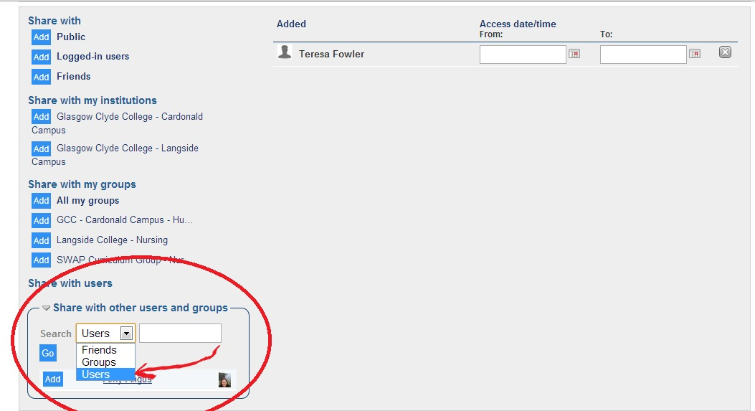
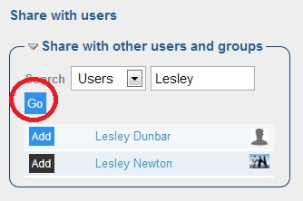
- After clicking ‘Go’ you will see a list of users whose names match your search.
- Click ‘Add’ next to the name of the person you want

CONTACT US:

If you have any questions about using Mahara to complete your PHE, please contact the SWAPWest office on 0141 564 7206 or send an email to: swapwest@scottishwideraccess.org

