

UCAS Online applications for
SWAPWest Access students

Guidelines for applicants

For detailed information, please refer to UCAS handbook
‘How to apply’ and ‘Applying online’ or speak with your college tutor.
Introduction

SWAPWest students must apply to university via UCAS online. Payment is required and you must pay by credit or debit card – this can be yours or someone else’s card. If this poses a problem please speak to your college tutor.

Web address: www.ucas.com/apply

SWAPWest has its own “exam centre” number – 78792

Deadlines are:

15 October - for applications for Medical, Dental and Veterinary Schools

15th January - for all other applicants

If you are applying for Primary Education, see your tutor for further guidance.

Please check the Progression Routes for up-to-date deadlines (available from your college tutor and the SWAPWest office in late October/early November).

Quick Essentials:

- The buzzword is swapwest2018 (no spaces). Enter the buzzword when prompted.

- Upon successful registration, you’ll reach the Welcome screen on which will be displayed your UCAS Personal ID number. Make a note of this number and keep it somewhere safe. (Top Tip: text or email it to yourself so it cannot be lost; you will need it again)

- A step-by-step guide is provided in the pages that follow, as well as in alternative formats online (visit the SWAPWest web site “Prep for HE” section).

- Access to Humanities / Social Science students may apply to only one option at the University of Strathclyde.

- Any student applying to study Psychology must take special care to ensure that the correct UCAS code is used (e.g. the code for the faculty/school that corresponds with your SWAP programme). Speak to your tutor or contact SWAP if you are uncertain. Use of the wrong code will result in a rejection from the university, which cannot be reversed.

Responsibility

Your class tutor and/or college support staff will be able to give you some guidance, but it is your responsibility to ensure that your application form is completed correctly.

Pay particular attention to the guidelines below, which will help ensure you identify yourself correctly as a SWAP Access student. If you make a mistake and fail to identify yourself as a SWAP student, you will be considered an ordinary student applicant and so any special arrangements that would be available to you as a SWAP student will not apply.

Should you make a mistake and require it to be rectified, seek advice from your tutor and if you need SWAP to make a change, we must receive a written instruction before we can do so.

Registration

Before you can apply, you must register. Follow the instructions below to complete the registration process.
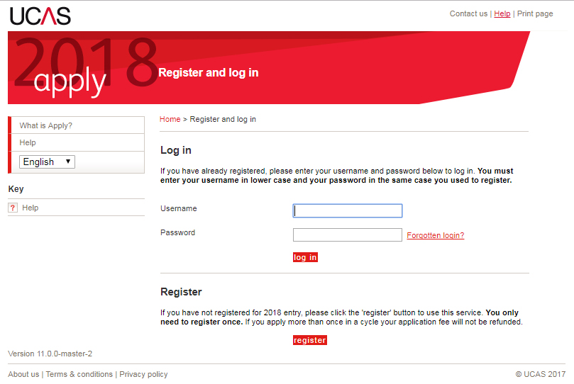
Registration - Step 1: Click on REGISTER
Registration - Step 2: Fill in the pages that follow, beginning with your name and including your address, telephone number, etc. During this process, you’ll be asked to create your own password. Follow the instructions, and then make a careful note of your password. You will need it to log in, so keep it safe.
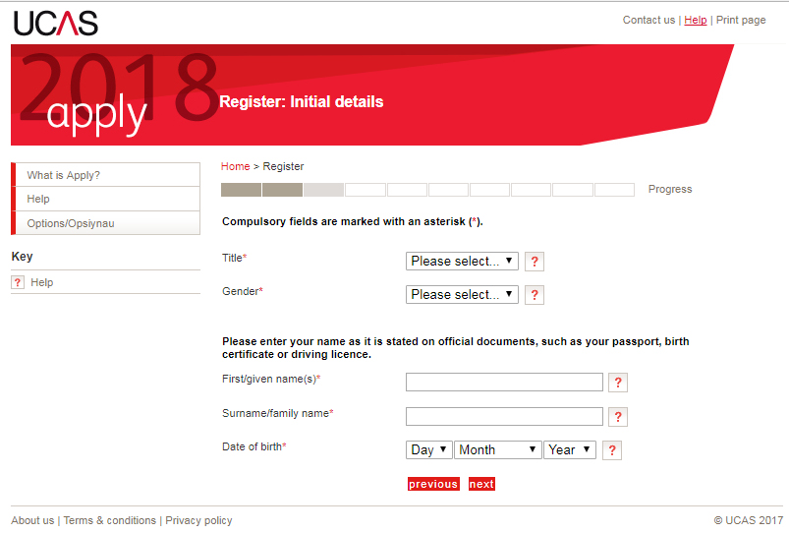

Registration - Step 3: Take a note of your user name. You will need it (along with the password you created) to log in at the end of the registration process, and begin your application.

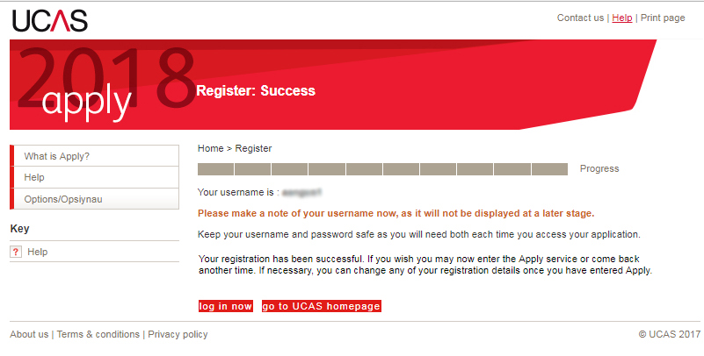
Registration – Step 4: Return to the home page and click on SIGN IN, then click on UNDERGRADUATE SIGN IN, and choose SIGN IN AND APPLY FOR 2018 ENTRY.
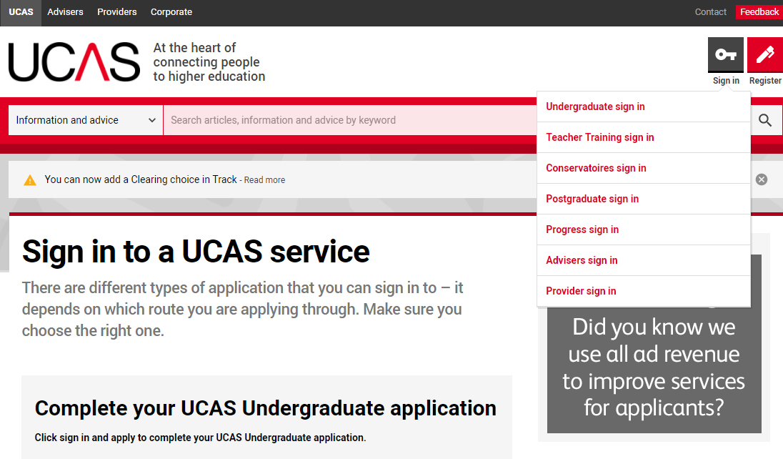

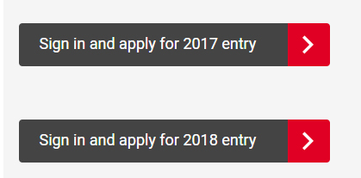

Registration – Step 5: Answer the question “How are you applying” by selecting: THROUGH MY SCHOOL/COLLEGE

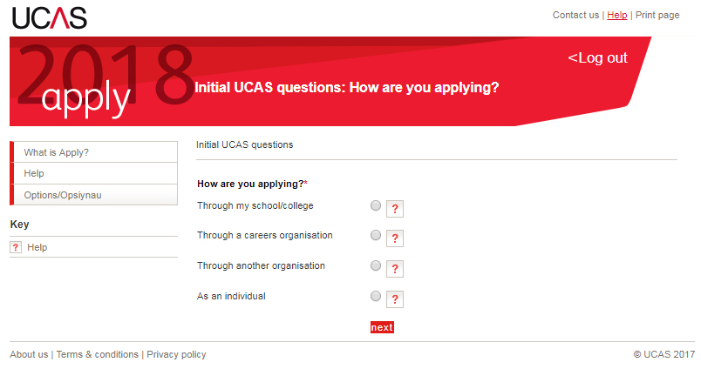

Registration – Step 6: Input the SWAP buzzword: swapwest2018

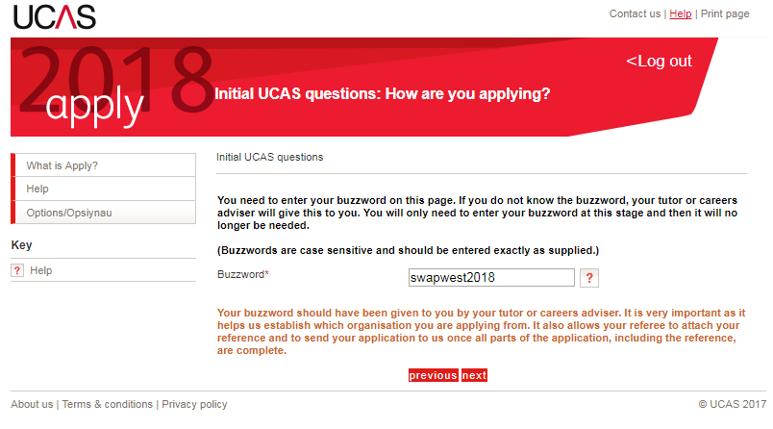
NB: No spaces; no capitalization.

Registration – Step 7: Answer YES to confirm that you are registering through SWAP (the SWAPWest office is on the campus of Glasgow Kelvin College).
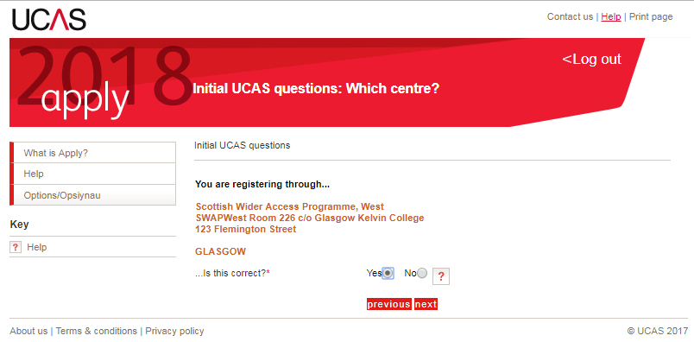

Registration – Step 8: Select your College, Campus and Curriculum Group from the drop-down menu.
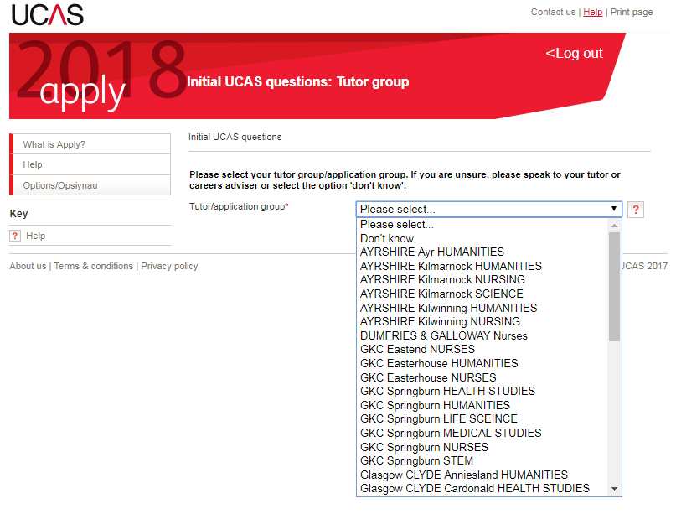

Registration – Step 9: Verify your e-mail address. Open a new browser window or tab and check the email you used to register. Make a note of the verification code that is sent to you, then return to the UCAS page and click the link shown.
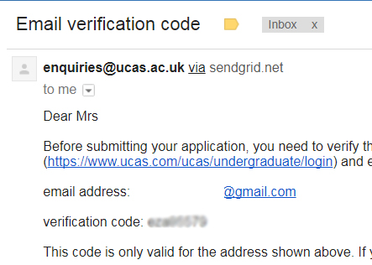

Input the verification code in the space provided, then click on VERIFY EMAIL:
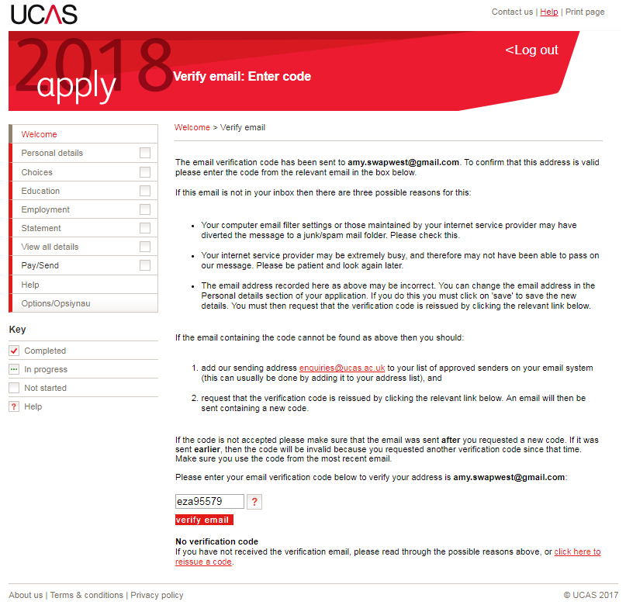

Registration – Step 10: Make a note of your Personal ID (a.k.a. your UCAS ID), as you will need it in the future. Then watch the video linked on the page.
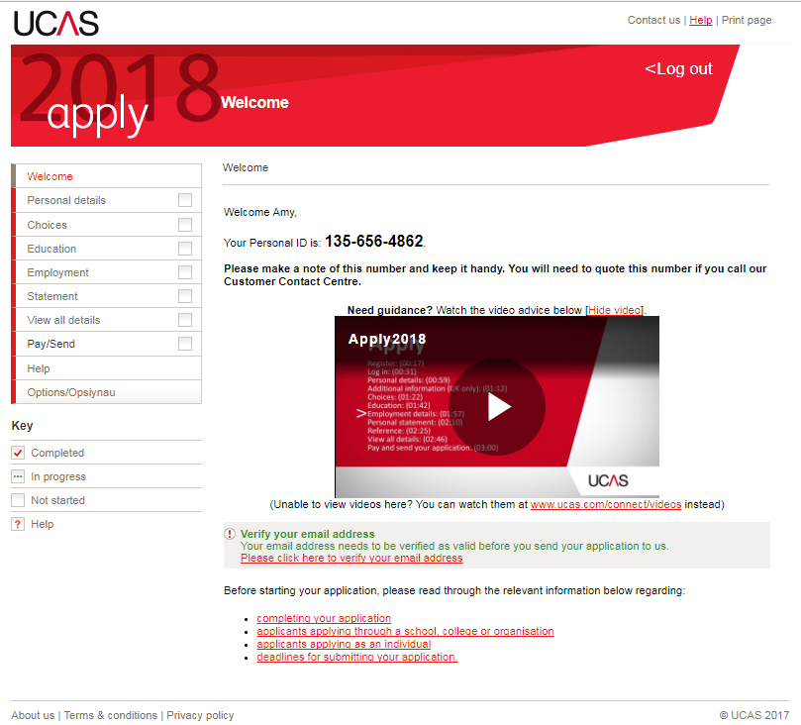

Begin Your Application

Now you can begin filling in your application. The pages you need to complete are listed in the panel on the left-hand side of the page. Work your way through each of these pages, marking them complete as you go.

NB: You may skip around and complete them out of order, if you wish. You may also pause your application and return to complete your it some other time; UCAS will save your progress.

First, check that your personal details are correct and complete. UCAS will copy these over from the registration fields you just completed, but you should double-check them for accuracy and immediately correct any mistakes. You must also provide additional details, such as the Student Support Fee Code (which for most students will be 02 – UK, ChI, IoM, or EU student finance services).

Choices

Your “Choices” are the courses that you wish to apply to.

You can list as many courses as you like, up to a maximum of five. You can choose any combination of degree courses. We strongly advise you to use all 5 choices and to apply for more than one partner university.

Your position will depend upon the SWAP Learner Agreement you signed at the beginning of the year (for example, if you are applying for a specific programme such as Nursing). Refer to your Learner Agreement for details. If you have not signed an agreement or do not have it to hand, please contact the SWAPWest office for a copy: swapwest@scottishwideraccess.org

If you want to apply for more than one course at the same university you must make a separate entry for each choice. However, remember that some universities operate a “faculty entry” system whereby the entry requirements are the same for all courses within a faculty, so one course choice per university may be sufficient.

In the case of the University of Strathclyde, applicants to Social Science subjects are permitted ONE CHOICE ONLY. Please do not apply to more than one Social Science subject at the University of Strathclyde, as all applications will be rejected if you do.

You may enter your courses in any order; they will automatically be arranged alphabetically. The fee is £25.00 for more than one choice (2018).

Do your research into your choices thoroughly and check carefully that you have given the correct course and university codes. This is especially important if you are applying to study Psychology. Different universities use different course codes, and some offer Psychology as a subject in a number of different faculties/schools. If you use the wrong code, your application will be rejected and the decision cannot be reversed. Double-check with your class tutor or the SWAP office if you are unsure.

When you’re ready to enter your choices, click on “Add a choice”.
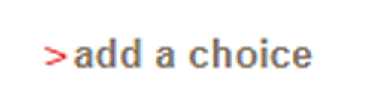

NB: Use the worksheet on the next page to gather all of your choices before you begin. Give a copy of this worksheet to your class tutor BEFORE YOU APPLY, so that s/he can check that you have made sensible choices.

My 1st choice:
University name and code: ……………………………………………………………..
Course Name and code:………………………………………………………………
Entry requirements (e.g. ABB, BBB)…………………………………………………
This is listed among the SWAP progression routes: Yes No

My 2nd choice:
University name and code: ……………………………………………………………..
Course Name and code:………………………………………………………………
Entry requirements (e.g. ABB, BBB)…………………………………………………
This is listed among the SWAP progression routes: Yes No

My 3rd choice:
University name and code: ……………………………………………………………..
Course Name and code:………………………………………………………………
Entry requirements (e.g. ABB, BBB)…………………………………………………
This is listed among the SWAP progression routes: Yes No

My 4th choice:
University name and code: ……………………………………………………………..
Course Name and code:………………………………………………………………
Entry requirements (e.g. ABB, BBB)…………………………………………………
This is listed among the SWAP progression routes: Yes No

My 5th choice:
University name and code: ……………………………………………………………..
Course Name and code:………………………………………………………………
Entry requirements (e.g. ABB, BBB)…………………………………………………
This is listed among the SWAP progression routes: Yes No

Education

Highest Level of Qualification:
Because you are applying to university on the basis of your SWAP qualification, you should select “Below honours degree level qualifications” in the drop-down menu provided.

Then click on add new school/college/centre
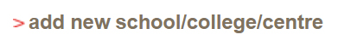

NB: SWAP is treated by UCAS as if it were a high school or college; however, “SWAP” doesn’t appear in the drop-down list on the “add new” page, so you will have to write it in. Follow the instructions below carefully.

How to identify yourself as a SWAP student:
It is important to identify yourself as a SWAP student. Failure to do so will result in your application being treated as if from an ordinary applicant rather than as a SWAP applicant, which can have implications for your progression to university.

- When you first land on the “add new” Education screen, the School/College/Centre space will be greyed out.
- Click the “Find” button and a pop-up window will appear.
- In the pop-up window, type in “Scottish Wider Access Programme.”
- You’ll then see the result: “0 matches found”.
- Click the link below that reads: “My school/centre is not listed here”.

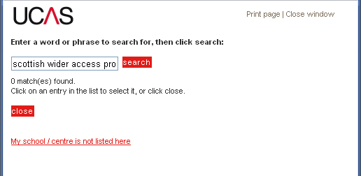
You will then be able to type in your school/college/centre name. Type: Scottish Wider Access Programme (see image on next page)
- Enter the exam centre number: 78792
- Start and end dates for your SWAP course are provided by your college (usually Aug-Jun)
- Indicate that you have been full-time and that you will receive a formal qualification at the end

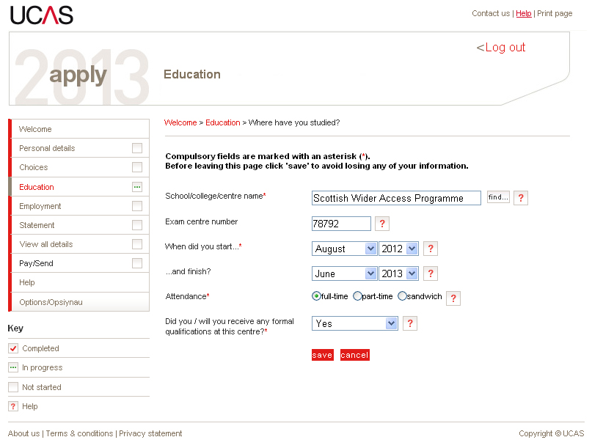

After completing this form, click on Save to return to the main Education page. You will then be able to add your qualifications (the National Units you have been studying at college) to your application.

Education qualifications
- Click ‘Add a qualification’
- Then click ‘National Units – Scotland’

Add the units of your programme (your college tutor can provide you with a list of units and their levels). The qualification date will be the end of your SWAP programme (usually June) and the awarding body is SQA. Click on ‘save and add similar’ to add another unit. Click ‘save’ after you have entered all units to be returned to the main Education page. You may also include any other qualifications you hold, if you wish (e.g. from school or previous study). When you have completed all education information, you can mark the section completed by ticking the box.

You will be reminded to input a Scottish Candidate Number (SCN) for Scottish Qualifications. This number is either from your previous Scottish certificates or will be issued to you by your college.

Employment

Follow the prompts to add employers and details of any previous work experience you may have. You are not required to include employment information if it is not relevant to your application or if you have not worked. However, you must mark the section as complete (by ticking the box) before your application can be considered complete.

Statement (i.e. Personal Statement)

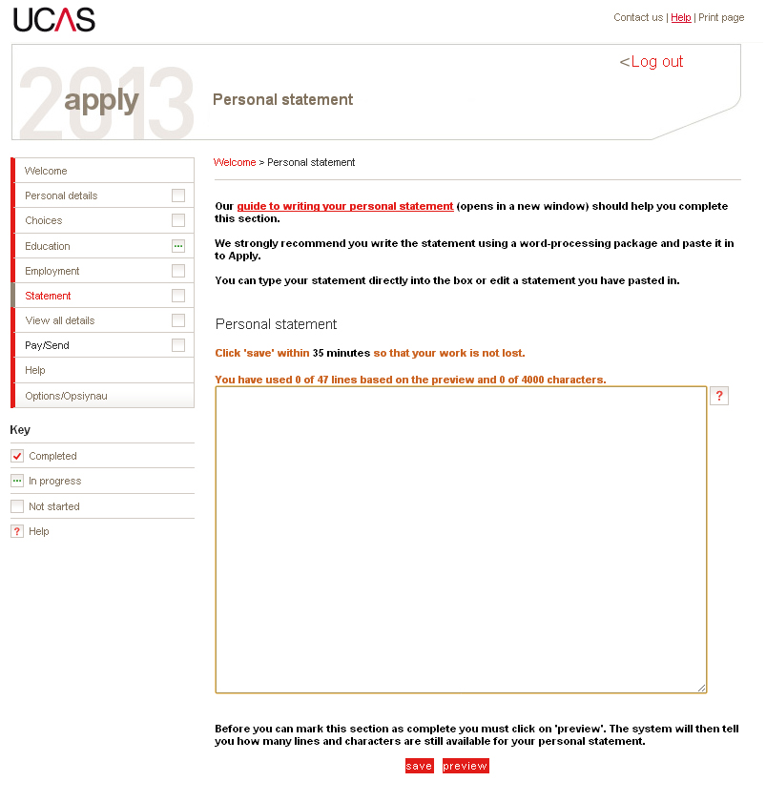
Your personal statement is your best opportunity to tell the universities and colleges about your motivation, commitment and suitability for your chosen courses. It should include relevant practical experience, transferable skills or qualifications not mentioned elsewhere.

A good personal statement is important; it could help to persuade an admissions officer to offer you a place. The statement should be clear and concise with correct punctuation and spelling.

Long paragraphs of unbroken text can be difficult to read so use headings and/or shorter paragraphs. You do not have to fill the entire space, and you must not use more than 4000 characters.

The Personal Statement field has a timer attached to it which, when it expires, will “refresh” the window and cause you to lose all of the information you have typed unless you continually click Save as you are working. For that reason (among others), it is a good idea to prepare your statement offline.

Create your Personal Statement in a Word document and paste it into your online application after it is complete. Please read through the Personal Statement section in the Preparation for Higher Education unit and take advantage of the guidance provided by UCAS on how to write a good personal statement.

Pay and Send

Once you have completed all sections, you will be able to pay for your application and then release it to your class tutor so that s/he can attach a reference. Your college will have its own procedures for this part of the process, so check with your class tutor for more information.

Additional Notes

Criminal convictions
Universities ask applicants to state on the “Personal Details” section of the application form if they have a relevant, unspent criminal conviction. You must disclose all relevant, unspent criminal convictions, including traffic violations. Failure to do so, even if the offence was minor or a long time ago will mean that any offer made by a university may be retracted for non-disclosure. For applicants to certain professions (e.g. teaching, social work, nursing, medicine), certain convictions will always be relevant. If you have any criminal convictions, read the advice given by UCAS. You may also contact the SWAP office to discuss.

Declaration
You must confirm that the information provided on your application is complete and accurate. You must also confirm your agreement to UCAS’ conditions by entering a tick in a box. If you do not provide this confirmation, UCAS cannot process the application.

Submission of application
Your application is not formally submitted until the reference has been attached and the application approved by your tutor. Your college will provide you with dates that you must strictly adhere to for completion of your application. These dates are normally around the beginning of December. Please continue to check your status, as you cannot be certain your application has been received until you receive acknowledgement from UCAS. Please check with your tutor if you have not received acknowledgement and it is approaching the 15th January.

What happens after your application is sent away?

Decisions
When UCAS receive your application they will send you an applicant number so that you can track your application online (Log in to UCAS and click on Track). They will also send you a booklet entitled ‘Advice for Applicants’ which explains how to respond to offers. You do not have to make a final decision until you have heard from all your choices. Do not rush to accept offers until you have consulted with your class tutor for guidance.

An offer may be either conditional or unconditional (most SWAP students will receive a conditional offer) and the offer letter will tell you the year and month that the course starts.

Conditional offer (C)
This means that the university or college has made you an offer that depends
on certain conditions; usually that you must satisfactorily complete all units of your Access Programme and obtain appropriate grades in your profile.

Accepting or replying to offers
When your chosen institutions have decided whether or not to offer you a place, UCAS will send you a Statement of Decisions letter and a reply slip. You must reply to each offer in one of the following ways.
- Firm acceptance (F)
- Insurance acceptance (I)
- Decline (D)

You may not want to wait for all your choices to make their decisions (see UCAS application guide “When to Reply”). But you should think carefully before you decide which offers to accept because once you accept an offer, including an insurance offer; you are committed to that course. You should feel satisfied that both the course and the college or university are right for you because you will be spending the next three or four years there. We recommend that, where possible, you attend open days or visits before you make your decision. You can delay your replies to UCAS until after your visits, as long as you reply by the date given in your Statement of Decisions letter.

If you change your mind after accepting an offer, you can withdraw but you will not be able to apply for other courses or go through Clearing in the same year.

Firm acceptance (F)
You can only accept one offer firmly. If you firmly accept an unconditional offer (UF), you commit yourself to that course. You must turn down all other offers through UCAS and then you won’t deal with UCAS again. Afterwards, you will just be directly in contact with your chosen university or college.

If you firmly accept a conditional offer (CF), you will be guaranteed a place on that course provided you achieve the grades that are needed or meet any other conditions. If you meet all of the conditions of your ‘Conditional Firm’ offer, you are then committed to the course and you will not be able to go elsewhere.

Insurance acceptance (I)
If you receive two or more offers, and you firmly accept a conditional offer, you must also decide whether to accept a second offer as insurance. This could be either an unconditional offer (UI) or another conditional offer (CI). If you choose
a conditional offer as your insurance, the grades needed for this place should be lower than the grades needed for your firm choice. This will give you a safer ‘fall-back’ option in case you don’t achieve the grades required for your Firm choice.

Why have an Insurance choice?
If you do not meet the conditions of your firm choice, but you do meet the conditions of your insurance choice, you are guaranteed a place on your insurance choice. You are committed to the course and you will not be able to go elsewhere.

Decline (D)
When you have decided on your firm acceptance and insurance acceptance, you must decline (D) all other offers through UCAS. If you want, you can decline all the offers. You will then be able to apply to other universities and colleges either through UCAS Extra or Clearing depending on the time of year.

Examples of ways you can accept offers

UF Firmly accepted unconditional offer.
You cannot have an insurance choice.

CF Firmly accepted conditional offer.

CF + CI Firmly accepted conditional offer plus a
conditional offer that you have accepted
as an insurance.

CF + UI Firmly accepted conditional offer plus an
unconditional offer that you have accepted
as an insurance.

Finally

Your college is asked to retain your student UCAS number (the UCAS number starts with year of entry e.g. 18) on file. This information is required for your Student Profile and is written on your offer letter(s). Please make sure that you give your student UCAS number to your tutor – it is very important.

