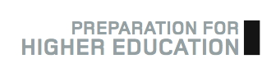

Study Diary

Your SWAP programme is an opportunity for you to approach learning in a completely different way from your previous experiences. If you are able to reflect on how you learn and are aware of how you learn best,
your time at college (and later at university) will be more productive.

Use this generic Study Diary form to record completion of any Prep for HE activities you may complete offline in the months of c. Nov-Feb. For example, you can use this form to record:

* Completion of your UCAS personal statement and your application to university.

* Offline activities, such as organising and conducting mock university interviews with your classmates (e.g. for the professions such as Primary Education, Social Work, Nursing, Medical Studies, etc.)

* Attendance at SWAP Study Skills Days or other visiting opportunities

* Further reflections on your learning experience so far

* Anything else that you consider to form part of your preparation for higher education.

Study Diary Winter

…

