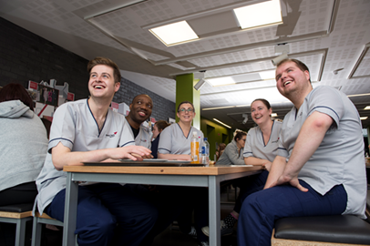**School of Health and Social Care**

**Nursing Interview preparation session**

**Wednesday 7th February**

**Lecture theatre 1D02, Sighthill Campus, Edinburgh Napier University**

13:00 Introduction, School of Health & Social Care

13:10 Academic Skills & Transition Support - Widening Access Team

13:40 Preparing for interview - Confident Futures team

14:25 Break

14:40 Group Interviews, What to expect - Adviser of studies & Programme Representatives School of Nursing, Midwifery & Social Care

15:30 The Student Experience & Q&A - School of Health & Social Care Students & Staff

16:00 Close