**SWAP**

Student Welcome Pack

2017-18



**Access to Nursing**



**Welcome to SWAP!**

You have enrolled on an Access programme which is operated by your college in partnership with the **Scottish Wider Access Programme**. The SWAP programme is designed to get you ready to study at the next level, and to give you the qualification you need to apply to HN or university degree courses.

**The programme is designed for** **adults who wish to progress to university or HN** but do not have sufficient qualifications to apply. Since the first SWAP programme in 1987, we have seen over 30,000 students progress to Higher Education. Former SWAP students can now be found working as engineers, environmental scientists, biologists, teachers, nurses, social workers—and in hundreds of other careers. Some of your college lecturers may even be former SWAP students.

We now offer a variety of Access programmes, including Science, Technology, Engineering and Maths (STEM), as well as Humanities (Social Sciences), Primary Education, Social Work, Nursing, Allied Health and Medical Studies. Each programme consists of at least **18 academic units**, the SWAP ‘Preparation for Higher Education’ unit (commonly referred to as PHE or **Prep for HE**), and the final **SWAP Student Profile** which will be issued by your college at the end of the year.

SWAP is a national organisation. You have joined **SWAPWest**. Our office is based in Glasgow and we have partnership agreements in place with the colleges and universities in the West of Scotland. Our partner Higher Education Institutions are:

* Glasgow Caledonian University (GCU)
* Scotland’s Rural College (SRUC)
* University of Glasgow
* University of Stirling
* University of Strathclyde
* University of the West of Scotland (UWS)
* Glasgow School of Art
* Royal Conservatoire of Scotland

This pack contains important information about the benefits of SWAP, as well as your responsibilities as a SWAP student. Please read it, paying special attention to the SWAP Student Agreement. Also, it is compulsory that you **register online as a SWAP student**.

Keep this information handy for future reference, and check with your course tutor or SWAPWest if you have any questions.

All the best,

Kenny, Lisa, Amy, and Erica

SWAPWest

**REGISTERING AS A SWAP STUDENT**

Registration is **mandatory** so that we can support you as a SWAP student. We need to be able to keep in touch with you, to advise you of university and college information, and to confirm with universities and colleges that you meet SWAP criteria.

**Please register as soon as possible and no later than seven days** after your college SWAP induction talk.



**How to register:**

1. Visit [www.scottishwideraccess.org](http://www.scottishwideraccess.org) and then click **WEST**

2. Click on the link ‘New Student Registration’.

3. Complete the form and submit it.

NB: You will not receive a confirmation email. If you experience problems in registering or if you’re not certain your registration has gone through, please contact the SWAPWest office on 0141 564 7206 to check.

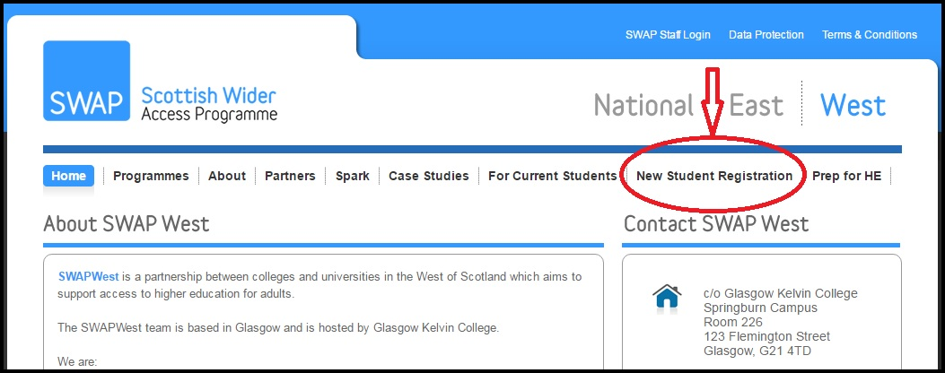

**After registration:**

* Inform your guidance tutor/class tutor that you have completed registration as a SWAP student.

**SWAPWest Student Agreement (Session 2017 – 2018)**

**Access to Nursing**

The SWAPWest partnership of colleges and universities provides access programmes for adults with no or few qualifications who are looking to return to education. The programme you are studying is recognised by our partner universities as an entrance qualification for nursing.

The Student Agreement sets out the specific criteria and requirements that we expect from you to ensure you make the most of the opportunities provided by the SWAP programme.

**Due to the limited number of places available at our university partners** it is not possible for us to ensure that all SWAPWest students will be able to progress straight to university. Completion of a SWAP programme will also allow you to progress to HN at college. You must ensure that you research fully all of the branches of nursing and health care options prior to applying.

**We would highly recommend applying for the HNC Health Care as well as to university for Nursing to ensure progression from your access programme.**



“Although I was hugely disappointed when I didn’t get my first choice...in the long run, it has worked out for the best. I was so focused on that one university course, it never entered my mind that it wouldn't happen -- until it didn’t. But now when I look back, I can see that it wasn't as devastating a result as I imagined it would be, and I am thoroughly enjoying what I'm doing now.” – Karin S.

**You must follow specific SWAP application processes** (as outlined in the Prep for HE workbooks) in order to ensure that your application for nursing will be considered. For example, you must apply to university through the SWAP UCAS “school”. If you do not, you will not be considered as a SWAP student.

If you receive an offer from a university it is subject to **4 specific conditions:**

1. **You must complete all of the units** of your programme. Non-completion of any of the units means that you will not receive a place at university.
2. **Your student profile must meet the requirements** of the university progression route for that degree. The student profile is an enhanced reference by your college which is given to the university. A sample copy of the profile is available to view on the SWAPWest web site. For nursing, your communication skills are particularly emphasised but you should also look at the back page as it specifies all of the issues that the College will report on. **If you do not meet the required level then you will not be offered a place at university.**
3. **You must complete the Preparation for Higher Education unit.** Worksheets and other materials are available from the SWAPWest web site. It is anticipated that you will work through these materials on your own throughout the year. Your college will provide you with additional assistance but Prep for HE is your responsibility. You will be asked at the end of the year to provide evidence that you have completed all of the elements of Prep for HE.
4. You will require a satisfactory health check and membership of the PVG Scheme.

**For entrance to all university degrees you are required to use a service called UCAS.** UCAS administers entrance to university places. You must apply for your degree choice through UCAS by 15th January 2018. Any application after that date does not have to be considered. It is your responsibility to ensure your application has been sent off properly.

**Once you receive a reply from the universities:**

All SWAP students should ensure once they receive offers that they accept a FIRM place. Note that you need to keep in touch with UCAS to ensure you do not miss your deadline date. **You will lose your place at university if you do not confirm your place on time.**

**SWAP Students and Disclosure of Criminal Convictions**

If you are a student applying through UCAS to universities and colleges, you are asked to disclose whether you have any criminal convictions. It is essential that you make an honest declaration as checks will be carried out. **Failure to disclose any details will exclude you from your chosen course.**

For nursing and health courses involving work with children or vulnerable adults, you **must** declare any criminal convictions including spent sentences and cautions (including verbal cautions). You should note that, as part of the application process, the University will require membership of the Protecting Vulnerable Groups Scheme (PVG scheme) for further information on the PVG scheme please visit [www.disclosurescotland.co.uk](http://www.disclosurescotland.co.uk).

If you are in any doubt over your declaration, please speak with a Higher Education admission tutor in your area of interest.

Kenneth Anderson, Director, SWAPWest.

**I fully understand the nature of the SWAPWest student agreement.**

Signature: _________ Date:

Print Name: _____

**Advice from former SWAP Access to Nursing students:**



“At the beginning when you first start at college, you may question your decision and think you have bitten off more than you can chew. The first few weeks are crammed full of information, coupled with the challenge of meeting new people—no wonder if you feel overwhelmed. Before you know it, it will be exam time and you really will be surprised by how much you know. Have faith in yourself and your abilities. June comes around extremely quickly and you will no doubt surprise yourself again by how well you have done. So, relax and enjoy the experience. Believe you can do it!”

“I was out of education for 20 years, and coming to college was daunting. I have two children and had to learn to prioritise quickly. Use Moodle and take notes. Read the [Prep for HE] packs. It is tough and stressful, and at times you will wonder if you can do it. You have to put the time and effort into the studying! Attendance is a huge part of it. Don’t be afraid to ask questions.”

“Hello future SWAP students! This will be the quickest year of your life. The subjects are interesting and there is a lot of information given, so ensure you take notes and read over them regularly to give you the best chance in your exams. Don’t leave studying till the last minute. Good luck and enjoy the course!”

**Checklist for Success:**

* I have attended an induction talk from SWAPWest
* I have received a copy of SWAP Student Welcome Pack
* I have read the SWAPWest Student Agreement
* I have registered online as a SWAP student on the SWAP web site (see p. 3)
* I have visited the **Prep for HE** page ([www.scottishwideraccess.org/west-prep-for-he](http://www.scottishwideraccess.org/west-prep-for-he)) and set reminders to complete Prep for HE exercises monthly
* I have read the information provided on the **SWAP Student Profiles** page.



**Top Tips for Success:**

1. Develop study methods and strategies that are effective for you
2. Access additional academic support as soon as you need it; don’t delay
3. Complete Prep for HE exercises regularly throughout the year
4. Respond positively to feedback on course work; act on it to improve your skills
5. Offer support when you can give it; ask for support when you need it

**Reflections from former SWAP students:**

“It was overwhelming at first and a huge learning curve, but a great experience overall. SWAP has given me opportunities that I never thought I would have.”

“Thanks to SWAP, I am heading off to university. The skills and knowledge I have learned will stay with me forever. SWAP prepares you very well.”

“SWAP will undoubtedly give you a fantastic opportunity to progress to university, but you will need to work hard. You get out what you put in!”

“Doing this course has been an amazing experience; the fastest year of my life and the best year ever.”

- Access to Nursing students (2012-13)

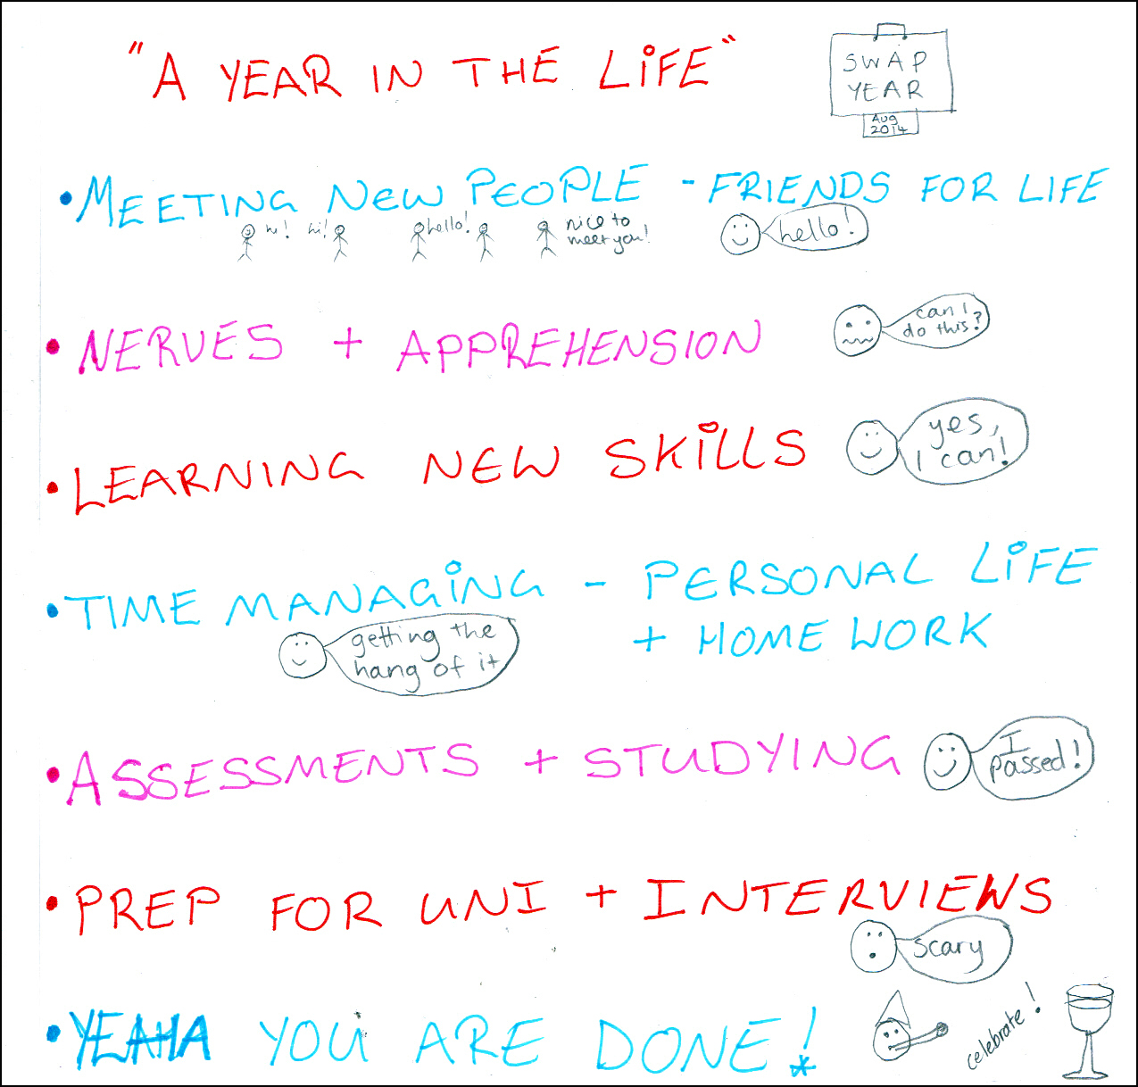

**PREPARATION FOR HIGHER EDUCATION:**

To be successful in Higher Education, you must develop and improve skills such as academic writing, critical thinking, note-taking and referencing. The Preparation for Higher Education unit (Prep for HE) is designed to help you do that.

**Prep for HE will help you:**

* Create strategies for more effective learning
* Apply to universities via UCAS and write an impressive Personal Statement
* Develop academic skills
* Apply critical thinking skills to academic work
* Respond effectively to feedback on course work and assessments
* Develop strategies for managing finances whilst studying full-time

**Where to find Prep for HE:**

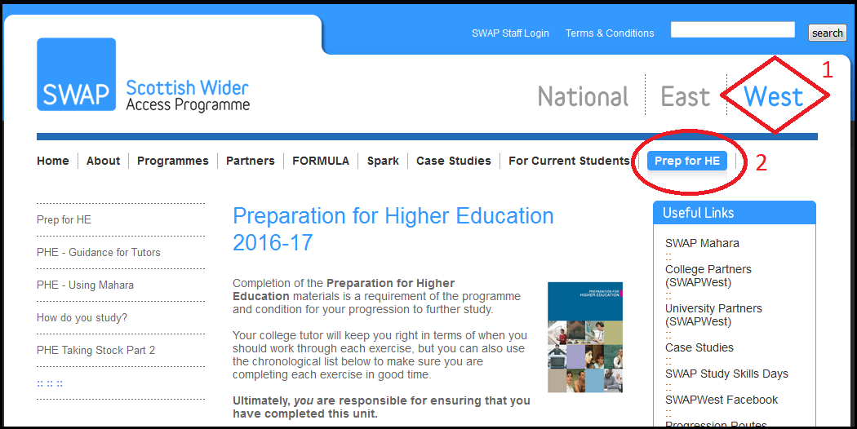

Use the guidance on the SWAPWest web site to help you keep track of which Prep for HE exercises are most useful at key points during the year. You can start today! [www.scottishwideraccess.org/west-prep-for-he](http://www.scottishwideraccess.org/west-prep-for-he).

**CONTACT US**

Your first point of contact is your course tutor. However, you may contact the SWAPWest office at any time if you have an enquiry or need additional information about the programme or the Prep for HE unit.

|  |  |  |
| --- | --- | --- |
| **Address** |  | Scottish Wider Access Programme (SWAPWest)  c/o Glasgow Kelvin College  123 Flemington Street, Room 226  Glasgow G21 4TD |
| **Telephone** |  | 0141 564 7206 |
| **Email** |  | [swapwest@scottishwideraccess.org](mailto:swapwest@scottishwideraccess.org) |
| **Web** |  | [www.scottishwideraccess.org](http://www.scottishwideraccess.org) |
| **Facebook** |  | [www.facebook.com/swapwest](http://www.facebook.com/swapwest) |
| **SWAP Student Mentors** |  | [www.facebook.com/groups/swapmentors](http://www.facebook.com/groups/swapmentors) |