The secret of a good presentation lies in the preparation
you do. Anyone who prepares thoroughly can give a successful presentation.

Even if you are not required to make a presentation as part
of your interview for a place at university, you will almost certainly be called upon to do this at some stage in your studies. University tutorial sessions often require small groups of students to work together to create a presentation on a relevant topic, with each student receiving a mark that contributes to the final grade. Therefore, it is important that you begin cultivating these skills before you go to university.



Preparation

Thorough preparation is the key to success in giving presentations. You first need to think about the various aspects of giving presentations and learn some of the techniques involved in presenting well. This booklet helps you think about how to:

Plan the presentation

Speak effectively

Deliver an effective message

Engage your audience

Prepare to answer questions

Be ready to deal with the unexpected

Practice

Presentation skills, like all others, improve with practice. If you are asked to give presentations in college, don’t resist or try to put it off. Instead, make the most of the opportunity to try some of the different planning methods and different presentation styles that you will learn about in this section.

You may also find it helpful to privately critique any presentations you may view, identifying what works well and what could be improved (e.g. television presenters, news readers, and even your own college tutors).

Where do I start?

The first thing you need to do is make sure you understand exactly what kind of presentation
you are required to do.

All presentations are not the same. A presentation may be part of an interview or it could be a brief presentation to others in your class as part of your Communications unit. Later, you may find yourself giving an ‘expert’ talk where you have a particular area of expertise which will be useful to others. For example, many of our former SWAP students revisit their old colleges to give short, informal presentations to current students about the experience of progression to university.

Although it is important to understand the type of presentation you are planning, remember that the core elements are the same no matter which kind of presentation you are doing.

Over the next few pages are some exercises on how to plan and write your presentation. You could do the exercises with a particular presentation in mind – for example, you might have one coming up at college – or you could pick a subject of your choice to practise.

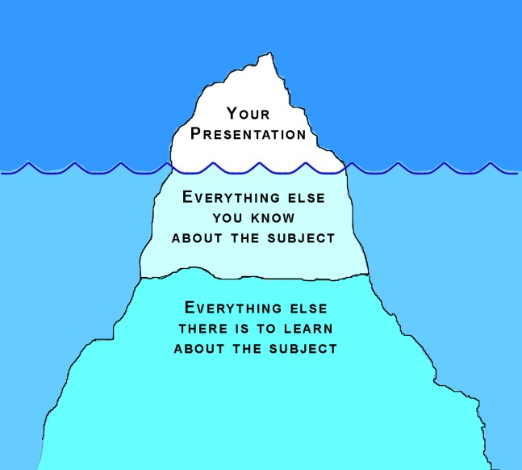
Research:

Many students think they have to do loads of research before they begin to prepare their presentation. While a good knowledge of your subject is important, remember that a presentation lasts only a short time and the amount of information your audience can digest is very limited.

Imagine that the entire body of knowledge on the subject is an iceberg, keep in mind that you will be presenting only the very tip of it to your audience. There is no need, therefore, to do additional extensive research about your subject. Instead, focus more on structuring your presentation to ensure that the information is presented clearly and in an engaging manner.

EXERCISE

Plan the Presentation

Glance over the questions below, then read through the sections that follow, completing the exercises. By the end, you should be able to answer these questions and begin planning your next presentation.

Q1: What is the purpose of the presentation?

........................................................................................................................................................................................................................................................

Q2: What is the main theme of the presentation?

........................................................................................................................................................................................................................................................

Q3: Who will be listening to the presentation?

........................................................................................................................................................................................................................................................

Q4: How much time do I have for the presentation?

........................................................................................................................................................................................................................................................

Q5: Do I have to leave time for questions?

........................................................................................................................................................................................................................................................

Q6: What is the venue for the presentation and what facilities do they have? Will I be able to use Power Point or a flipchart? Could I use video or audio? Will I need a microphone or is the room small enough for my voice to carry?

…………………………………………………………………………………………………………………………………………………………………………………...

When you are clear about the items listed above you can begin to prepare.

The Purpose of the Presentation

Focussing on the purpose of your presentation is key to the overall success of your talk.

For example, if the content of your presentation is most important you will have to make sure you have a good grasp of the main points and can communicate these effectively to your audience. If the purpose of the presentation is to judge how effectively you speak to a group, then the points for presentation can be minimal but the way in which you deliver them is important.

The Main Theme of the Presentation

EXERCISE

Think of a presentation that you have been asked to make. This could be a presentation that is coming up in the near future (if you have one looming) or you can think about a presentation that you have given in the past.

What am I going to talk about?

What key points do I wish to make?

1.

2.

3.

4.

WORKED EXAMPLE

What am I going to talk about?

Why recycling is important

What key points do I wish to make?

1. Saves energy

2. Reduces pollution

3. Saves money

4. Can create jobs

Sometimes it is quite easy to think of what your key points ought to be, particularly if you know the subject very well, as they will spring to mind right away without much effort. At university, however, you will often be asked to give presentations on material that is relatively new to you. When that happens, you may need to use other methods to generate ideas and get you started on the process of putting a presentation together.

‘Spidergram’ or Mind Map

If you need help getting started on the planning of your presentation, you may find it useful to use a ‘spidergram’ or mind map to identify some possible key points, like the one on the next page.

To begin, write the theme or general subject of your talk in the middle section and then write down any ideas that come to you round about it. Try not to spend too much time picking the ‘perfect’ key points; just jot down the first seven or eight key ideas that come to mind.

After you have brainstormed a bit, you can read over all the ideas carefully and select a few which best fit your theme. As a general rule of thumb, you should have no more than four or five points in a short presentation; more than that will be too much for most audiences to digest. You may choose to have fewer points (perhaps two or three) so that you can cover them in more detail.

Spidergram

Here is an example of a spidergram with the theme ‘Returning to Study: My experiences as a SWAP student’. A blank version is on the next page but you may, of course, make your own.

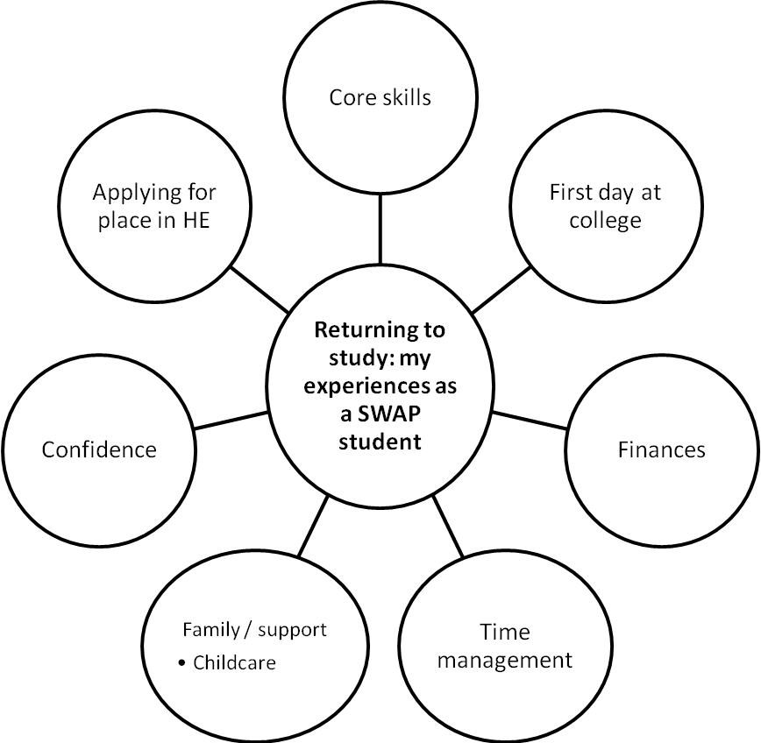

Spidergram



Audience

Now that you have decided on the key points of your talk you have to think about the audience; who will be observing and listening to your presentation?

Who are they?

........................................................................................................................................................................................................................................................

How many will be there?

........................................................................................................................................................................................................................................................

How much do they know about the subject?

........................................................................................................................................................................................................................................................

What do they expect to get out of it? What do you hope they will get out of it?

........................................................................................................................................................................................................................................................

The answers to the above questions will determine the content, format
and delivery of your talk.

For example if the audience knows nothing at all about the topic, you will have
to provide some basic background or a general introduction. If the audience knows quite a bit about the subject then you may wish to choose a particular focus or ‘argument’ to concentrate on or a single aspect of the subject to explore in greater depth.

If there are only three or four people listening (as in an interview for example) you do not have to worry about projecting your voice as much as if there were forty people. You still have to make yourself heard, of course, so make sure that you actually practise speaking aloud and don’t just read over your notes silently when you are preparing.

Structure

Here we will think about how you will introduce and present your main points and how you will conclude the presentation.

The simple narrative approach where you have a beginning, middle and end is a good way to think about your presentation.

- Beginning: a clear introduction which explains why you are making the presentation and sets out briefly what you will be talking about and in what order.

- Middle: this is the bulk of the presentation, where you state your points in detail.

- End: draw together the points you have made and present some brief conclusions. Make reference to the initial statements you made in your introduction, showing that you have addressed everything you set out to cover.

To greatly simplify the above:

- Tell them what you’re going to tell them
- Tell them
- Tell them what you’ve told them!

Structuring your main points:

It’s a good idea to think about how you present your main points. Here are a couple of structures you might want to try in your own presentation.

Separate but equally weighted points:

Lectures are often presented like this. Perhaps the points are presented in chronological order or in a logical progression with an exploration of ‘for and against’ before moving on to the next point. One point may not directly relate to the next.

- Point 1
- Point 2
- Point 3

(Adapted from GCVS presentation notes – ‘Making Presentations’ published by Dorling Kindersley)
Emphasising one main point and supporting it by secondary points:
This structure works well when you have one main point or argument. Everything else you say will be in support of this point and you will refer back to it throughout the main body of your presentation. This works well when presenting to an audience that is knowledgeable about the subject.

- Main Point
  - Supporting Point 1
  - Supporting Point 2
  - Supporting Point 3

Overlapping points:

This structure has separate points but they are all interconnected and would be referred to and cross-referenced throughout the presentation. It works will with informal talks to small audiences that are able to cope with the presentation of complex information.

Point 1
Point 2
Point 3

Keeping the audience’s attention

Audience attention levels fluctuate. A person is at their most attentive at the beginning of a presentation so you may want to think about presenting your most important points early on.

Remember, too, to signpost what part of the talk is coming next. Tell the audience that you are moving towards your final point or that you will spend a few minutes expanding on your last point before moving on to the next section.

To raise flagging attention levels towards the end, tell the audience that you are nearly finished. This will refocus them. Try to notice it yourself when you are in class. If you’re tired or losing concentration, you’ll be surprised at how quickly you perk up when the lecturer tells you there is only one more point to deliver before the end.

How Much Time Will I have?

This is the most critical factor of all. No matter how good your material is, if you do not allocate time properly to each section you won’t make a coherent, complete and therefore effective presentation.

As a working example, imagine that you have twenty minutes allocated for your presentation. How would you divide the time?

EXERCISE

Use the chart below and fill it in as you think appropriate.

Number of minutes

Introduce yourself/give background

Introduction to subject

Key points of the presentation

Conclusion

Parting remarks / questions

If there are to be questions from the audience remember to build in time for them. Also, be careful not to run over time. This is especially important if there are others waiting to make their presentations.

Effective Delivery

Try the exercise below and pick out the one which is most important.

EXERCISE

Which of the following will be most important in helping you deliver your talk effectively? Rate the following below from 1-10 with 1 being the most important and 10 being the least important.

A clear speaking voice

A varied tone of voice

A confident manner

A good knowledge of the subject matter

Speaking without notes

Plenty of practice beforehand

Good visual aids

- Making good eye contact

- Speaking slowly

- Smiling

Practice Makes Progress

What did you rate as ‘1’ on the previous page? Although many of the items on the list are important factors in an effective presentation, by far the most important is ‘plenty of practice beforehand.’

Practise with a friend, a member of your family or, if all else fails, in front of the mirror. You could also set up your camera or mobile to record your presentation so you can watch yourself later. If you practise using any of these methods, you will be better able to spot some of those distracting habits speakers often have: saying “um” or repeating words too often; swaying or rocking backwards and forwards; or turning away from the audience while speaking (this is particularly likely if you use Power Point or other visual aids).

Practice is what will give you confidence – and confidence means a successful delivery. If you are confident, you can then concentrate on making sure you are speaking clearly and distinctly.

Some other notes regarding the list on the previous page:

Whether you’re using notes or reading from a script (either is fine – do whatever makes you feel comfortable) if you practise beforehand you will be familiar with your material and it will sound fluent.

Nerves are usually caused by a feeling of lack of control – a well-practised talk puts you in control.

Remember to speak more slowly than you would normally – but not so slowly that it sounds unnatural. Again, practice is the key.

Visual aids are useful but not essential. If you are at all doubtful about your ability to use a visual aid (e.g. Power Point, a flip chart, etc.) it’s probably best to leave it out. If your talk is short and well practised, your audience will not require them.

Power Point

Speaking of visual aids, there is no getting away from the prevalence of Microsoft Power Point, especially in presentations at university. Most people will at some point use Power Point for a presentation and, while there is generally nothing wrong with doing so, many people misuse its features and rely too much on letting the slides do the talking.

Remember, Power Point (like any other visual aid) is meant to enhance or further illustrate what you are saying. It should not take the place of your actual words and it should not distract from your message. For a bit of fun, visit the link below to watch a Power Point presentation about Power Point presentations.

Life After Death by Power Point 2010
by Don McMillan
http://youtu.be/KbSPPFYxx3o

EXERCISE:

Watch another clip (see the link below) and note that, although the presenter is greatly exaggerating some of the common pitfalls of presentations, they are common enough to be quite recognisable (and amusing) to his audience.

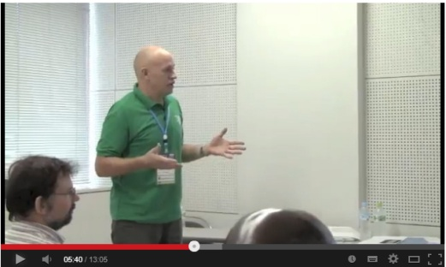
How Not to Give a Presentation
by David Barker
http://youtu.be/ENOvAGQ5UlU

As suggested by this presenter, perhaps you could work with a classmate on this exercise. Watch the video, making notes as you go, and then compare your notes with your classmate and discuss. Thinking critically about the performance of someone else can help you to develop your own skills and avoid common pitfalls.

Engaging Your Audience

It is far more pleasant to give a presentation to an audience that is interested in what you are saying. It is difficult to maintain the energy and enthusiasm you need to perform well if your audience is clearly “switched off.” The good news is that you can do quite a bit to encourage their attention.


Smile

Remember, this is not a trial by jury! Your audience will be well disposed towards you and prepared to listen to what you have to say – take advantage of that fact and greet them with a smile, even if you are nervous about your presentation and don’t feel very cheerful.

Research has shown that smiling during brief periods of stress, such as you might experience when preparing for and giving a presentation, can actually reduce your body’s stress response (e.g. heart palpitations, trembling, shortness of breath, etc.) even if the smile is fake. So, smile!

Eye Contact

One recommendation for making sure your audience stays engaged is to focus on individual members of the audience in turn, to make each one feel you are directing the information to him or her. With a large audience, you could also focus on people sitting at either end of a line of seats, sweeping your eyes across the people in the middle of the row as you alternate. If you really struggle with making eye contact, try the “sweeping” glance across the back of the room; people will assume you are looking at members of the audience behind them, which is better than staring at the floor.

Structure

Remember your structure and refer to your notes to keep you on track. No matter how brief your talk, you may find it useful to use repetition to emphasise your key points. Remember:

Beginning: Tell the audience what you are going to talk about

Middle: Give them the key facts (Tell them)

End: Repeat (in a shorter form) what you have just told them.

Having a clear structure can help you to stay focussed on your key point and help you to keep within your time limit. It can also help your audience to stay engaged as they follow you from beginning to end.

Activity
Depending upon your subject, you may not have to do all of the talking during your presentation. If your subject lends itself to such, you may find it very effective to engage the audience with some sort of activity. This could be in the form of a quiz or perhaps you could invite a member of the audience to help you with a demonstration, as a form of visual aid.

For example, imagine that you have been asked to give a presentation to your classmates on the symptoms of diabetes. You could, as part of your introduction, hand out paper and pens to your audience members and ask them to list any symptoms of diabetes that come to mind. After your presentation, you could ask them to do the same again, comparing their two lists to check that they have learned something new from your presentation.

Answering Questions

If your talk is part of an interview you may be expected to answer some questions about the content of your presentation. If you raised interesting points, your interviewers may ask you to expand upon them or to clarify certain aspects.

If you have prepared well for your talk you should have no difficulty with this, but if there is anything you do not know or are unsure of it is best to be honest; don’t try to make up an answer. One way to respond would be to say something like, “That is a very good question. I’m afraid I don’t know the answer but I would be interested to find out, so I will look into it. Thank you.”

Putting It All Together

Here is an example for you to practise.
You have been given the topic: ‘Why I decided to enrol on a SWAP Programme’ for a twenty minute presentation to your classmates.

EXERCISE

Use the headings below to get you started.

What is the purpose of the talk?

........................................................................................................................................................................................................................................................
........................................................................................................................................

What is the main theme of the talk?

...................................................................................................................................................................................................................................................................................................................................................................................

Who will be listening to the talk?

....................................................................................................................................................................................................................................................................................................................................................................................

How much time do I have for the talk?

...................................................................................................................................................................................................................................................................................................................................................................................

Do I have to leave time for questions?

....................................................................................................................................................................................................................................................................................................................................................................................

Will I use visual aids?

....................................................................................................................................................................................................................................................................................................................................................................................

Putting these elements in writing may seem very straightforward but if you get into the habit of answering these questions before you begin, it will help with the format of any presentation.

The Main Theme of the Presentation

EXERCISE

List below four or five key points you wish to make.

1.

2.

3.

4.

5.

(Remember you can use a spidergram or mind map for this exercise).

Timing

You have a total of twenty minutes. Fill in below how you are going to allocate the time.

Number of minutes

Introduce yourself

Introduction

Key points of the presentation

Conclusion

Parting remarks / Questions

And Finally . . .

The only way to become effective at making presentations and giving talks is to take every opportunity to do so.

Use the ideas in this booklet and the notes you will have from your Communications class to help you.

Try not to be nervous: it’s easy for us to say that but if you prepare well and practise, what can go wrong? Your audience will be interested in what you have to say. If you still feel nervous, practise deep breathing. It’s impossible to panic while at the same time concentrating on breathing slowly in and out – your body can’t do the two things at once! Some people find ‘7/11’ breathing very helpful; this is where you breathe in for a fast count to seven, then breathe out for a fast count to eleven. Practise this for five minutes whenever you feel nervous.

Try it now:

Organise a group session with a few others in your class to practise making presentations.

Choose a topic acceptable to all of you and practise in the way suggested.

Give each other encouragement and point out each other’s strengths, but also suggest some improvements that could be made.

Your time in college is very limited so you have to create opportunities
for yourself.

Effective spoken communication is a great asset for any student. And you
can improve your skills in this area if you prepare well.

Good luck!

