**2018/19**

**Introduction**

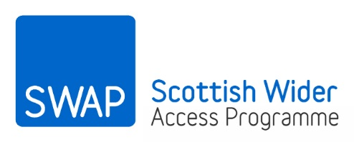

**preparation for higher education**

The SWAP East Preparation for Higher Education (Prep for HE) materials have been designed to complement the work you do on your access programme. It is hoped that by working through the materials you will build and develop the confidence, self-awareness and academic skills you will need to progress your studies and be successful in higher education.

1. What is Prep for HE?

Prep for HE is an important part of your SWAP East access programme. It consists of a range of activities, which include completing college-based personal development units, attending university open days and SWAP East study skills events and working your way through the SWAP East Prep for HE materials.

1. When should I work on the Prep for HE materials?

A suggested schedule is detailed in the table below. You can complete the materials online or print them off and fill them in by hand. You must make sure that you save your work so you can show you have done it.

1. What are the Prep for HE materials for?

The aim of the Prep for HE materials is to prepare you for the next step in your studies. The materials include exercises which will challenge you, develop your academic skills and encourage you to be reflective and think critically. The materials also include information that will help you as you research which college or university you want to study at and how to apply

1. What if I need help?

Your tutor can help you with any questions you have about the Prep for HE materials. You can also contact the SWAP East team anytime. We will be happy to help you.

1. Prep for HE schedule

|  |  |
| --- | --- |
| Section | Date completed |
| Week 1 to end of programme | |
| Study diary |  |
| September | |
| Taking stock 1 |  |
| September/October | |
| Essay-writing |  |
| Note-taking |  |
| Presentation skills |  |
| Referencing |  |
| Top tips |  |
| October | |
| Taking stock 2 |  |
| January/February | |
| Interview skills |  |
| May | |
| Taking stock 3 |  |