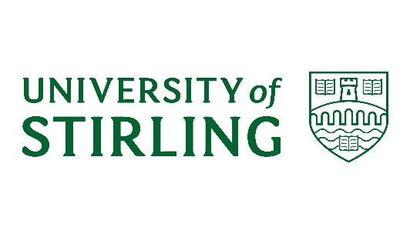



**University of Stirling / SWAP**

**Study Skills Day**

**Friday 22nd February 2019**

**Cottrell Building, Lecture Theatre A3**

|  |  |
| --- | --- |
| **10.00 – 10.30am** | **Registration**  Record your attendance in the crush hall and find a seat in the lecture theatre. |
| **10.30 – 10.45am** | **Welcome**  Tracey Kerr from The University of Stirling will welcome you and tell you all the important stuff for the day. |
| **10.45 – 11.15am** | **Note-taking at University**  SWAP West staff will discuss lectures and learning and introduce you to various note-taking methods you can try during the lecture that follows. |
|  |  |
| **11.15am – 12.00pm** | **Lecture**  Dr. Mike Walsh from The University of Stirling will deliver a lecture on change |
| **12.00 – 12.15pm** | **Lecture**  How did you do? A look at your notes. |
| **12.15 – 12.45pm** | **LUNCH** |
| **12.45 - 1.15pm** | **Seminar Skills - Critical Thinking Workshop**  Nick Hutcheon from SWAP East will introduce you to an essential study skill: critical thinking. |
| **1.15 – 1.45pm** | **Transitions**  Tracey will give you information on making the transition from college to university and introduce you to an essential study skill through the medium of Lego! |
|  |  |
| **1.45 - 2.30pm** | **SWAP Students Q & A**  Former SWAP students now studying at the University of Stirling will be available to take any questions you have about student life and making the transition from college to university. |
| **2.30pm** | **CLOSE / CAMPUS TOUR**  Time to go home, or have a tour around campus |

**Student Panel**

Courtney Harper (Nursing)

Allen Iruoesiri (Aquaculture)

Paul MacLaine (Film and Media / Journalism)

Laura McGuckin (Law)

Martin McLeary (Nursing)

Valentina Poletto (Int Man and Languages)