**SWAP**

Student Welcome Pack

2018-19



**Access to Nursing**



**Welcome to SWAP!**

You have enrolled on an Access programme which is operated by your college in partnership with the **Scottish Wider Access Programme**. The SWAP programme is designed to get you ready to study at the next level, and to give you the qualification you need to apply to HN or university degree courses.

**The SWAP team can be contacted by email –** [**swapwest@scottishwideraccess.org**](mailto:swapwest@scottishwideraccess.org) **or by phone on 0141 564 7206.**

**The programme is designed for** **adults who wish to progress to university or HN** but do not have sufficient qualifications to apply. Since the first SWAP programme in 1987, we have seen over 35,000 students progress to Higher Education. Former SWAP students can now be found working as engineers, environmental scientists, biologists, teachers, nurses, social workers—and in hundreds of other careers fields. Some of your college or university lecturers may even be former SWAP students.

We now offer a variety of Access programmes, including Science, Technology, Engineering and Maths (STEM), as well as Humanities (Social Sciences), Primary Education, Social Work, Nursing, Allied Health and Medical Studies. Each programme consists of at least **18 academic units**, the SWAP ‘Preparation for Higher Education’ unit (commonly referred to as PHE or **Prep for HE**), and the final **SWAP Student Profile** which will be issued by your college at the end of the year.

SWAP is a national organisation. You have joined **SWAPWest**. Our office is based in Glasgow and we have partnership agreements in place with the colleges and universities in the West of Scotland. Our partner Higher Education Institutions are:

* Glasgow Caledonian University (GCU)
* Scotland’s Rural College (SRUC)
* University of Glasgow
* University of Stirling
* University of Strathclyde
* University of the West of Scotland (UWS)
* Glasgow School of Art
* Royal Conservatoire of Scotland

This pack contains important information about the benefits of SWAP, as well as your responsibilities as a SWAP student. Please read it, paying special attention to the SWAP Student Agreement. Also note that it is compulsory that you **register online as a SWAP student**. Keep this information handy for future reference, and check with your course tutor or SWAPWest if you have any questions.

All the best,

Kenny, Lisa, Amy and Erica

SWAPWest

**REGISTERING AS A SWAP STUDENT**

Registration is **compulsory** so that we can support you as a SWAP student. We need to be able to keep in touch with you, to advise you of university and college information, and to confirm with universities and colleges that you meet SWAP criteria. When you register, you will be informed of our Data Protection policies.

**Please register as soon as possible and no later than seven days** after your college SWAP induction talk.



**How to register:**

1. Visit [www.scottishwideraccess.org](http://www.scottishwideraccess.org) and then click **WEST**

2. Click on the link ‘New Student Registration’.

3. Complete the form and submit it.

NB: If you experience problems in registering or if you’re not certain your registration has gone through, please don’t register a second time; instead, contact the SWAPWest office be email on swapwest@scottishwideraccess.org for assistance.

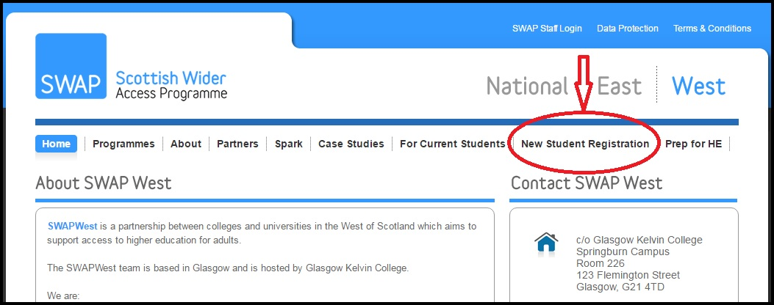

**After registration:**

* Inform your guidance tutor/class tutor that you have completed registration as a SWAP student.

**SWAPWest Student Agreement (Session 2018 – 2019)**

**Access to Nursing**

The SWAPWest partnership of colleges and universities provides access programmes for adults with no or few qualifications who are looking to return to education. The programme you are studying is recognised by our partner universities as an entrance qualification for nursing.

The Student Agreement sets out the specific criteria and requirements that we expect from you to ensure you make the most of the opportunities provided by the SWAP programme.

**Due to the limited number of places available at our university partners** it is not possible for us to ensure that all SWAPWest students will be able to progress straight to university. Completion of a SWAP programme will also allow you to progress to HN at college. You must ensure that you research fully all of the branches of nursing and health care options prior to applying.

**We highly recommend applying for a suitable HNC/D as well as to university, to ensure progression from your access programme.**



“Although I was hugely disappointed when I didn’t get my first choice...in the long run, it has worked out for the best. I was so focused on that one university course, it never entered my mind that it wouldn't happen -- until it didn’t. But now when I look back, I can see that it wasn't as devastating a result as I imagined it would be, and I am thoroughly enjoying what I'm doing now.” – Karin S.

**You must follow specific SWAP application processes** (as outlined in the Prep for HE workbooks) in order to ensure that your application for nursing will be considered. For example, you must apply to university through the SWAP UCAS “school”. If you do not, you will not be considered as a SWAP student.

If you receive an offer from a university it is subject to **4 specific conditions:**

1. **You must complete** **all of the units** of your programme. Non-completion of any of the units means that you will not fully meet the conditions of your offer.
2. **Your student profile must meet the requirements** of the university progression route for that degree.
   1. The student profile is an enhanced reference by your college which is given to the university. A sample copy of the profile and an explanation of profile grades can be found on our web-site. Please read it.
   2. Your communication skills are particularly emphasised but you should also read the back page as it specifies all of the issues that the college will report on.
   3. If you do not meet the required profile grades, then you will not be offered a place at university.
3. **You must complete the Preparation for Higher Education unit.** Materials are available from the SWAPWest web site and/or from your tutor. Your college will provide you with support, but **Prep for HE is your responsibility.** You will be asked at the end of the year to provide evidence that you have completed all of the elements of Prep for HE.
4. **You will require a satisfactory health check** and membership of the PVG Scheme.

**For entrance to all university degrees you are required to use a service called UCAS.** UCAS administers entrance to university places. You must apply for your degree choice through UCAS by 15th January 2019. Any application after that date does not have to be considered. It is your responsibility to ensure your application has been sent off properly.

**You must respond to offers:**

After you have received your final response from the universities to which you’ve applied, you must return to UCAS and select a firm choice. You need to keep in touch with UCAS to ensure you do not miss your deadline date. **You will lose your place at university if you do not confirm your place in time.**

**SWAP Students and Disclosure of Criminal Convictions**

If you are a student applying through UCAS, you will be asked to disclose whether you have any criminal convictions. It is essential that you make an honest declaration as checks will be carried out. **Failure to disclose any details will exclude you from your chosen course.**

For nursing and health courses involving work with children or vulnerable adults, you **must** declare any criminal convictions including spent sentences and cautions (including verbal cautions). You should note that, as part of the application process, the University will require membership of the Protecting Vulnerable Groups Scheme (PVG scheme) for further information on the PVG scheme please visit [www.disclosurescotland.co.uk](http://www.disclosurescotland.co.uk).

If you are in any doubt over your declaration, please speak with a Higher Education admission tutor in your area of interest.

Kenneth Anderson, Director, SWAPWest.

**Sign the Induction Register:**

By reading the information in this welcome pack and signing the register that will be circulated during your induction meeting with SWAP, you attest that you fully understand the nature of the SWAPWest learner agreement and agree to be bound by its terms.

**Advice from former SWAP Access to Nursing students:**

“At the beginning when you first start at college, you may question your decision and think you have bitten off more than you can chew. The first few weeks are crammed full of information, coupled with the challenge of meeting new people—no wonder if you feel overwhelmed.

“Before you know it, it will be exam time and you really will be surprised by how much you know. Have faith in yourself and your abilities. June comes around extremely quickly and you will no doubt surprise yourself again by how well you have done. So, relax and enjoy the experience. Believe you can do it!”

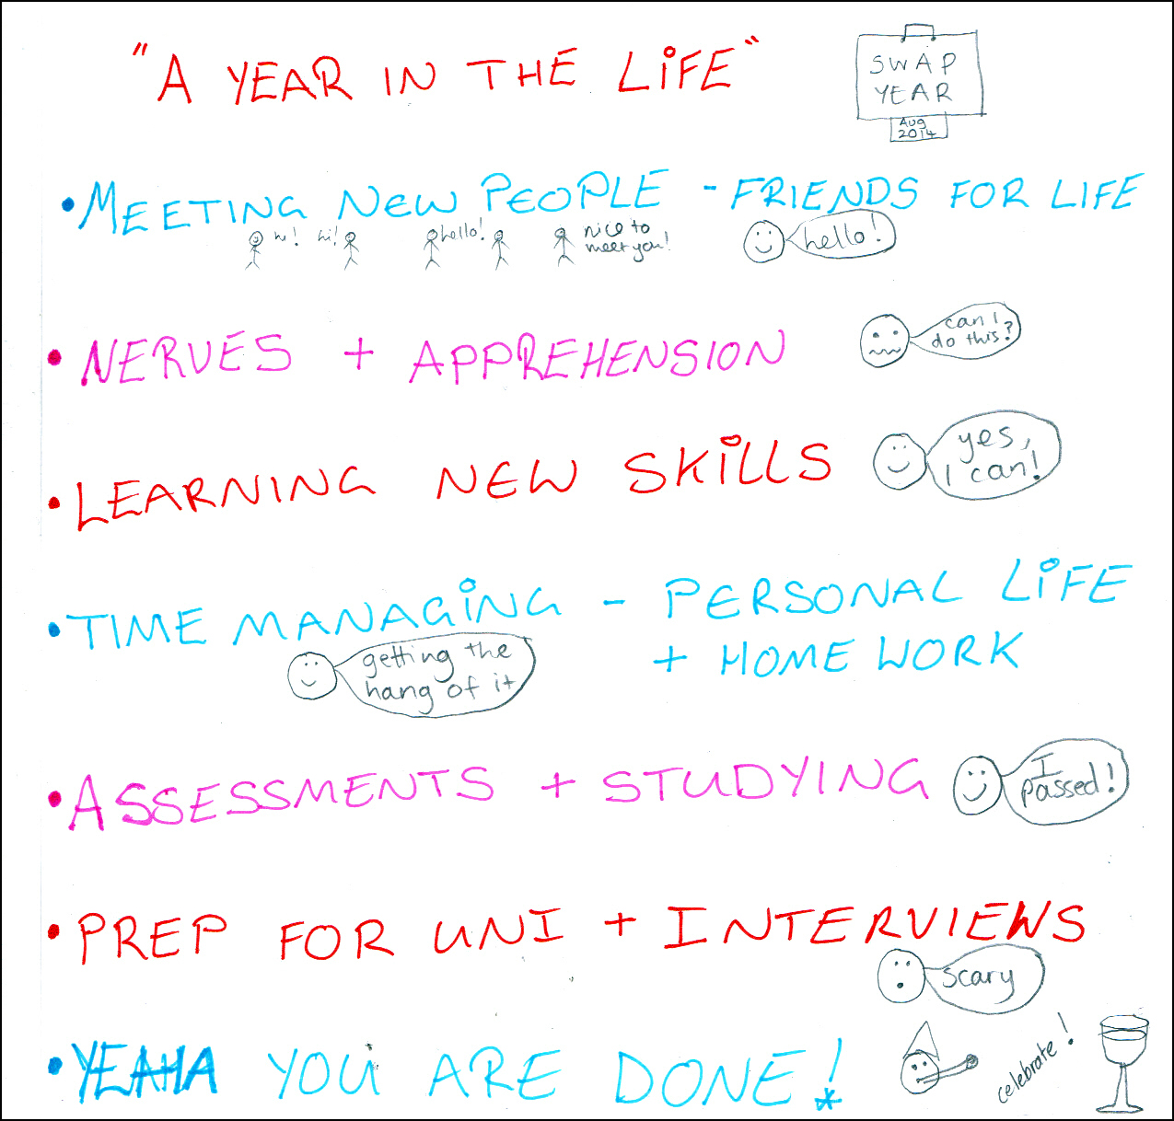

“I was out of education for 20 years, and coming to college was daunting. I have two children and had to learn to prioritise quickly. Use Moodle and take lot of notes. Read the [Prep for HE] packs.”

“It is tough and stressful, and at times you will wonder if you can do it. You have to put the time and effort into the studying! Attendance is a huge part of it. Don’t be afraid to ask questions.”



“Hello future SWAP students! This will be the quickest year of your life. The subjects are interesting and there is a lot of information given, so ensure you take notes and read over them regularly to give you the best chance in your exams.”

“Don’t leave studying till the last minute. Good luck and enjoy the course!”

**PREPARATION FOR HIGHER EDUCATION (Prep for HE):**

To be successful in Higher Education, you must develop and improve skills such as academic writing, critical thinking, note-taking and referencing. The Preparation for Higher Education unit (Prep for HE) is designed to help you do that.

**Prep for HE can help you:**

* Create strategies for more effective learning
* Apply to universities via UCAS and write an impressive Personal Statement
* Develop academic skills and apply critical thinking skills to academic work
* Respond effectively to feedback on course work and assessments
* Develop strategies for managing finances whilst studying full-time

**Where to find Prep for HE:**

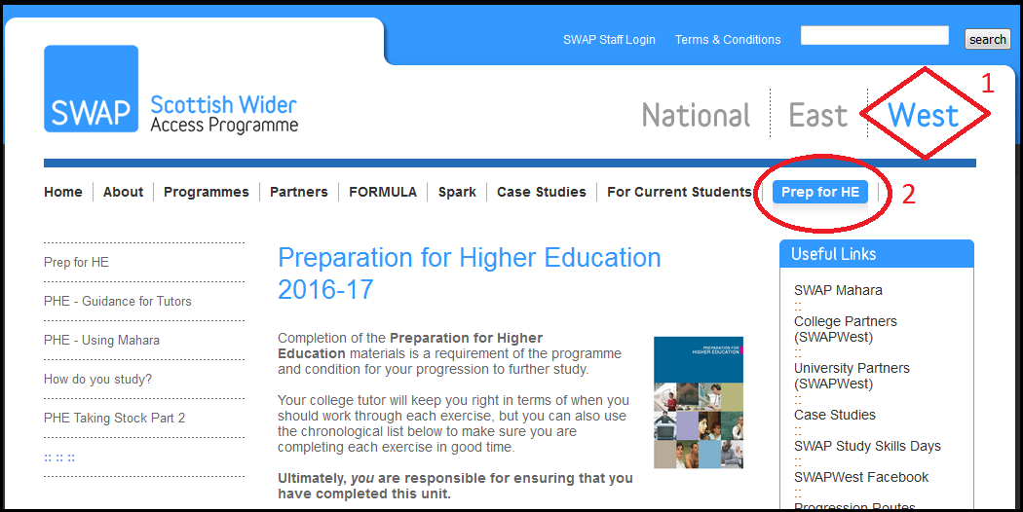

Use the guidance on the SWAPWest web site to help you keep track of which Prep for HE exercises are most useful at key points during the year.

You can start today. [www.scottishwideraccess.org/west-prep-for-he](http://www.scottishwideraccess.org/west-prep-for-he).

**PREP FOR HE: Frequently asked questions:**

You may find the checklist (overleaf) useful for keeping track of your Prep for HE progress. Please note that although some exercises may be done using the web-based forms that are linked from the SWAP website, others simply require you to download and read through the information, or perhaps organise discussions with classmates around the topics.   
  
Your class tutor may organise activities similar to the ones on our list, but using materials of their own devising or provided by your college’s own academic support team. If so, you may mark the Prep for HE module as ‘complete’ even if you did not use SWAP resources.

**The point is to prepare yourself for the next level of study, so any reasonable means you use to do so may count towards completion of your Prep for HE unit, provided your class tutor is aware of what you’re doing and approves it.**

The timeline we suggest is provided as a guide only; you and your class tutor may find that certain modules are more useful than others at certain times of year, depending upon your programme. Provided you do the work at some point, you are not required to adhere strictly to the suggested timeline. Follow your tutor’s guidance.

Finally, some modules may not apply to you (e.g. you do not need to complete the ‘Science Reports’ module if you are not on an Access to Science/STEM programme).

Ask your tutor or SWAP if in any doubt.

**Prep for HE Checklist:**

|  |  |  |  |
| --- | --- | --- | --- |
| **When** | **Module** | **Name** | **Completed √** |
| Sep | PHE01 | Taking Stock – Part 1 |  |
|  | PHE02 | Study Diary (Sep) |  |
|  | PHE03 | How do you study? |  |
| Oct | PHE04 | Study Diary (Oct) |  |
|  | PHE05 | Critical Thinking |  |
|  | PHE06 | Academic Referencing |  |
|  | PHE07 | Taking Stock – Part 2 |  |
| Nov | PHE08a | UCAS Application Guide |  |
|  | PHE08b | Personal Statement |  |
|  | PHE08c | Personal Statement Guidance Notes |  |
|  | PHE08d | UCAS Flow Chart |  |
|  | PHE09 | Study Diary (Nov) |  |
|  | PHE10 | Interview Skills *(if applicable)* |  |
| Dec | PHE11 | Listening Skills |  |
|  | PHE12 | Academic Reading |  |
|  | PHE13 | Miscellaneous Prep for HE (Autumn) |  |
| Jan | PHE14 | Memorisation Techniques |  |
|  | PHE15a | Academic Writing |  |
|  | **PHE-N01** | **Nursing supplement:** Anatomy Quiz |  |
|  | PHE15b | Academic Writing (Science Reports) *(if applicable)* |  |
|  | PHE16 | Study Diary (Jan) |  |
| Feb | PHE17 | Presentation Skills |  |
|  | **PHE-N02** | **Nursing supplement:** Case Studies |  |
| Mar | PHE18 | Miscellaneous Prep for HE (Winter) |  |
|  | **PHE-N03** | **Nursing supplement:** Proofreading |  |
| Apr | PHE19 | Managing Finances |  |
|  | PHE20 | Study Diary (Apr) |  |
|  | PHE21 | Feedback, Evaluations and Exams |  |
|  | PHE22 | Taking Stock – Part 3 |  |
|  | **PHE-N04** | **Nursing supplement:** Professional Language |  |
| May | PHE23 | Study Diary (May) |  |
|  | **PHE-N05** | **Nursing supplement:** Report Writing, Referencing and Plagiarism |  |
|  | PHE24 | Miscellaneous Prep for HE (Spring) |  |
| Jun | PHE25 | What Happens Next? |  |

**Checklist for Success in SWAP:**

* I have attended an induction talk from SWAPWest
* I have received a copy of SWAP Student Welcome Pack
* I have read the SWAPWest Student Agreement
* I have registered online as a SWAP student on the SWAP web site (see p. 3)
* I have visited the **Prep for HE** page ([www.scottishwideraccess.org/west-prep-for-he](http://www.scottishwideraccess.org/west-prep-for-he)) and set reminders to complete Prep for HE exercises monthly
* I have read the information provided on the **Student Profiles** web page.



**Top Tips for Success:**

1. Develop study methods and strategies that are effective for you
2. Access additional academic support as soon as you need it; don’t delay
3. Complete Prep for HE exercises regularly throughout the year
4. Respond *positively* to feedback on course work; act on it to improve your skills
5. Offer support when you can give it; ask for support when you need it

**CONTACT US**

Your first point of contact is your course tutor. However, you may contact the SWAPWest office at any time if you have an enquiry or need additional information about the programme or the Prep for HE unit.

|  |  |  |
| --- | --- | --- |
| **Address** |  | Scottish Wider Access Programme (SWAPWest)  c/o Glasgow Kelvin College  facebook.png123 Flemington Street, Room 226  Glasgow G21 4TD |
| **Telephone** |  | 0141 564 7206 |
| **Email** |  | [swapwest@scottishwideraccess.org](mailto:swapwest@scottishwideraccess.org) |
| **Web** |  | [www.scottishwideraccess.org](http://www.scottishwideraccess.org) |
| **Facebook** |  | [www.facebook.com/swapwest](http://www.facebook.com/swapwest) |
| **SWAP Student Mentors** |  | [www.facebook.com/groups/swapmentors](http://www.facebook.com/groups/swapmentors) |