**Quick Reference Tutor Guide**

The following pages form a “quick reference” guide with answers to the most frequently asked questions:

|  |
| --- |
|  |
| 1. Working with SWAP during a pandemic |
| 2. How do students become registered officially with SWAP? |
| 3. What is ‘Preparation for Higher Education’ and how is it to be delivered? |
| 4. How are SWAP students different from other college students? |
| 5. How do I deal with UCAS as a SWAP tutor? |
| 6. How do I help students avoid problems with their UCAS applications? |
| 7. How do I support students who must interview for university places? |
| 8. Are students required to attend Prep for HE days? |
| 9. What is the SWAP student profile and what do the grades stand for? |
| 10. Do I need to send SWAP an interim student profile for all students? |
| 11. Do I need to give students a copy of their profile at the end of the year? |
| 12. What information do I need to send to SWAP at the end of the year? |
| 13. Who sends the students’ results to the universities? |
| 14. Who is eligible for SWAP? |

**More extensive answers** to the above questions (and others) may be found in the section entitled ‘**The SWAP Year’ (Section 3)**, which outlines in chronological order the main events and key issues that you need to be aware of from month-to-month throughout the academic year

.

|  |
| --- |
| **1. Working with SWAP during a pandemic. When can I get in touch?** |

Following on from what we learned last year, we will continue the same core working principles.

* Appreciating we are still working through a pandemic and that this will have consequences for our students.
* Finding solutions for students in terms of completion and progression. We know a little bit more now in terms of what works well, and that evidence will support our work this year. Pretty clear our students are a resilient, hardworking bunch who manage challenges.
* In finding solutions we will work with as much flexibility as we can.

The SWAP team are continuing to work remotely. We can be contacted in the first instance by email on [swapwest@scottishwideraccess.org](mailto:swapwest@scottishwideraccess.org) or by phone 0141 564 7206. We always prioritise tutor work and will always endeavour to contact you as quickly as possible. Please never hesitate to get in touch with the office.

What we learned last year was that it was easier to deal with issues promptly so there is nothing too small to run by us. SWAP students need a lot of re-assurance and the pandemic seems to have polarised anxieties. For SWAP we like to ensure we can pre-empt concerns and anxieties. The SWAP office is therefore reliant on college tutors to advise us of any difficulties.

In terms of communicating with students, SWAP will send information to tutors. We will only in some limited circumstances contact students direct. We are therefore reliant on the content of our emails to be sent on to students when required. If that is difficult then please let us know. All tutor updates as well as being emailed are available on the SWAP tutor section of the web site. <https://www.scottishwideraccess.org/tutors.php?section_id=1071>

Tutor updates are our main way of general communication and at beginning of term will be sent regularly. At the height of the pandemic these were going out weekly. Mainly to ensure students were re-assured by the SWAP process. We would hope that we will be able to move to a monthly update. We know how busy your inboxes are!

The SWAP team are though a resource for you to use throughout the year and please do not hesitate to do that.

We will virtually visit each class at the beginning of the academic year for a SWAP induction. The induction visit will follow on from the 01 SWAP induction. This is an online induction that we would like students to engage in prior to our virtual visit. The link for induction is as follows <https://www.scottishwideraccess.org/moodle/course/view.php?id=3>

If you can also highlight to students the learner agreement. You may want to take some time going through the agreement with students prior to the SWAP visit. The agreement sets out SWAP and student responsibilities. It is the crucial part of the induction.

In addition, for access to nursing programmes we set out in a gentle way the progression to our university partners. It is available as 16 (Supplement) Access to Nursing.

For access to primary education please refer students to 15 (Supplement) Access to Primary Education. Again this provides an introduction to the unique SWAPWest approach to primary education.

At key points in the year, we organise **Curriculum Group meetings.** Your attendance at these meetings is highly valued. You may also find it beneficial in terms of networking and sharing good practice with other SWAP tutors from different colleges, as well as direct contact with SWAP.

Near the end of the academic year, we will conduct **focus groups** with a selection of classes. We may contact you to request such a meeting or you may contact us to volunteer.

|  |
| --- |
| **2. How do students become registered officially with SWAP?** |

At the beginning of the year (ideally in the first 2-3 weeks of term), you should direct students to the SWAP national web site: <https://www.scottishwideraccess.org/west-new-student-registration> to click on the ‘New Student Registration’ link. Students must complete the brief online form and submit it in order to become officially registered with SWAP. From the beginning of November, we will send you a Form A, with the students who have registered on the database. If you have any students not enrolled we ask you to ensure students do register.

We need students to register in order that they are processed as SWAP students by our university partners. Our database also ensures that we are able to send the correct results to university and college partners at the end of the year.

|  |
| --- |
| **3. What is ‘Preparation for Higher Education’ and how is it to be delivered?** |

The ‘Preparation for Higher Education’ unit (often referred to as Prep for HE or PHE) sits alongside the academic units in the programme. This core SWAP access programme unit supports the acquisition and development of key attributes for lifelong learning and builds the foundation for successful progression and transition to HN and degree level study. Students will focus on developing academic skills which will enhance and support core taught SQA programme units. The unit also supports learners in the development of lifelong learning competencies. The unit adopts a number of delivery methodologies to provide flexibility for tutors and students.

The exercises also offer **practical help** with tasks such as the UCAS application and personal statement. Our university partners value the Prep for HE unit as an essential component of the SWAP programme. As such, completion of the Prep for HE unit is required for progression.

You will find suggestions for how and when students should complete Prep for HE in the prep for he tutor section - <https://www.scottishwideraccess.org/west-prep-for-he-phe-guidance-for-tutors>

While we are rolling out a new online prep for he this year. There is a great deal of flexibility in how and when students should complete their Prep for HE unit. Please read through the Prep for HE section of this guide for a fuller understanding of what is required, how to facilitate it, and how students may evidence completion.

|  |
| --- |
| **4. How are SWAP students different from other college students?** |

As part of the partnership, SWAP students are entitled to apply to a wide range of university degree courses, commonly referred to as the **SWAP Progression Routes.** Students can view the current Progression Routes online via the SWAP web site. Progression Routes are updated annually, and we will contact you in late October to let you know when the new routes are available. Over the years since the first pilot of the SWAP programme (1987), SWAP students have shown themselves to be among the most committed, focused and engaged members in any classroom and, as such, are highly valued by our university partners.

SWAP students are exactly like the rest of your students in most respects. However, you may find that common guidance issues for a typical SWAP student may be slightly different from those of a typical school leaver. These issues may involve particularly negative thinking, doubts about personal abilities, and/or an aversion to particular subjects or tasks (e.g. a great reluctance to use computers). Naturally, this behaviour tends to diminish over time, as students develop their competences and ability to learn.

Difficulties around juggling family commitments may be expressed frequently, as well as pressures from work and other responsibilities. Students may isolate themselves or think that their difficulties are unique, so **talking openly** about such issues can have a positive effect. Knowing that others have overcome similar circumstances can encourage students to view issues as “opportunities for growth” rather than obstacles.

Students should be reminded that contributing to and relying upon **peer support** will be important to their success. If there are personality clashes, students should be reminded to look upon their year at college as the first year in their new career or profession, and to behave accordingly. Some will need to be reminded that setting aside personal issues in order to achieve a common goal is an important skill to cultivate for success at university and in work. As with the general student population, some SWAP students may have undiagnosed **learning disabilities**. Again, open discussion about this possibility can encourage students to disclose known issues or enquire about being assessed. Signpost students to support for learning disabilities from the specialist provision in College. Be alert to students who are reluctant to seek help or express embarrassment over their difficulties.



“We tell ourselves we’re useless. We’ve got a habit of negative thinking and we tell ourselves that’s it too hard. Sometimes we think we need to ‘soldier on’ and do it all ourselves. But asking for support is really crucial.”

Robert, 49, Springburn

Learning Disabilities Nurse

(Access to Nursing 2007-8)

|  |
| --- |
| **5. How do I deal with UCAS?** |

Students have ample support through **Prep for HE** for the practical aspects of applying to university. Students should be pointed to the Prep for HE guides available in 04: Choices applying to University and HNC. The section will include information on UCAS and ‘Personal Statement’. Step-by-step guidance is provided in signing up for UCAS and completing the application form correctly (i.e. by using the **SWAPWest buzzword**, and not the college buzzword).



Students who say they have “no idea” how to proceed with UCAS probably have not read through their Prep for HE guides. You may find it expedient to review these guides together as a class.

**Support from SWAP**

In early October, SWAP will register you on the SWAP UCAS school. We will use your work email address and you then will verify this with UCAS and create your own password. You can monitor your students’ progress in applying to university. Alternatively, if your college employs a designated UCAS administrator, we can provide that person with the appropriate permissions. If you are unfamiliar with UCAS and would like additional support, we would be happy to meet up with you for a chat through the basics. Just give us a call or email to arrange.

**References**

Depending upon your college’s policies, you may be asked to provide a reference for each of your SWAP students, or students may be given the option to request a reference from a tutor of their choice. Using your UCAS login, you will be able to add the reference to each student’s application form before it gets sent off to UCAS. The reference you provide will be on behalf of all the tutors who are teaching the student at that stage. If you require advice on putting together the reference please contact SWAP

**UCAS Choices**

The most important role you will play in the UCAS application process is in providing guidance to students about their **choices**. As above, full step-by-step guidance to help students make good choices is provided via the Prep for HE workbooks. Before discussing an application with a student, ensure that s/he has completed these exercises, as doing so will answer most of their questions.

Ask students to provide you with a copy of their ‘Choices’ for review. This is a list of the universities and courses to which they are planning to apply, including the entry requirements. Check to make sure that students have given themselves a range of options. A very common mistake is in choosing only one course (which should be strongly discouraged) or only courses that have exactly the same entry requirements. Choices should include two or more courses with a variation in the entry requirements (e.g. ABB, BBB). For a fuller explanation, visit: <http://www.scottishwideraccess.org/west-for-current-students-progression-routes>

**Personal Statement**

All SWAP students should begin the personal statement by identifying themselves as such (e.g. “I am currently studying on SWAP Access to Humanities programme...”). Although the application form will elsewhere identify the student as a SWAP applicant, it is essential for university partners if students include this information in the Personal Statement as well.

The remainder of the Personal Statement should be strictly the applicant’s own words. Although you (or learner support staff) may give guidance on general issues of structure, grammar, spelling, etc., the overall content should be produced by the student.

As mentioned above, ample guidance and detailed information is provided to students through the **Prep for HE** exercises, which will enable them to produce a good quality statement. Students must put the effort in themselves, so in the first instance you should re-direct enquiries about how to write the Personal Statement to the SWAP PHE section.

**UCAS Deadline**

The deadline for students applying for Medicine, Dentistry or Veterinary Medicine (or for students applying to Oxford or Cambridge) is 6pm on **October 15th.**

All other students must meet the UCAS deadline of 6pm on **January 15th.**

Your college will likely have a policy of requiring students to complete their applications well in advance of this date (usually in the first or second week of December) in order to give you time to complete a reference for each student, check that everything is in order with choices and correct any errors or omissions. With this in mind, it is advisable to set an even earlier internal deadline for your students to complete their Personal Statements if you plan to offer your services in reviewing and giving feedback. For general applicants, the best time to start work on these tasks is shortly after the October break. The month of November, therefore, is when the bulk of the work on UCAS and Personal Statements will be completed.

|  |
| --- |
| **6. How do I help students avoid problems with their UCAS applications?** |

Despite everyone’s best efforts, we occasionally have a student whose application doesn’t go smoothly. SWAP can usually facilitate a solution to any problems that arise, so students are advised to **contact SWAP for help**, rather than contacting the universities directly. Please make sure to remind students about this before any panic sets in.

**SWAPWest Buzzword: swapwest2021**

One of the most common problems arises when a student fails to use the SWAPWest buzzword on UCAS. This is easily remedied, but can be prevented by ensuring that all students follow the Prep for HE sessions. If a student has put in wrong buzzword. If you can advise them to phone UCAS and have it changed. They then need to email the SWAP office so we can accept them onto the SWAP UCAS school.

**Problems with Choices:**

A more challenging error to correct is when a student makes poor choices, which is why your role as guidance tutor is so critically important. It is almost always a mistake for a student to choose **only one course** when there are five UCAS Choices available.

Related to this issue is the problem of choosing **multiple courses that all have the same entry requirements**. As above, this could endanger the student’s progression to university, as failure to meet the requirements of one would mean failure to meet the requirements of all. Emphasise to students the importance of following the guidance in the Prep for HE to avoid this sort of problem.

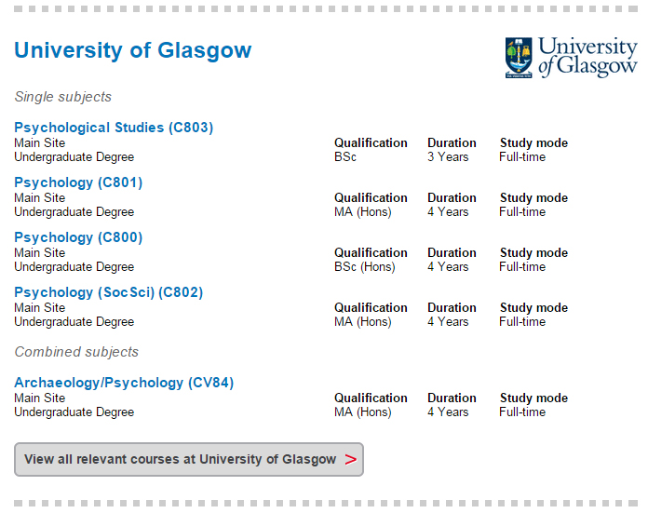Sometimes the problem is due to a mistake, such as **using the wrong UCAS code**. This is common with courses like Psychology or Geography, where multiple UCAS codes may be in use for a single institution across two or three different faculties. The SWAPWest progression routes will make students aware that some universities operate a “faculty-wide” entry system so that a subject like Psychology could be studied either as a Social Science, a Science or an Arts degree. If in doubt, students should contact the university’s admissions office to clarify which UCAS code is the correct one for their faculty. **The wrong UCAS code usually means a wasted choice on the application,** so it is critical that students do their research and double-check their information.

**Firming Up Choices:**

Another common mistake is naming **Firm** and **Insurance** choices in the **wrong order** (e.g. where the Insurance choice has higher requirements than the Firm choice). Some students make the mistake of naming a Firm choice when they are actually **hoping to get their “Insurance” choice instead**. This happens when students underestimate what they will achieve on their profiles, or in a misguided attempt to include a selection of choices with different entry requirements. The advice to students here is to choose as Firm the course and institution to which they really wish to progress. Then, they should choose as Insurance a choice that has lower entry requirements. If there are no such courses available in the SWAP progression routes, students should apply to HNC/D at college as a backup. As above, careful attention to the UCAS instructions in Prep for HE will prevent most of these problems.

|  |
| --- |
| **7. How do I support students who must interview for university places?** |

Some university courses are especially competitive, particularly the professions (e.g. social work, education, medicine, nursing, etc.) and there are a few university courses that will require SWAP students to interview for progression. Students will be notified well in advance of the interview date(s) so that they may prepare accordingly. It is worth while reminding students to keep checking UCAS track and the email they have used on UCAS.

Students will find guidance in **Prep for HE for “Interview Skills”,** which can augment any work that you may do with them during your guidance period. Direct students to Prep for HE in the first instance or consider facilitating some of the suggested exercises during your guidance period to get students started.

**Interview Questions:**

It is not possible (or desirable) to tell students exactly what questions to expect. Instead of trying to guess at the questions, students should undertake research to ensure that they fully understand what is required of the course to which they are applying, as well as the profession they wish eventually to join. A candidate for nursing, for example, should have a fairly well-developed understanding of the qualities and skills that make a good university nursing student, as well as the qualities and skills that make a good nurse. The best candidates always draw connections between these “ideal” qualities/skills and their own experience and give examples to support any statements they make about themselves.

**Unsuccessful at interview?**

Because the number of places varies and because there is competition for places, there will be disappointed students. After the interviews are concluded, those who are not offered a place may feel very discouraged or even embarrassed. One way to mitigate the impact of this situation is to **raise the issue beforehand** during the guidance period (perhaps by looking at a case study), and get the group thinking positively about the options available to anyone whose path goes in this direction. Ask students to identify the kind of support that they think would be most useful and encouraging if they happen to be unsuccessful (and remind them of this at interview time when some of their classmates need extra support).



“I worked hard at college and applied for Primary Education along with many of my classmates but, to my great disappointment, I did not get offered a place. I was gutted.

“Although I was hugely disappointed, my tutor reminded me to consider my other offers. Now when I look back, I can see that it wasn't as devastating a result as I imagined it would be, and I am thoroughly enjoying what I'm doing now.”

Karin, 33, Paisley

University of Glasgow

Archaeology & Classics

Students who have been unsuccessful at interview should be encouraged to consider the wide range of opportunities that are still available to them through their backup plans. There will be alternative routes by which they may reach the same end-goal (e.g. HNC/D and then degree, or post-graduate study to gain professional qualifications). An appointment with your college’s guidance and advice team would not go amiss, and students are always welcome to contact the SWAP office for additional guidance. Persevering, maintaining professionalism and continuing to work hard is the best way forward.

|  |
| --- |
| **8. Are students required to attend Prep for HE days?** |

SWAP and partners organise ‘Prep for HE’ days at key points in the year. We intend to continue to do that even though we expect they will be mainly online. The Prep for HE ‘Study Skills Days’ will also move to online if it is not appropriate to hold them at university.

Attendance forms part of the student’s Prep for HE unit and is strongly encouraged. General ‘Open Days’ are also fine to attend, but students should be made aware that those are aimed at the general population, whereas the SWAP events are aimed specifically at SWAP students.

In addition to the events organised by SWAP, the universities also extend offers to SWAP students to attend focused events (e.g. Strathclyde’s **‘Insight Day’** or GCU’s **‘Biorama’**). Indeed, students who hope to progress to specific degree programmes will be required to attend before they may apply for a place. SWAP will share this information on how these events are going to progress when we hear from our university partners.

|  |
| --- |
| **9. What is the SWAP student profile and what do the grades stand for?** |

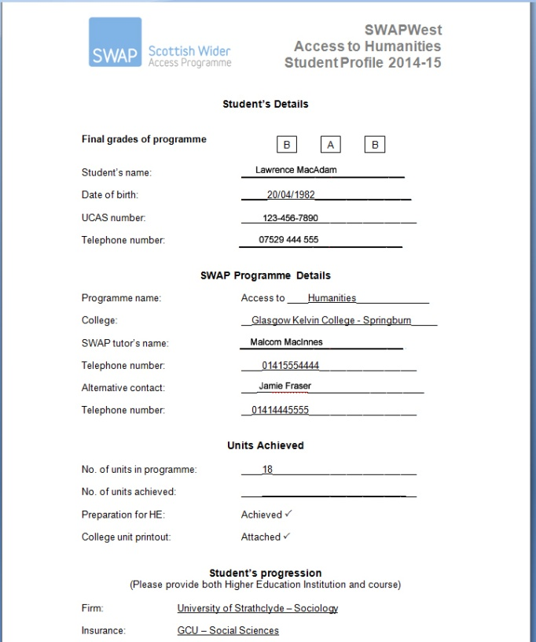All SWAP students should receive an end-of-year student profile detailing the number of units passed and confirming completion of the Prep for HE unit. Profile grades are based on the requirements of the degrees relevant to the curriculum area. Universities will set conditions relating to the letter grades.

Conditions for students’ offers will be specified on UCAS. **These conditions will also be highlighted on the reports you will receive from the SWAP office.** We will also highlight if the condition is unusual. Take a note of these as your final profile of the student may need to take these issues into consideration. For example some degrees will want specific results (e.g. 80% or better) for particular units such as optometry, pharmacy, biomedical science.

The key areas to be graded will depend upon the curriculum group. Please see the guides on the following two pages for specific information about profile grades for:

* **Humanities / Social Science / Nursing & Care**
* **Life Science / STEM / Health & Medical Studies**

|  |
| --- |
| **Profile Grades: Humanities / Social Sciences / Nursing / CHP** |

The letter grades on the Humanities/Nursing profile do not reflect grades for specific academic subjects, nor an average of grades. Indeed, programme units are generally “pass/fail” rather than “graded”, as such. Consequently, the profile grades reflect the student’s **academic performance and potential** for successful study in Higher Education, in the following key areas:

**Grade 1:** **Ability to handle text**  
This includes reading, comprehension, analysis and evaluation (i.e. cognitive skills)  
  
**Grade 2:** **Fluency of expression**  
Ability to communicate understanding of what has been learned (e.g. through written work, presentations, class discussions, etc.) Includes both written and oral communication skills.   
  
**Grade 3:** **Overall performance**Includes: punctuality, attendance, meeting deadlines, working well with others, being resilient to setbacks, offering and asking for support, responding productively to feedback on coursework, completing Prep for HE in a timely manner, etc.

The final grades should be agreed by the entire teaching team, based upon your collective professional judgement of the student’s performance and potential. As course tutor, you will need to solicit your colleagues’ opinions; some SWAP tutors do this by calling a brief team meeting to discuss each student in turn, while others circulate a list of students by email, and collate the responses. Please consult the SWAP office for more detailed information about student profiles.

|  |
| --- |
| **Profile Grades: Life Science / STEM / Health & Medical Studies** |

**Three Key Areas (Access to Life Science, STEM or Medical Studies):                                                                                                         
Grade 1.  Science subject 1 at Higher level**  
*For Life Science/Medical Studies this will be Biology; for STEM/Engineering this will be Mathematics.*  
  
**Grade 2.  Science subject 2 at Higher level**  
*For Life Science/Medical Studies this will be Chemistry; for STEM/Engineering this will be Physics.*  
  
**Grade 3.  Overall performance**  
Includes attendance, punctuality, meeting deadlines, completing Prep for HE, working well with others, responding well to feedback and general attitude towards studies.

**What do the grades mean?**

**Grade A** - Achieved the units with great ease and required little or no assistance.  Displayed a very able overall performance. Degree level study is well within the capabilities of this student.   
  
**Grade B** - Achieved the units with relative ease and required little to moderate assistance. Displayed an able overall performance. Degree level and HNC study should be within the capabilities of this student.      
  
**Grade C** - Achieved the units but required considerable assistance.  Additional study in college may be more appropriate than degree level work at this stage.

|  |
| --- |
| **10. Do I need to send SWAP an interim profile for students?** |

Our university partners may ask for additional information prior to making an offer through UCAS. In order to assist with this process, SWAP may provide you with pro-forma interim profiles to complete. These can vary, depending upon curriculum areas. **We will let you know if we need you to complete interim profiles for your students.** If requested, profiles are normally submitted in February.

Students should be made aware of how they stand in terms of meeting the conditions of their university offers. If you have a student who consistently struggles to complete course work unassisted or to pass assessments, the indication is that s/he may not be ready to progress to the next level. One of our experienced SWAP co-ordinators advises:

“Do not be frightened to say the dreaded words: **‘not ready for university’.** It’s best for the student and for your reputation. Make sure that all teaching staff know what the SWAP programme is about and the importance of a profile that accurately reflects the students’ academic performance and potential, even if that means some students are disappointed.”

Ideally, students should begin to develop an understanding (based on feedback received from teaching staff throughout the year) of whether they are likely to meet the conditions of their offers and, if not, what they can do to improve. They should also be realistic in terms of ensuring that they have a back-up plan in place, by applying for HNC/D, where applicable.

|  |
| --- |
| **11. Do I need to give students their profile grades at the end of the year?** |

Yes. Before the students depart at the end of the year, you should communicate their results to them, making it clear that you are referring only to the profile grades agreed by the teaching team. This is particularly relevant if the students still have work to be handed in or marked in order to pass all units.

Keep in mind that most university conditions will specify completion of the programme (passing all units) and may also request specific profile grades, so the final student profile is only part of the picture. In addition, some universities will ask for a “full” profile, which includes further commentary on the student’s personal qualities and abilities, which they may require in order to make a decision on a borderline candidate.

There should be **no surprises** at this stage. All students should be aware of how they stand with regards to meeting the conditions of their offers through their regular meetings with you, feedback from all tutors on their assessments and, if applicable, their interim profile grades. A profile that includes ‘C’ grades indicates that further College study be more appropriate for the student. Students whose profiles are disappointing (i.e. they have not met the conditions for either of their offers) may need to be reminded that the grades are agreed by all tutors on the programme, and the decision is based upon their professional judgement and understanding of what will be involved in Higher Education.

Finally, **students do not need to notify the universities of their results**. The SWAP office will ask you to send us results and we will check and forward these results to the universities.

|  |
| --- |
| **12. What do I need to send to SWAP at the end of the year?** |

We will ask you to send us the **SWAP Student Results Summary** (referred to as ‘Form C’), which is simply a spreadsheet listing all of the students who started the programme, their profile grades, and their destination (firm and insurance choices). We would ask you to notify us if there are any missing students or if there are students on the list who have left the programme. It would be useful if you could tell us the general reason for their withdrawal, if possible.

In addition to the Student Results Summary, you should provide a **profile** for each student, as well as a **transcript** (or the equivalent) of the units passed for each student. Transcripts may be referred to as “Learner Agreements” (on Columbus) or may be generated as a “student report” on other systems. On occasion, you may be asked to provide a “full profile” for a student, which will include further commentary on the student’s personal qualities and abilities. These materials should be sent to the SWAP office at the end of term, preferably by mid-June. **We will be in touch with you by email to advise you of the target date nearer the time.**

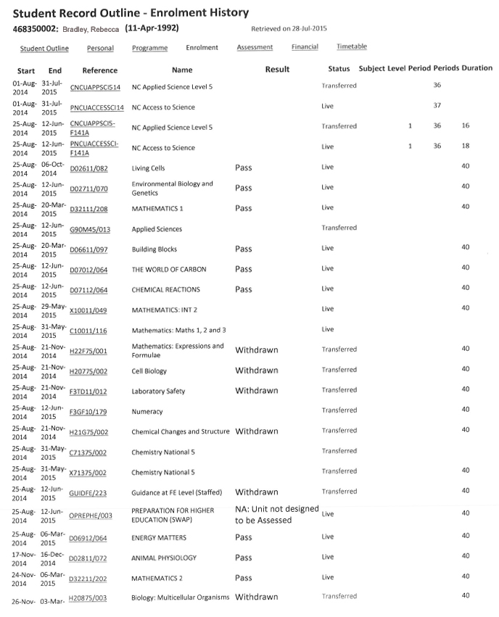

|  |
| --- |
| **13. Who sends the students’ results to the universities?** |

After you send us the materials listed above (see question 12), we will double-check that all results have been received and we will match the students to their universities. This process takes a few weeks, and is usually conducted from late-June to mid-July. If during this time we discover any missing information, we will get in touch with you to request it. If you will be away on annual leave during June/July, please email us with the name of a colleague who can access student information in your absence. It would also be very helpful to have the name of a contact on your college’s MIS team who can run reports and who has your permission to speak to SWAP about students.

After all results have been checked, SWAP will then send the results to the universities. Students can expect to see their UCAS offers change to “unconditional” by the end of July or first week in August, and the universities will then begin contacting students directly with information about enrolment and matriculation. Some students will have additional conditions to meet (e.g. PVG registration or SSSC registration for social work). If students have met these conditions, they must simply wait for the information to reach the UCAS system in order for the offer to be updated.

|  |
| --- |
| **14. Who is eligible for SWAP?** |

SWAPWest programmes are specifically designed for **adults** seeking to return to higher education who have **no or few qualifications, or whose qualifications are not relevant** for the appropriate progression routes. Programmes are designed by the partnership so that students can acquire the appropriate academic knowledge and skills as an entrance qualification to university or HN courses. Students study the programme within their local college, providing a supportive structure to enable the student to return to formal education, consider their options and to progress to higher education. The partnership provides, through the “Preparation for Higher Education” framework, support for students to ensure they will succeed at degree level.

**Criteria for selection for interview**

1. **Under-represented group** in higher education must be evident (e.g. through postcode, Scottish Index for Multiple Deprivation (especially most deprived quintile – SIMD1), ethnic minorities, gender [where under-represented within chosen progression area e.g. nursing, science or primary education], disability, former care experienced or 1st generation to participate in higher education. Students will be asked to register at the beginning of the programme to ensure criteria is met.
2. **An adult seeking to return to education** who does not have the relevant entry qualifications. The programme is specifically designed for those who left formal education and, after a period away from formal education, want to return to education and progress to higher education. The period of time away from formal education will depend on each candidate’s personal circumstances and their length of time away from formal secondary education.

Candidates at interview will be asked to exhibit evidence that they have the relevant life skills to successfully complete the SWAP programme. Evidence of life skills may include level of maturity, experience of skills related to the potential choice of degree subject – including paid employment or volunteering -- and awareness of subject choice. These examples are not mutually exclusive – candidates should be given an opportunity to explain their life skills relevant to the programme.

1. **Qualifications** - these must be none, very few or not relevant for the progression route sought. Students should not have studied qualifications above SCQF level 5. Consideration will be given to length of time outwith formal education and relevance of subject area, however, see below for further clarification.

**For example:**

Someone who has studied and achieved qualifications at SCQF level 6 must have a gap in their education of at least 5 years prior to commencing a SWAP access programme. If the gap is less than 5 years, they should be advised to apply directly to uni, to consider HN or to study additional Highers.

A student who left school with no qualifications above SCQF level 5 may be considered with a gap of 3 years from formal schooling, provided they have given evidence of sufficient maturity and life skills as specified in Criteria 2. They should be fully advised on alternative options within the college.

A student with an HNC in an unrelated subject to the programme may be considered for an access programme, taking into account his/her level of skills and academic ability. The position should be checked with universities first and students should be encouraged to discuss articulation arrangements.

A student who left school more than three years ago but returned to college to study at SCQF level 5 may be considered for an access programme. Students can progress to an access programme the following year as their level of study has not been at SCQF level 6 and there has been a gap in their education from formal secondary education.

Where there are exceptions from the criteria in terms of time away from education, the SWAP office will liaise with HEI partners to establish criteria prior to commencement of the programme.

1. Students should demonstrate a **strong personal commitment** to wanting to progress with their education.

Students should be aware that there are a number of alternative routes to progress to higher education and these will be explained to students at or before the informal interview.

We strongly recommend that students be **interviewed** prior to selection. Applicants should be advised about the criteria for admission on to a SWAP programme, specific programme requirements (e.g. for primary education, social work and the medical profession, where arrangements must be in place prior to the programme starting). A pro-forma for questions is provided by SWAP, but each college tutor is free to develop his or her own provision. If there are any questions about the appropriate criteria for SWAP programmes, these can be referred to the Director of SWAPWest for clarification. Any uncertainty about applicants and issues with applications (e.g. PVG issues) will be referred to universities offering progression routes.

Students on Access to Medical Studies programme must be advised of the requirement of UCAT, and given advice on preparing a personal statement prior to the commencement of their programme.

Applicants who are unsuccessful at interview should be advised of why they did not meet the criteria and, where appropriate, provided with assistance or advice on how to return to study.

If a programme is having recruitment difficulties, the SWAP office can be contacted to provide additional marketing of the programme. Such difficulties should be reported as early as possible.

**Additional criteria for progression to specific routes:**

Curriculum groups are able to decide on additional criteria for SWAP programmes:

**Nursing**

Students require to be ‘ordinarily resident’ in Scotland for the past 3 years in order to ensure they will be eligible for funding as set out in The Nursing and Midwifery Student Allowances (Scotland) Regulations 2007 (as amended). The exception to this rule are those who have refugee status. Students with refugee status do not require to meet the 3 year residency requirement. Please contact the office if you require clarification.

**Primary Education** (West)

1. Previous experience -students should be able to demonstrate a realistic understanding of working with primary school aged children over a period of time (not necessarily in a school setting).
2. Students should demonstrate a strong personal commitment to Primary Education and Higher Education.
3. Students should have a good knowledge and understanding of Primary Education and related issues

**Medical Studies** – for medicine, dentistry, veterinary medicine and pharmacy

1. Qualifications

Due to the extent of the scientific element of the programme students should have a background in science, particularly chemistry and biology.

Alternatively, students will be requested to undertake further study prior to commencing the programme.

Graduate applications will not be considered.