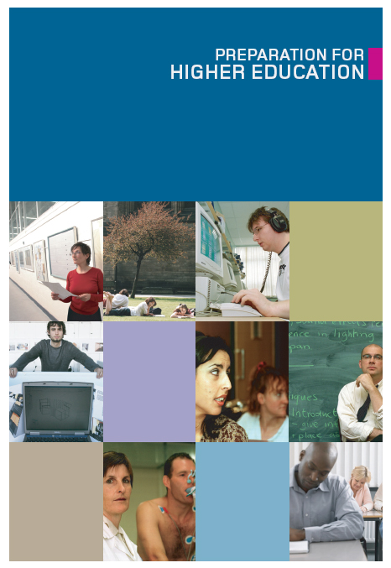

**SWAP ‘preparation for higher education’: overview**

Completion of the ‘Preparation for Higher Education’ unit (often referred to as ‘Prep for HE’ or ‘PHE’) is a requirement for progression. It provides a formal structure for the student support that you provide, which is so critical to the success of SWAP students.

Students must be able to demonstrate completion of Prep for HE at the end of the academic year and, as course tutor, you will be asked to confirm completion of Prep for HE on the SWAP student profile.

‘Preparation for Higher Education’ is designed to develop the student to become an independent learner and, in the process, to develop the skills necessary to succeed in Higher Education.

As a tutor information regarding your role in prep for he, is available on the SWAPWest web site - <https://www.scottishwideraccess.org/index.php?section_name=west-prep-for-he-phe-guidance-for-tutors>

The Preparation for Higher Education development guide provides an over view of the new developments in prep this year.

We will be asking you to support us in this development. Prior to the roll out of the new prep for he, you will be asked to review the materials. This will be 7 days in advance of the roll out to students. Your views will be very much appreciated. In addition, you will have an opportunity to evaluate how the lessons have been received and how you feel they can be improved. We will also ensure time for review at our curriculum meetings.

**Where to find Prep for HE materials**

Access to the latest version of the SWAP Prep for HE for students is available from the web site (<https://www.scottishwideraccess.org/west-prep-for-he>).

There is a SWAP video on how to access prep for he.

<https://www.youtube.com/watch?v=9VxXsdBK2Nw&feature=youtu.be>

You can see Amy showing how to access the work and also how the evidence will work.

**Please note: Students don’t need a password to access the SWAP Prep for HE. All materials are freely available.**

The SWAP website takes students to our SWAP moodle. All students are guests on SWAP moodle, they do not need to log in. If you can please re-assure students of this.

Only technical issue students might find is that they will need to enable pop ups, so new pages can “pop up”. Any other technical issues can be forwarded onto SWAP and we will try and support.

There is still the option to work through the exercises offline. We will send you a pdf version of the online materials.

When students are asked to reflect on their work, they will be able to do that online. For this year, the way that is saved is exactly the same as previous years. The work is sent to a student’s email address. If they don’t receive the work, it is normally due to them not entering their email address properly. The refection work will be their evidence. We are not being prescriptive in how that is put together. It is a student’s responsibility to keep their portfolio of development and to share that with you. It is always worth pointing out to students when they ask how much they do, that they are proving through prep for he that they are ready to study at HNC and degree level.

If a student is having difficult accessing their work then contact SWAP as we will keep the evidence they have emailed to themselves.

The Prep for HE materials offer **a framework** from which to operate; there is considerable good practice within colleges of additional work in preparing students for progression, so you may have alternative tools that you prefer to use. As the class tutor, please feel free to **blend your materials/exercises with the Prep for HE materials**, as you deem suitable.

You may find it useful to take students through some exercises as a group, or to facilitate students to work together. The whole of Prep for HE should be completed over the course of the academic year and students may be expected to gradually take over management of the Prep for HE as they grow in confidence and develop their capacity for independent study. It is good practice to **check progress periodically**, but students should be reminded regularly that the responsibility for completion lies with them, and that evidence of completion will be required.

**Outcomes**

Develop the skills required to be an independent learner to be successful in study at SCQF level 7 on either a college HNC or university degree. These independent learning skills will include:

**Developing academic competences relating to:–**

* Research - accessing and evaluating a range of source material.
* Academic reading and writing - be confident in accessing and approaching a range of source material. Demonstrate the ability to read effectively, efficiently and incorporate referencing.
* Understand and answer essay and assessment questions. Develop structured writing in line with expected demands. Display an understanding of format, grammar, punctuation and syntax.
* Engage with IT and digital resources including online learning platforms, web-based resources and software presentation packages.

**Developing the competence of “Learning to Learn”**

* Critical thinking - determine the relevance of ideas and be able to understand the linkage of ideas. Evaluate ideas and sources in order to create an effective argument.
* Develop a belief in engaging with their potential to continuously learn and progress.
* Awareness of and confidence in one's own and others’ abilities to learn, improve and achieve with **work and dedication.**
* Understanding that learning is a lifelong process that requires openness, curiosity and determination
* Reflecting on other people’s feedback as well as on successful and unsuccessful experiences to continue developing one’s potential
* Develop self management of learning.
* Awareness of one's own learning interests, processes and preferred strategies, including learning needs and required support
* Develop and consolidate skills including time management and focus on additional practical activities such as note taking, working within groups and delivering presentations
* Apply to HNC and degree level study. Considering choices and well thought out decision making. Demonstrate a preparedness for competitive selection where applicable.
* Be engaged with transition materials and activities in relation to HNC and degree level progression as well as understanding the importance of engaging with various forms of support for future success.

**Developing social and personal skills:**

* Communication – use of relevant communication strategies, listening to others and communicating appropriately
* Collaboration - engagement in group activity and teamwork acknowledging and respecting others
* Self-regulation - awareness and management of emotions, thoughts and behaviour. Nurturing optimism, hope, resilience, self-efficacy and a sense of purpose to support learning and action. Development of time management strategies
* Flexibility - ability to manage transitions and uncertainty, and to face challenges. Managing transitions in personal life, social participation, work and learning pathways, while making conscious choices and setting goals
* Wellbeing - pursuit of life satisfaction, care of physical, mental and social health; and adoption of a sustainable lifestyle

**Prep for HE: Towards Independent Learning**

The resources in Prep for HE are very much about asking the students to consider **their own development** and to reflect on the areas or skills that they require to work on.

While you and your colleagues will be working on a day-to-day basis with the students, the resources should be used to re-enforce to students that they must take responsibility for their own progression throughout the year.



At all stages, encourage students to do as much as possible for themselves, given the range of experiences there will be in a group of mature students.

The student reflection tool (look back / look forward) is a useful tool to ask students to consider how they feel they have developed during the programme.

**Prep for HE: Making Good Choices**

Colleges have arrangements for visits to (and from) HEIs and provide information to students regarding the range of opportunities available. These are often a time-effective way of enabling students to ask questions about a particular institution or area of study. This is useful even for those students planning to continue with an HNC/D in the first instance as it enables them to consider longer-term planning.

The SWAP progression routes are a good source of information for the university degree courses to which students may apply using their SWAP qualification. Signpost students to this resource around mid-October, after SWAP has completed the annual update and notified you.

If you’re new to teaching SWAP students you may find that there is a fine balance to be struck between enabling the student to take the time necessary to make the appropriate choice, or spending too much time on the huge variety of choices available and becoming overwhelmed. The SWAP progression routes should be used as the main source of information, but students may consult universities’ own web sites for further clarification of course content and structure. Many academic departments make first-year course information available for download, and these documents may contain key details that can help students make good decisions.

The student profile is a key part of the decision as to whether a student progresses directly to an HEI or takes the HN route as the first step. Students should be made aware of the importance of the student profile right from the beginning of the year and kept informed of their progress throughout the year. **Students are entitled to a copy of their profile.**

The UCAS application will be dealt with by individual colleges and advice given to students in accordance with college policy; however, students must apply using the SWAP buzzword, rather than the college buzzword, if they wish to be recognised as SWAP students. **Buzzword is swapwest2021**

Please encourage students to apply for more than one degree or course, ensuring that their second choice requires lower profile grades than their first. By doing so, they will have a fall-back option in case they do not achieve the grades for their first choice. With few exceptions, all students must use all their UCAS choices, as specified in their SWAP Student Agreement.

If a student is considering applying for a place out with the progression routes (i.e. to an institution outside the West of Scotland), then can you please contact the SWAP office so we can advise the university about the programme. By contacting us early, we can avoid difficulties at a later stage.

**Prep for HE: Making Progress in Higher Education**

Tutors will be well aware that gaining entry to a Higher Education Institution is only the first step. 'Preparation for Higher Education' aims to ensure students are equipped from day one of the university or HN study with the tools they will need to succeed.

The Prep for HE resources are designed to enable the students to consider the essential elements of success in higher education.

Students should at all stages be given good feedback on their readiness for university or HN. They should be encouraged during the study skills sessions to be fully aware of the preparedness that is required for their continuing study.

Information on the various opportunities for “summer schools” and other bridging courses from universities should be given to students in good time to enable them to consider all options.

The STAY section of Prep for HE should be handed out during one of your final guidance sessions with the students, in order to bridge the transition between completing the programme and starting their next stage of study.

<https://www.scottishwideraccess.org/stay.php?section_id=1034>

|  |
| --- |
| **PHE – Forms of Evidence** |

Students may complete Prep for HE exercises using the online forms linked to the exercises in the Look Back and Look Ahead sections. Or they may upload their own writing, reflections or videos. You may decide which method works best for you and instruct the students to use it, or leave it up to the students to choose.

**1. Online / Electronic**

Students may complete most of the Prep for HE exercises online, or download and save them to a computer or memory stick and complete them electronically. You could ask them to forward completed exercises by email, or simply check during your usual guidance meetings that they are keeping up with the tasks.

**2. Paper**

Students may opt to download the pdf documents from the SWAP web site or from yourself to their own computers or memory sticks, print them out and complete the exercises by hand, along with any additional notes or materials acquired. These paper copies can be kept in a binder or folder, which can later be shown to you as evidence of completion.