**‘The SWAP Year’ – A chronological guide**

Whether you are a new or returning SWAP programme tutor, you may find it useful to refer to this section on a monthly basis for information about the main issues that are likely to arise at specific points throughout the year, and to help students to stay on track in completing their ‘Preparation for Higher Education’ unit.

Although the timings for some items are fixed (e.g. the UCAS application deadline), many other items are flexible. When it comes to the sequence in which PHE activities should be completed, you are the best judge of when students should cover certain topics. Feel free to change the chronology to suit.



The information in this guide is not meant to duplicate existing college procedures, but to complement them. When in doubt, please contact the SWAP office on 0141 564 7206 for further guidance.

|  |
| --- |
| **August to October: settling in** |

Like any students, SWAP students may feel nervous about commencing their programmes. Some will have had a considerable gap in their education, which may intensify those feelings. Family pressures, financial worries and competing demands for their time will likely emerge in the first few weeks of term.

You will know best how to engage students and set them at ease, but it may be worthwhile highlighting some aspects that are particularly common amongst SWAP students, which you may not encounter as frequently with other groups. These may include feelings of guilt at neglecting family responsibilities; anxiety over the extra “burden” placed on partners or other family members; doubts about personal suitability for academic work due to poor experiences at school; negative reactions to challenging tasks (e.g. using computers for course work). The pandemic does seem to have polarised these aspects and some students require additional reassurance in the early stages.

Most students will respond to the college’s induction practices and will settle in quickly. Some will be desperate to get on with the academic work and may seem impatient with icebreakers and administrative tasks, so a fine balance is required.

**Student Finance**

One issue that students tend to find particularly worrisome is money. Students should be reminded to apply for bursaries as soon as possible (if they haven’t already done so), and informed that bursary payments are often contingent upon attendance above a certain percent. Most students will also be eligible for a discount or exemption from paying Council Tax for the duration of their study and some students will be eligible for additional funds, credits or allowances, so it’s worthwhile making an appointment with the college’s student finance service to find out exactly what they are entitled to claim.

**SWAP Student Registration**

All SWAP students must complete a ‘New Student Registration’ online form at the beginning of the academic year. This form is linked from the SWAP national web site home page: <https://www.scottishwideraccess.org/west-new-student-registration>

Registration is required so that SWAP can confirm each student’s entitlement to progression to HNC/D or university degree. The evidence confirms that students meet the appropriate curriculum criteria. The registration form asks for personal information, including previous education. Many students will have no previous qualifications, in which case these fields may be left blank. Other fields, such as the number of miles between home and college, may be estimated.

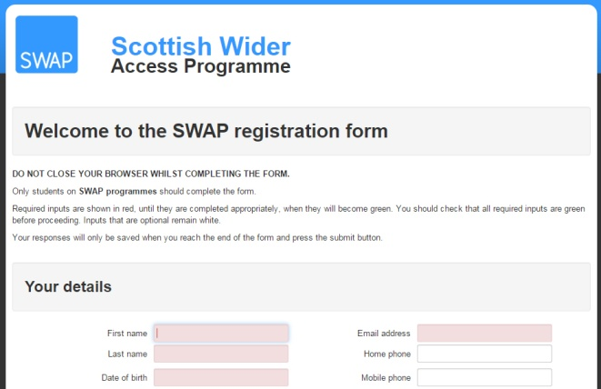

The student registration form provides an evidence base spanning over a 30 year period that can be used to provide evidence of the success of the programme, so students should make their best effort to recall the information requested. However, **they should not delay registration if they can’t remember precise details.**

Ask students to do their best to record as much information as possible, and to complete registration **within the first month.**

NB: Students do not need to “log in” to use the SWAP web site. All information on the site is freely available without a login. Simply visit [www.scottishwideraccess.org](http://www.scottishwideraccess.org).

|  |
| --- |
| **Settling in – contacting SWAP** |

**Schedule a SWAP Induction**

If you can get in touch with the SWAP office, we will arrange a virtual visit.

We have put together an online induction visit. If you can send this onto the students. Ask them to work through it prior to our visit.

The induction visit sets out what it means to be a SWAP student. How the programme is put together, and the three elements – academic, preparation for higher education and student profiles.

The visit will provide an opportunity for students to ask questions and have an opportunity to find out about the programme.

We would recommend highlighting the **SWAP Student Agreement**, which outlines the main features of the programme and the students’ responsibilities. Students should keep this document safe and accessible for consultation as needed, should questions arise during the year.

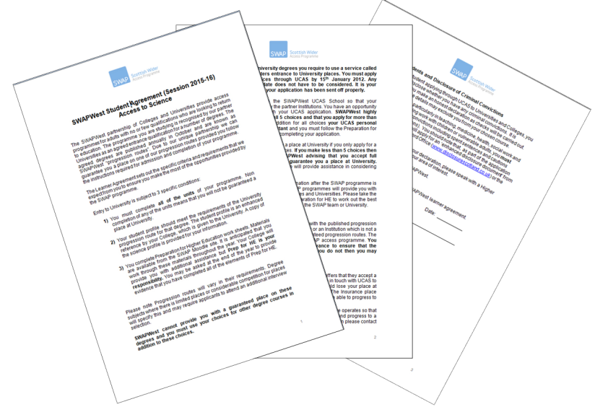

For certain curriculum groups we will also take some time during the induction talk to explain special features of the programme (e.g. the application process to university for Primary Ed candidates).

The induction talk takes about an hour (slightly longer for those on specialist programmes) and should take place before the end of October. It is better to visit a single class rather than combined classes. If any students are unable to attend the SWAP induction talk on the date arranged, then you should ensure that the student completes registration at the earliest convenience.

|  |
| --- |
| **University progression routes and UCAS applications** |

Progression routes will be updated by university partners in collaboration with the SWAP office.

Progression routes will be shared with tutors by email on return from the October holiday. They will also be updated on the SWAP website. <https://www.scottishwideraccess.org/west-progression_routes.php?section_id=285>

We have kept last years progression routes on the web site. For those that are keen to see what is offered. It is worth pointing out to students that circumstances may be very different this year.

Exercises found in Prep for HE are designed to help students think carefully about their choices. Students at this stage should be encouraged to start to explore their options and to research universities and courses thoroughly. The choices exercises will be shifted to the UCAS PHE.

Encourage students to virtually visit university partners and participate in any “virtual” visits from universities.

The deadline for UCAS applications to **medicine, dentistry** and **veterinary** courses is **October 15th.** The same applies to those applying to Oxford or Cambridge. **The deadline for everyone else** (e.g. Humanities, Science, Nursing) **is January 15th.**

SWAP exists as a “school” in the UCAS system, which means that SWAP students will register on UCAS and apply as a member of the SWAP “school”, rather than as a member of your college. That means that students will use the SWAP buzzword, not the college buzzword.

**SWAP buzzword is swapwest2021**

If you are new to the programme as a SWAP tutor we will register you on our UCAS school. If additional staff need passwords, contact the SWAP office. From a university perspective it is better if the SWAP reference comes from the named SWAP tutor so a rounded statement is given on the students development.

The SWAP password allows you to see the progress of your students and if they are receiving the offers you expect. It is a really useful guidance tool.

**IMPORTANT!** By the end of November, students should submit to youa list of the five university/course choices they are planning to make. Check that these are sensible in terms of the range of entry grades required and that any courses with multiple UCAS codes (e.g. psychology) have been double-checked for accuracy. A student who applies to the wrong faculty will be rejected.

SWAP is a partnership programme and progression routes are fundamental to that progression. If a student wants to apply out with the progression routes, can you please notify them of the following:

* To avoid difficulties, students must notify SWAP office before submitting the UCAS application. If we receive notification prior to 30th November then we will check with the university to see if they will accept SWAP programme.
* Progression to universities other than those in our partnership is not agreed in advance and must be negotiated through SWAP.
* All UCAS choices must be used, including at least three from our progression routes, to ensure that the student will have a safety net.

|  |
| --- |
| **SWAP paper work** |

From beginning of November, SWAP will return a **class list** to you with details of students who have completed their SWAP student registration online. This registration form will provide the basis of the SWAP Student Results Summary sent out to colleges in April, so please check it carefully. Students whose names do not appear on the Summary should complete the SWAP student registration online immediately. You can also let us know if students have withdrawn, or if you find any errors or omissions on the list.

|  |
| --- |
| **January** |

**Welcome back!**

We hope you have had a relaxing break.

**UCAS Deadline**

The UCAS deadline is 15th January. Applications (with tutor reference attached) must be completed and dispatched to UCAS before this date or they will not be considered.

**Confirmation of UCAS applicants**

The SWAP office will send you confirmation of applicants currently listed on UCAS. Please check that all of your students who hope to progress to university appear on this list, and let us know of any errors or omissions.

**Interim Profiles**

We will contact you if we need you to produce interim profiles for your students, which some universities may request before they begin making offers. You may also opt to provide students with an interim profile to help them consider their progression options. Any student who consistently struggles with course work should be aware of how this may impact upon final profile grades and should be strongly encouraged to apply for HN courses as a backup plan.

|  |
| --- |
| **February** |

**Some of the key events in February will include:**

**Prep for HE ‘Study Skills Days’**

We work with our university partners to organise opportunities for SWAP students to visit university campuses to a taste of what’s to come. These events typically include information from university learning support staff, study skills workshops (e.g. note-taking in lectures, critical thinking, etc.) and a sample first-year lecture in which to practise these skills. University partners may also offer information about student finances, guided tours of the campus or other suitable activities. We also invite former SWAP students who are studying at that university to attend for a question-and-answer session at the end of the day.



Feedback from students indicates that the Study Skills Days are one of the most important elements of Prep for HE in terms of helping students prepare for the practicalities of university study. Students should aim to attend one of the days offered. The programmes at each university are very similar, so it is not necessary to attend more than one, although students who are still trying to decide between two universities for their firm and insurance choices may find it helpful to do so.

**Interviews:**

Students on Access to Primary Education, Nursing or Medical Studies programmes will be facing interviews. The Prep for HE ‘Interview Skills’ workbook may be useful at this stage, and students should also endeavour to practise as much as possible the skills of listening to questions carefully, answering questions extensively and supporting any assertions with evidence. This can best be accomplished by conducting **mock interviews**. You may lead the students in this activity during their Prep for HE time, or allow them to organise it themselves, using the Prep for HE guide and any other materials you may find useful.

Students will begin receiving offers from universities, but there will usually be one or two who aren’t processed at the same time as the rest of the class. If the student’s UCAS application is in order and was sent off by the deadline, don’t worry. Advise the student to be patient, as UCAS will be dealing with a very high volume of applications. Students will respond to offers after they have heard from all universities to which they have applied. In the meantime, the best use of their time and energy is in completing their course work and Prep for HE exercises.

|  |
| --- |
| **March - April** |

Progressing to university, which for many students will have been merely a “dream” for many years, will begin to feel a bit more real. Students will likely feel excited and apprehensive all at once. Some may wobble a bit in terms of self-confidence and you may notice a slight resurge of self-doubt. The best remedy for this is reflection – looking back to the beginning of the year and noting how far they have come in a short time, and how much they have achieved.

Another good use of guidance time at this point is in actual preparation for the study skills that will be required in Higher Education. See the list below for some suggestions.

Finance is a worry for students, and the time is fast approaching for students to apply to SAAS ([www.saas.gov.uk](http://www.saas.gov.uk)), which usually opens around mid-April. Students may also wish to look for scholarships or university bursaries for which they may be eligible to apply. University web sites or charities such as Turn2Us ([www.turn2us.org.uk](http://www.turn2us.org.uk)) can be useful in finding additional sources of funding.

|  |
| --- |
| **SWAP paper work – Form C and students UCAS decisions** |

**SWAP Student Results Summary form (formerly known as “Form C”)**

The SWAP office will send to you by email a spreadsheet that contains a list of all students who initially enrolled in your class. (NB: If you are one of several tutors in a single college/campus, your local SWAP co-ordinator will receive this form from SWAP and will distribute the relevant form to you).

This spreadsheet (formerly known as the “Form C”) is the SWAP Student Results Summary form and, as indicated by the title, should be populated with information about the results of each student’s programme as of the end of the academic year.

Although you will receive this in May, you will naturally be awaiting results of assessments in May and June before you can complete it. However, now is a good time to (a) check that all of your current students are listed on the spreadsheet and (b) check that any students who have left the programme are marked on the spreadsheet as such and (c) make a note of any unusual university conditions for progression.

|  |
| --- |
| **UCAS offers – making firm and insurance choices** |

**UCAS Offers**

Students should be aware that the first of the final deadlines for responding to UCAS offers is in the first week of May. This is only for those who have received all of their offers. If a student is still waiting for an university response then the deadline will be later.

Anyone who has not already responded to all of their offers must log in to UCAS and do so, or lose the place.

**Student Profiles**

Start to think about completing the SWAP student profile for your students. SWAP will provide you with a template to use. Essentially, the profile is an enhanced reference which you (and the rest of the teaching team) provide for each student in support of their application to university. Students are entitled to receive a copy of their profile.

Work out how you are going to receive the evidence from your colleagues. If you are concerned you have a student who is either not going to complete the programme or will not receive their profile grade for university then now is the time to speak to them.

Discuss with the student all of their options, including HN. You can contact SWAP at this stage to find out if we can discuss with the University options for the student, for example summer school or other degree options. Leaving these discussions until June can often be too late.

**Focus groups**

In order to improve the programme and to highlight examples of good practice, we organise 4-5 focus groups in May of each year. These groups will be selected from across all curriculum areas and partner colleges. If your class is selected, we will contact you to make the request, and you can check that your students are happy to take part. The focus group meeting should take around one hour and will likely be a mixture of discussion and activities designed to elicit feedback on the strengths and weaknesses of the programme. We will also ask students to contribute some words of advice and encouragement for next year’s cohort of students.

|  |
| --- |
| **June** |

**It’s now time to start thinking ahead.** Please send us a copy of the units proposed for your programme next year. SWAP negotiates progression routes with universities in June so we need to authorise your programme for suitability. Any changes must be emailed to the SWAPWest Director.

**Before you head out for holiday** we have the most important job of the year: to provide evidence to our university and college partners that your students are ready to progress

**SWAP Student Results Summary form (formerly known as “Form C”)**

You now need to complete the spreadsheet entitled SWAP Student Results Summary (a.k.a ‘Form C’). SWAP will send you an initial spreadsheet in May, followed up with one in June. Please, check for the following:

Are all students listed on this spreadsheet? (Contact SWAP if any are missing)

Are there any students listed who have withdrawn? (Mark the spreadsheet with the reason for leaving.)

For each student, input the information indicated in the column header (for example):

Completed (i.e. the student has passed all units) (Y=yes or N=no)

Profile grades (if applicable): A, B, C – see below

Comments (additional information about this student)

**Profile Grades**

Profile grades are agreed by the entire teaching team, based upon a professional judgement of the student’s performance and potential. As class tutor, you will need to solicit your colleagues’ opinions; some SWAP tutors do this by calling a brief team meeting to discuss each student in turn, while others circulate a list of students by email, and collate the responses. When you have agreed the grades for each student, enter them on the spreadsheet. Please also check the university conditions for each student’s Firm and Insurance place and note on the Results summary form whether those conditions have been met.

**If a student has just missed out but there are mitigating factors then please complete the full student profile and forward to the SWAP office. Again the quicker this can be done the better. SWAP will explore all options for students who have just missed out.**

**Completion Tutor Checklist:**

Finalise the following items (due to be returned to SWAP by mid-June):

The SWAP Student Results Summary **spreadsheet** (formerly known as “Form C”) with each student’s details completed.

For each student, generate a **list of units** completed (i.e. a transcript or student record, which usually can be generated by the college MIS system, or equivalent).

A **profile** sheet for each student (of which the student may receive a copy), containing the student’s profile grades, confirmation by you that Prep for HE has been completed and any additional comments about the student’s performance and potential. You should give a copy to the student and ensure those who have not met the grade have alternative options.

Before you leave for your much-deserved summer break, please email SWAP with contact information for your MIS department and/or a colleague who is able and willing to access student records in your absence. This will be extremely helpful in cases where there are difficulties with a student’s application or progression options.



Notify SWAPWest by email if any students may require additional assistance to progress. SWAPWest will contact universities over the summer so that alternatives can be considered.

|  |
| --- |
| **July** |

SWAP will carefully check the Student Results Summary spreadsheets and profiles before delivering the final student profiles to universities, who will then process the students’ applications as normal and convert offers to “unconditional” where conditions have been met. This step is usually accomplished by the end of the third week of July.

Students can expect to hear from their chosen university in due course, usually from mid-July onwards, with information about pre-registration, matriculation and enrolment.

|  |
| --- |
| **August** |

**External Exam Results**

Those students who have sat an external exam (e.g. National 5 Maths) in order to fulfil the entry requirements of a particular course should report their results to the SWAP office by email: [swapwest@scottishwideraccess.org](mailto:swapwest@scottishwideraccess.org) with the following details:

* Full name:
* College/campus name:
* Results of exam: