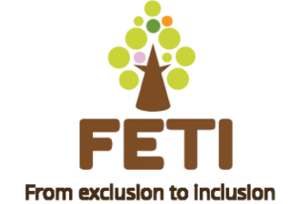

**FETI Project**

SWAPWest was the lead partner for Intellectual Outcome 1 of the FETI Project which was a report of a local needs study across the five European partners, involving stakeholder organisations from all the countries in the partnership. The outcome also included writing a brochure for promotion of the project (see below). This outcome was completed on time in March 2020.

Intellectual Outcome 2 was headed up by our Norwegian partners and is the development of a new model and structure for academic and vocational offer through a mapping tool. We have been busy developing a strategy for this and SWAPWest has developed a workshop model around the assessment of key competences for adults who have few or no qualifications. To date we have delivered this to thirteen people from our target group of refugee and immigrant learners.

The Covid-19 situation means we cannot deliver to face-to-face groups and must use on-line platforms. Feedback from the groups has been very positive and we will be continuing with this after the Christmas holidays.

For further information or to get involved, please email to feti.swapwest@gmail.com.

**FETI Local Needs Study Brochure**

The FETI local needs study provides the structure and foundation for the basic data/baseline needed for the consortium’s work to produce and deliver the models and structure for academic and vocational offers and the mapping tool.

The findings allow for both qualitative and quantitative data to be readily assimilated by not only the partners but also by local education providers and other organisations out with the project who may wish to use the information or join with the aims of the project in delivering new curricula methods.

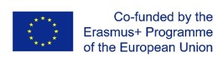The project has been funded with support of the European Commission (Erasmus+ programme – KA2 Strategic Partnership for adult education).

The European Commission support for the production of this publication does not constitute an endorsement of the contents which reflects the views only of the authors, and the Commission cannot be held responsible for any use which may be made of the information contained therein.

The FETI project is an initiative aimed at matching the participating immigrants’ and refugees’ skills to the current needs of the labour market. There are many factors which contribute to their ‘social exclusion’. Some adults in our participant groups will have had little opportunity of primary or secondary education, whilst others have little or no work experience. Many of our participant group will have challenges with language skills, and some will naturally have little understanding of how their new countries function both socially and economically.



Challenges such as social integration, adult learning and immigration in their entirety are far too large for any single project to solve but since many countries share the same issues, it was felt that a coordination of methods might at least go some way towards assisting the refugee population in securing work, education or training leading to employment.

We plan to encourage the integration of immigrants and refugees into the society of the host country. We believe that the best way of achieving this is to develop strategies, methods and educational opportunities which strengthen each individual’s position rather than developing a blanket approach for all such people. We will assess each person’s attributes, skills and competences and build upon the assessment to develop key competences. Our model will support individuals to enter education or the workforce by ensuring that they are aware of their own learning strategies. We will strive to ensure each participant is self-aware of the pathway which best suits their needs in order to gain employment or entry into education.

Language barriers, lack of income and cultural differences are some of the issues which our participant group must overcome to integrate themselves into their new societies. We plan to ease the pathway for this population and where necessary develop new routes.



The data returned by partners showed a wide variation on both the numbers in refugee and asylum-seeking populations in the locales and the provision of services to encourage them to integrate into existing societies. Turkey had by far the greatest number (3.9m) compared to Norway with 238,000, Italy with a foreign population of 5,255,500 residents In the two areas of the project Piedmont and Turin, the figures are 427,911 and 117,979 respectively but these figures are inclusive of all foreign populations, not only refugees. In Scotland the refugee population is 5,500.

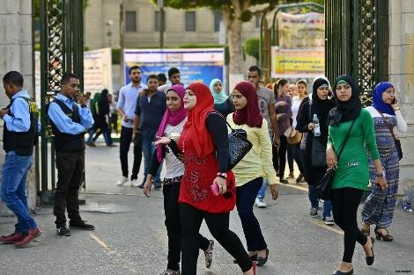

Services offered also varied widely: from financial assistance, housing, employment and training advice and language training different levels of support ranged from almost none to extensive programmes.

Charities and small support agencies were mentioned in several responses as well as government intervention.

Our small target groups (20 in each country) will be provided with individualised help in the aspiration that this model could be extended to multiple agencies in future and provide a valid grounding for independence.

Services offered to the particpating groups also differed from advice and support offered almost immediately after entry to educational planning once residential status had been granted.

Partners aim to produce materials and tools to help with assessment of skills to encourage integration into either the job market or education and training.



**The study concluded:**

* Partners’ work focused on the whole range of assistance to the target group from early days’ signposting towards financial help, assistance with accommodation and necessary bureaucracy to finetuning in careers and educational guidance once refugees had attained a settled status from the reception country. In many instances, the refugees’ skills sets did not match the current labour market needs, leading to exclusion from even low-level occupations and vocational training or further education.
* Relationships between agencies need to be developed to make them more streamlined to the needs of individual refugees and asylum seekers and enable them to quickly become valued members of society. • Experimentation in a range of tools and models will help the target population to lead more productive lives.

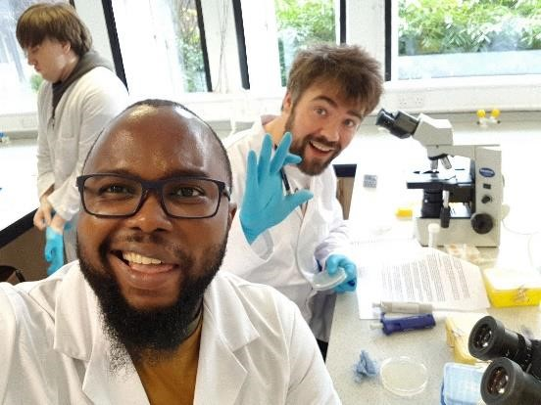

* Working with a range of partners will be of benefit to the project as it will allow us to test the effectiveness of measures that meet the needs of refugees. The statistics of the percentages of Middle Eastern and African nationals proved, in some cases, difficult to extract from the data set that different countries provide publicly and from the partners’ own data. Since the project will work with 20 refugees from these target populations, it will be possible to ensure that they are from the target countries and so will benefit from the project interventions.
* The project gives an opportunity to consider the development of language skills in greater detail with the target groups and ensure that they will attain a competent level for progression because of the focus of support on them.
* The project dissemination and its communication with other agencies across Europe will allow for the sharing of the experience and expertise demonstrated by its activities and its tools and models for assessing skills.
* Advice and support to the target group takes many forms from access to language courses for adults, all levels of education to information and orientation. Help for arranging essential documentation and accommodation is offered. Careers guidance is available through the different agencies in each partner country.
* There were examples of skills audit from partners which may provide a basis for skills assessment guidance.
* There is a need for a more coherent system of skills assessment for refugees and asylum seekers to signpost them towards appropriate vocational work, education and training.

**Project Partners**

**Project coordinator (P1) – Oslo Voksenopplaering Service**

**Senter, Norway**

**P2 – Engim Piemonte Associazione, Italy**

**P3 – Istanbul University, Turkey**

**P4 – Scottish Wider Access Programme West SCIO, Scotland**

