Heriot-Watt University



SWAP Science and Engineering Study Skills

Tutorial Experience

Dr. Emma Coutts

05-02-2021

# Outline

Introduction.



What is a tutorial? And how to get the most out of it.

How does it work?

Mini maths tutorial.

Questions?

# Introduction

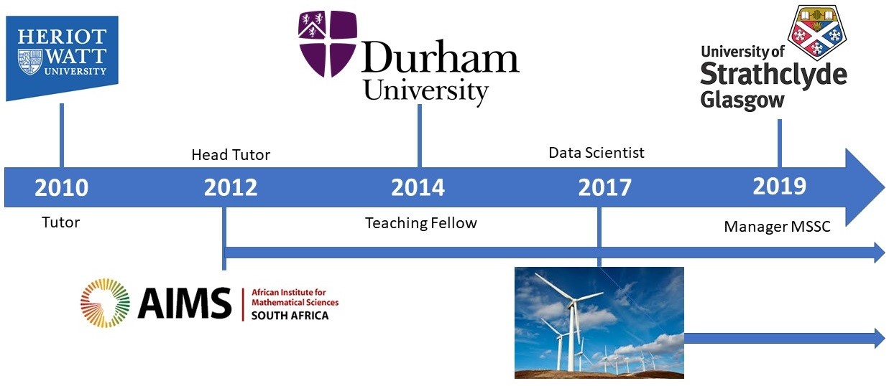

# Introduction



Feb 2020: Director of Maths Gym

Maths Gym is a student support service giving advice to any student who has maths/stats questions



Similar services exist at all Scottish Universities

What is a tutorial?

According to Cambridge Dictionary Online (https://dictionary.cambridge.org/dictionary/)

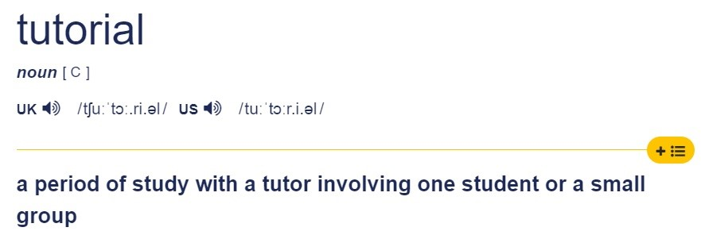

BUT I think it is so much more...

What is a tutorial?

Timetabled session to work through relevant problems with the help of tutors and/or lecturer



Chance to chat with your peers about the problems and help each other

Ask questions!

Get more in-depth answers/discussions

Develop your technical skills

Develop communication skills

How to get the most out of it.

University is a bit like a gym membership - the more you put in, the more you get out!



Lectures provide the (very important) information you need - bit like an orientation at the gym.

Self-study: you will have textbooks, exercises, homework to use this information - working out in the gym.



Tutorials give you a chance to apply your knowledge with support - going to a zumba class!



Other student support add to this eg library, study support services, wellbeing services... Don’t underestimate peer support too :)

How does it work?

Your lecture class will be broken down into smaller groups of 8-20 (ish).



The exact format depends on your lecturer/tutor but all very similar with same goal.

Meet regularly (weekly) with to discuss problems/exercises related to lecture material.



Work through the exercises in the tutorial with tutor walking around to help.



Discuss exercises you tried at home in preparation for the tutorial.

Chance to ask questions, talk to your group, get more detail...

# Climate Change Tutorial

In the lecture earlier today you talked about climate change and looked at Global Temperature changes.

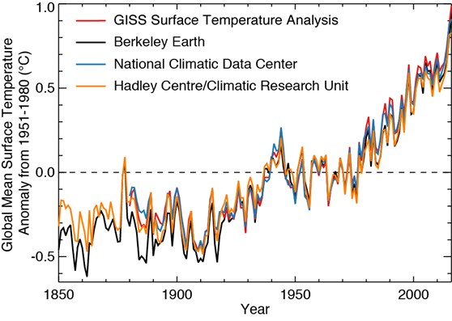

Thanks to Andy for the image he used :)

# Climate Change Tutorial

We are going to investigate the properties of a simplified version of the GISS data (I have averaged it over 5 years from 1960 - 2020).

|  |  |
| --- | --- |
| Year | Mean Temp Change |
| 1960 | -0.018 |
| 1965 | -0.044 |
| 1970 | 0.01 |
| 1975 | 0.06 |
| 1980 | 0.238 |
| 1985 | 0.256 |
| 1990 | 0.326 |
| 1995 | 0.446 |
| 2000 | 0.544 |
| 2005 | 0.640 |
| 2010 | 0.682 |
| 2015 | 0.938 |
| 2020 | 1.020 |

1. What is the mean and variance of the global temperature change?
2. Plot the data and describe the trend of the data.
3. Can we fit a straight line to the data (line of best fit)?
4. What does this tell us and can it be used to make future predictions?
5. Are there any pitfalls/issues/limitations with this analysis?

# Question 1

*n*

|  |  |  |
| --- | --- | --- |
|  |  | *n*  *i*=1 |
| Variance = *s*2 | = | *n*  1 X 2  (*xi* − *x*¯) |

Mean = ¯*x* X*xi*

*n* − 1

*i*=1

*n*

P*xi* = −0*.*018 − 0*.*044 + 0*.*01 + ··· + 0*.*938 + 1*.*020 = 5*.*0980

*i*=1



# Question 1

|  |  |  |  |
| --- | --- | --- | --- |
|  |  | (*xi* − *x*¯) |  |
| 1960 | -0.018 | -0.410154 |  |
| 1965 | -0.044 | -0.436154 |  |
| 1970 | 0.01 | -0.382154 |  |
| 1975 | 0.06 |  |  |
| 1980 | 0.238 |  |  |
| 1985 | 0.256 |  |  |
| 1990 | 0.326 |  |  |
| 1995 | 0.446 |  |  |
| 2000 | 0.544 |  |  |
| 2005 | 0.640 |  |  |
| 2010 | 0.682 |  |  |
| 2015 | 0.938 | 0.545846 |  |
| 2020 | 1.020 | 0.627846 |  |

*n*

P (*xi* − *x*¯)2 = 1*.*525 =⇒ *s*2 = 1*.*525 = 0*.*127

*i*

# Question 2

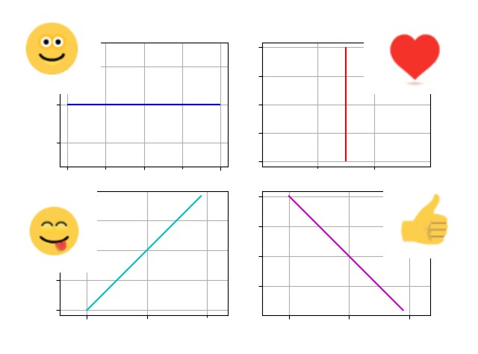

# Question 2

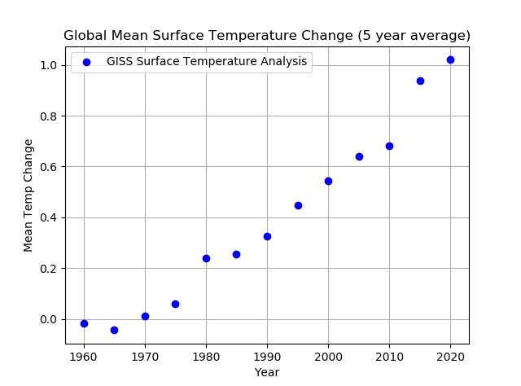

11/15

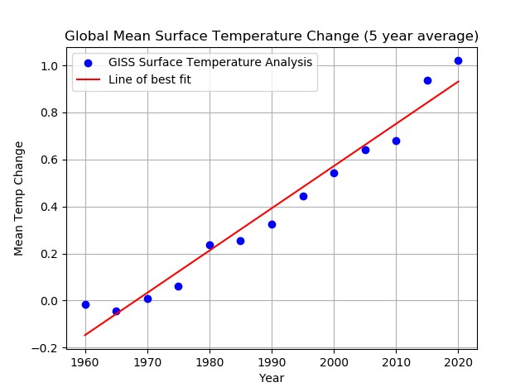

|  |  |  |
| --- | --- | --- |
| *y* | = | *mx* + *c* |
| *m* | = | *y*2 − *y*1 *x*2 − *x*1 |
| *y* − *y*1 | = | *m*(*x* − *x*1) |

*m* is the gradient *c* is the y-intercept



(*x*1*,y*1), (*x*2*,y*2) are any distinct points on the line.

Here (*x*1*,y*1) = (1990*,*0*.*4) and (*x*2*,y*2) = (2020*,*0*.*9) (approximately).

*y*2 − *y*1

*m* =

*x*2 − *x*1

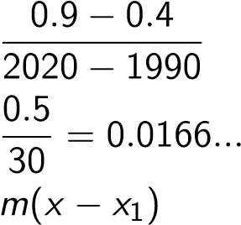=

= *y* − *y*1 =

*y* − 0*.*4 = 0*.*0167(*x* − 1990) *y* = 0*.*0167*x* − 0*.*0167 × 1990 + 0*.*4 *y* = 0*.*0167*x* − 32*.*83

# Question 4

Tells us (on average) temperature has been increasing with time.



Mean and the slope have positive values - increasing trend.

We could use this to make rough predictions (see Q5) by subbing in a future year to our new equation

13/15

# Question 5

Should we use this for future predictions?

1. Yes why not?! 
2. No, we have used descriptive statistics, they only describe!
3. No, a straight line was the wrong model to fit!
4. No, averaging the data over 5 years smoothed out the variations - we lost information!
5. Something else/combination of the above.

14/15

# Questions

Thank you and any questions?

15/15