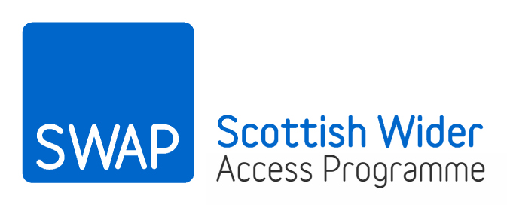

SWAP East eligibility and selection criteria: guidance for tutors

The SWAP East team are there to assist throughout the year. If you have questions about the information in this booklet or if you need advice or guidance at any point, please get in touch, by phone on 0131 650 6861 or by email at Swap.East@ed.ac.uk You might also find what you are looking for on our website: scottishwideraccess.org/east
1. SWAP eligibility

SWAP access courses are primarily intended for adults aiming to enter higher education for the first time and those returning to education after a significant gap. To meet the SWAP eligibility criteria, applicants must have been out of full-time education for at least 3 years, if they already have qualifications at, or equivalent to, SCQF Level 5, or at least 5 years, if they already have qualifications at, or equivalent to, SCQF Level 6 or above.
In certain circumstances, it may be possible to discount certain types of full-time study (e.g. ESOL courses) or consider recent full-time study (i.e. within the last three to five years) as pre-access. This would not affect an applicant’s SWAP eligibility. However, in such cases, the applicant would need to have been out of full-time education for at least three or five years prior to entering the pre-access course. To be considered as pre-access, courses must not be higher than SCQF level 5.
All applicants should be interviewed before being accepted onto a SWAP programme. Interviews should be used to check that applicants meet the SWAP eligibility criteria and also to ensure that they understand the content covered in the programme they are applying to and the level of commitment required of them in order to be successful. Applicants should be informed about progression routes to university, profile grades, course-specific entry requirements, sources of funding and, if appropriate, alternatives to university (e.g. HN). At this stage, it is very important to advise applicants that they must disclose all information relating to previous study at SCQF level 6 or above.
PLEASE READ THIS SECTION
Students who already hold a university degree are not SWAP eligible and should be signposted to the SWAP office or the university they want to study at for further advice on alternative routes back into higher education.
Students who have studied previously at university but did not complete their degree will not normally be eligible. However there may be individual circumstances which would allow this student to be considered SWAP eligible. College admissions staff should advise the student to contact the SWAP office to seek clarification on the student’s eligibility. At this stage, SWAP may also consult the university the student wishes to attend in order to obtain further guidance on other routes.
2. SWAP selection criteria
1. SWAP entrants should be able to demonstrate a strong desire and commitment to their education and personal development. They should show evidence that they have the necessary relevant skills and experience to enable them to complete the SWAP access programme. Evidence of this could include relevant experience or skills obtained through employment, internships, voluntary work or leisure time activities.
2. Priority should be given to applicants who have not previously studied beyond SCQF Level 5. However, consideration should also be given to the length of time applicants have spent out of formal education and the relevance of previous studies to their chosen subject area. Part-time study does not need to be taken into account when determining eligibility.
3. Particular consideration should be given to the following under-represented groups:
- applicants from the 20% most multiply-deprived areas in Scotland (as determined by the Scottish Index of Multiple Deprivation);
- applicants from ethnic minorities;
- applicants with a declared disability;
- applicants with no family background of university study;
- applicants who have experience of care (i.e. have/had caring responsibilities or have been in care themselves).
4. There are a number of SWAP programmes which include non-SWAP students (who will normally progress via HN routes). This is completely fine; however, places on SWAP programmes should not be allocated to non-SWAP applicants at the expense of others who are SWAP eligible. Priority should be given to applicants who meet the SWAP eligibility criteria.
5. There are no upper or lower age limits for SWAP eligibility. Applicants of any age can be accepted, provided they meet the SWAP eligibility criteria and demonstrate they will be able to cope with the demands of the programme. Note that applicants who are aged 60 and above are not entitled to a student loan from the Student Awards Agency for Scotland (SAAS) but are entitled to tuition fees.
3. Exceptional circumstances
All SWAP applicants are expected to meet the SWAP eligibility criteria, as set out above. These are the criteria agreed with the partner universities and the Scottish Funding Council (SFC). However, there is potentially some scope for flexibility in the 3/5 year ruling in individual cases where exceptional circumstances apply, for example:
- applicants whose previous education has been seriously disrupted by illness or injury;
- applicants who have been in care;
- applicants with a previously undiagnosed disability which has seriously disrupted their education;
- applicants whose education has been seriously disrupted by bullying;
- applicants who have asylum-seeker or refugee status.
All applications involving exceptional circumstances should be considered on an individual case-by-case basis and discussed with the SWAP East Director. If there are any questions or concerns about the eligibility of an applicant, or indeed in relation to anything in the above guidance, please communicate with SWAP East.
4. Additional information relevant to specific access programmes
Nursing
Applicants who wish to progress to a nursing degree should be made aware that they must have been ordinarily resident in Scotland for three years before their degree course begins in order to ensure they will be eligible for funding, as set out in The Nursing and Midwifery Student Allowances (Scotland) Regulations 2007. Applicants should also be made aware that the access to nursing programmes do not formally provide progression to degree courses in either midwifery or child nursing.
Primary education
Applicants who wish to progress to degree courses in primary education should be made aware that, in their university application, they will be required to show experience of working with children of primary school age, preferably within a classroom environment. Applicants will also be expected to show a good understanding of current issues relating to primary education and to demonstrate a strong personal commitment to learning and personal development.

