

**SWAP Tutor**

**Guidance Notes**

The SWAP East team is there to assist throughout the year. If you have questions about the information in this booklet or if you need advice or

guidance at any point, please get in touch. We are working remotely, so

please email us at **swap.east@ed.ac.uk**. There is also lots of information

and guidance for both you and your students on the SWAP East website:

<http://www.scottishwideraccess.org/east>

# Contents

1. Introduction _2
2. SWAP eligibility criteria ______2
3. Student Planner__________________________________________4
4. SWAP student registration ______4
5. SWAP induction talks _5
6. Preparation for higher education _5
7. UCAS APPLY and TRACK _____ _6
8. SWAP East progression routes ______9
9. SWAP East study skills events ______9
10. Results: SWAP profile-grading and academic transcripts _10
11. Further information and advice ____10

## 1. Introduction

These guidance notes are intended for college tutors and managers who are responsible for delivering access programmes affiliated with the Scottish Wider Access Programme (SWAP) East.

SWAP East access programmes are offered throughout the north and east of Scotland. To see details on where they are running, please click [here](https://www.scottishwideraccess.org/east-our-programmes) to go to the *Our Programmes* page on the SWAP website. In addition, there is a wide range of SWAP access programmes on offer at colleges in the west of Scotland. These provide progression routes into universities which are part of the SWAP West partnership. SWAP West can be contacted by phone on 0141 564 7206 or by email at swapwest@gmail.com

Further information and guidance for SWAP tutors is available in the *Tutors* section of the SWAP East website: <https://www.scottishwideraccess.org/east-tutors>

To access this section of the website, use the following details:

**Username: tutor**

## Password: teachSWAP

### 2. SWAP eligibility criteria

SWAP access programmes are primarily intended for **adults aiming to enter higher education for the first time** and those returning to higher education after a significant gap. To meet the SWAP eligibility criteria, applicants must have been out of full-time education for at least

3 years, if they already have qualifications at or equivalent to SCQF Level 5; or at least 5 years, if they already have qualifications at or equivalent to SCQF Level 6 or above. *Please note, however, that a student who has recently undertaken a full-time level 4/5 course would be allowed to continue directly on to the access programme provided that they had been out of education for 3 years prior to the level 4/5 course.*

All applicants should be interviewed before being accepted onto a SWAP programme. Interviews should be used to check that applicants meet the SWAP eligibility criteria and also to ensure that they understand the content covered in the programme they are applying to and the level of commitment required of them in order to be successful. Applicants should be informed about progression routes to university, profile grades, course-specific entry requirements, sources of funding and, if appropriate, alternatives to university (e.g. HN). At this stage, it is very important to **advise applicants that they must disclose all information relating to previous study at SCQF level 6 or above**.

**N.B. Students who already hold a university degree are not SWAP eligible** and should be signposted to the SWAP office or to the university that they want to go to, for further advice on alternative routes for returning to higher education. **Students who have studied previously at university (but did not complete their degree) will not normally be eligible.** However there may be individual circumstances which would allow this student to be considered SWAP eligible. College admissions staff should advise the student to contact the SWAP office to seek clarification on his/her eligibility. At this stage, SWAP may also consult with the university to which the student wishes to attend to obtain further guidance on other routes.

Exceptions to the eligibility criteria will depend on individual circumstances and be considered on a case by case basis. If you are unsure about an applicant’s eligibility, please contact SWAP East for advice. Note that there is no minimum age limit for SWAP students; eligibility depends on the educational experience of the applicant rather than their age.

Exceptions to time away from education include when a student has had their formative schooling years (S3/4/5) significantly disrupted through, for example, ill-health/bullying/family circumstances. In these instances, the 3 or 5 year ruling may be waived. Please seek advice from the SWAP office.

Full details on eligibility are found in the tutors’ section of the website.

Please give your admissions team access to this as well.

### 3. Student Planner

This year, because of COVID and the prospect of blended learning, students will receive a student planner from SWAP in digital form with links to information on the website. We will send you this booklet at the beginning of term and ask you to email it to all your SWAP students. It will also be in the [Information & Guidance](https://www.scottishwideraccess.org/east-current-students-info-and-guidance) page of the website. This booklet will give your student lots of information about SWAP, how it will support them and what they must do to help them prepare for the transition to higher education the following year.

#### 4. SWAP student registration

One of the first things we need your help with at the start of the academic year is **making sure that all of your SWAP students register with us**. Even though they will have matriculated with the college, we also need them to register with SWAP. This allows us to obtain their contact details, so that we can communicate directly with them and collect data relating to their education and family background—data which SWAP requires for reporting purposes. All personal information is treated confidentially and used only for the purposes set out in the *SWAP Statement on Data Sharing* and the *SWAP Data Protection* Policy, both of which students are asked to read and agree to when they register.

Registration is straightforward and can be done entirely online via the [*Current Students*](https://www.scottishwideraccess.org/east-current-students) section of the SWAP East website. New students register by clicking on *Registration Form*. This will bring up an online form to complete. All new SWAP students must register with SWAP East before the end of September. At that stage, SWAP will send out a class list to tutors to check on any students who have still not registered. SWAP will also cover registration during the induction talks.

#### 5. SWAP induction talks

We will be in contact with all SWAP tutors after the summer break to arrange a time to speak to your new SWAP cohort early on in the first semester. This is an opportunity for us to explain how SWAP works, cover any important points they need to know for the year ahead and give students an opportunity to ask any questions. These talks are informal and normally take between forty-five minutes to an hour. If you have a mixed class made up of SWAP and non-SWAP students, it is best if we can talk only to those who are SWAP eligible. This avoids any confusion that could be created regarding UCAS and university entry for those who won’t apply through SWAP. This year, we anticipate that these talks will be done virtually and we will liaise with each college tutor to set this up.

#### 6. Preparation for higher education (Prep for HE)

All SWAP students are required to complete at least one unit of Prep for H.E. as part of their access programme. It is, therefore, very important that students and tutors know how and where to access the SWAP Prep for HE materials. They can be accessed in the [*Current Students*](https://www.scottishwideraccess.org/east-current-students-prep-for-he) section of the SWAP East website.

The approach taken to Prep for HE varies from college to college and even within colleges. Most tutors use a combination of college-based personal development materials and SWAP materials, some use only SWAP materials and some prefer to work on a related SQA unit, such as Developing Skills for Personal Effectiveness. Regardless of how the Prep for HE element of the programme is delivered, it is essential that all SWAP students complete it and that you are satisfied that it has been completed to an appropriate standard. In 2020/21 SWAP is planning a significant update of the Prep for HE materials, using new software. We’ll liaise with you on these developments and give you and the students a chance to give feedback on what you think of them before we take away the existing materials.

**7. UCAS APPLY & TRACK –supporting students’ applications**

## Registration

All SWAP East students applying to UCAS **must** register with UCAS through SWAP East. When they register with UCAS, your SWAP students will need to use the SWAP East buzzword. The buzzword is always *swapeast* followed by the year of entry to university. e.g. **swapeast2021** Your college will have a different UCAS buzzword and this can sometimes lead to confusion, particularly if college guidance and student support staff are unfamiliar with SWAP. SWAP students must use the SWAP East buzzword, NOT the college buzzword.

## Completing the application

SWAP East exists as a centre/school within the UCAS system. Most of the application is straightforward but the education section is often where mistakes are made. When students are completing this section of the

UCAS application they will be asked for details of their centre or school.

For all SWAP East students, their school/centre is the **Scottish Wider Access Programme East**. Universities will know which college they are at when they receive their application, because they are assigned a tutor group on Apply. This is their college name and the name of their access programme.

Guidance on applying to UCAS can be downloaded from the [*Current Students*](https://www.scottishwideraccess.org/east-current-students-info-and-guidance) section of the SWAP East website. Students should use this document to help them fill in the application correctly - the guidance will really help – especially in the Education section. It is important to note that when completing this section students should provide details of all the units they are taking as part of the SWAP programme. They should list them under *National Units – Scotland*. Prior qualifications should also be listed. We recommend that UCAS applicants should include a line in the personal statement to make it clear that they are a SWAP student, as it is not always obvious to admissions officers.

Please also ask students to *opt in* to allowing tutors and SWAP to see their data on TRACK, otherwise we cannot support their application and ensure that their offers comply with the progression route agreements. **They do this by going to the “Your Details” section and then ticking on “School Data Sharing”.**

## UCAS APPLY & TRACK – using Advisers’ portal

If you were involved with UCAS applications last year, you will know that there were significant changes made in 2019 to both the layout and access of the student’s application on Apply and access to the university responses to students on TRACK. Tutors now set up their own log in and password. Any tutor who did this last year, should not have to register again. If you know of any new member of staff who will need access to the SWAP UCAS school, please ask them to get in touch with SWAP and we will add their email address to the staff list. This will then allow them to register. Should a tutor forget their password at any time, there is a self-service function on the Dashboard which allows you to re-new it.

Here is the link to the registration/log-in page.

[https://digital.ucas.com/Account/Login?returnUrl=https%3a%2f%2fdigital.ucas.com%2fsearch%2fda shboard](https://digital.ucas.com/Account/Login?returnUrl=https%3a%2f%2fdigital.ucas.com%2fsearch%2fdashboard)

Below is what the register/sign in page looks like:

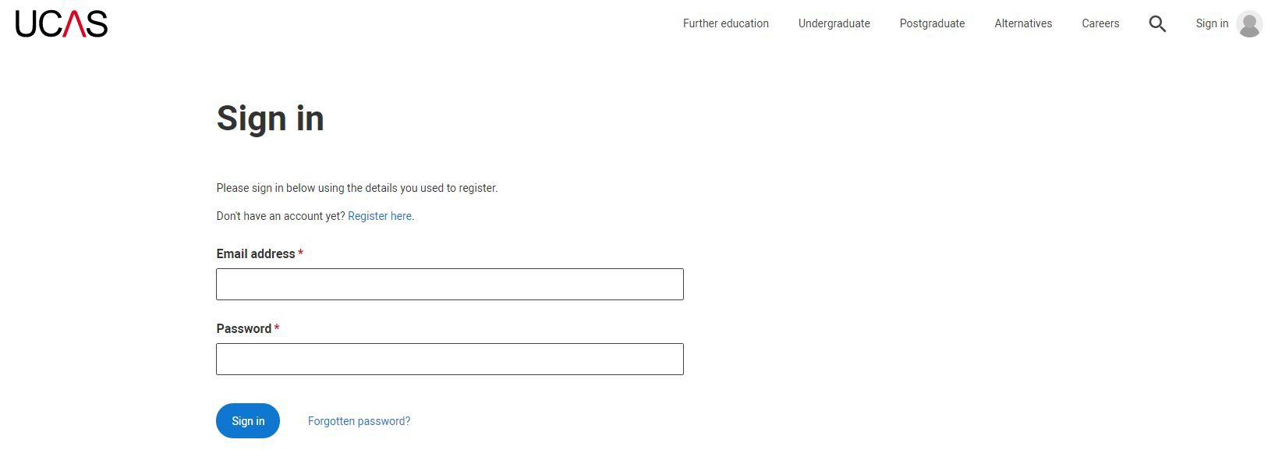

Once you have registered and UCAS have confirmed your account has been set up, you will be able to log in and go to the next page. The two most important links on this page will link you to your students’ applications. Firstly, to **Application management**, where you will find your students’ applications, and where you will review them, add the references, predicted grades (if applicable), and send off to UCAS. Secondly, **Tracking offers and decisions**. This is where you will be able to see the status of your students’ applications AFTER they have been sent to UCAS. You will only be able to see the applications and decisions made on students who are in your tutor group. Any advisers who have an overall college remit for UCAS should contact me if there is an access programme that you are not seeing. I will then add your name to that group.

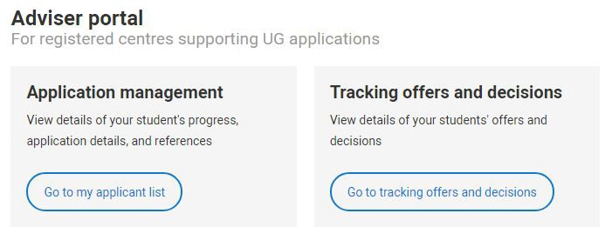

**Some things that are different in the new Adviser Portal:**

* Advisers do not need to contact SWAP if they forget their password.
* Advisers can see TRACK and see what the conditions of offer are.
* TRACK will update instantly and advisers will see the updates instantly.
* All advisers will be able to delete and undelete applications. Deleted applications will be archived, therefore if it was done in error, and is needed again for whatever reason, advisers can retrieve them.
* There is a tab on the student’s application home page called *View All details*, which allows you to see the whole application on one page.

**Important points to note**:

* Use the “BACK TO” button when wanting to go back to the previous page. Do not click on the webpage back button.

## Guidance

Guidance on writing a UCAS reference can be found in the [*Tutors*](https://www.scottishwideraccess.org/east-tutors) section of the website. Help with reference writing is also available on the UCAS website. If you are new to UCAS and would like some additional support or information, let us know. We will be happy to come out and talk to you or your students. When writing the reference, tutors should headline it with SWAP student and the name of the access programme, to help admissions officers identify that the student is SWAP.

If you have colleagues within the college who are responsible for advising students on UCAS-related matters, it would be very helpful if you could make them aware of the different arrangements in place for SWAP students or put them in touch with us, so that we can explain things to them.

### 8. SWAP East progression routes

From the earliest possible moment, students should be encouraged to use the [*Possible Degree Progressions*](https://swapsurvey.org/progression/east) tool, which can be found on the homepage of the SWAP East website. This allows students to find out what they can study, where they can study and what the entry requirements are for SWAP applicants.

Progression routes are updated annually, so it’s very important to check progression routes using the search facility, as some arrangements may have changed since the last time you looked.

Students can apply for degree courses which are not included in the progression routes or to universities that are not SWAP East partners. However, there is no guarantee that those universities will be willing to consider applications from SWAP East students; the chances of being accepted vary from university to university and from course to course. Students applying to study high demand subjects, such as primary education, physiotherapy or nursing, are unlikely to be offered a place at a university which is not a SWAP East partner.

### 9. SWAP study skills events

Study skills events are an important part of the access programme for all SWAP students intending to go to university. SWAP coordinates a series of study skills events with our partner universities: three for students in arts, humanities and social sciences (Aberdeen, Dundee and Edinburgh), four for nursing (Aberdeen, Inverness and Dundee - one at Ninewells and one at Kirkcaldy) and one for science and engineering (Edinburgh). Edinburgh Napier University also holds a Nursing event to which SWAP students are invited.

Study skills events are an opportunity for students to find out about what it’s like to study at university, get some tips and advice on study skills such as essay writing, critical thinking, note-taking in lectures, (practical lab and clinical skills workshop). They will also get a chance to speak to university support staff and meet former SWAP students who are now studying at university. All SWAP East students will receive an email inviting them to register for the relevant *Study Skills Day*. To get an idea of what they’re about, click [here](https://www.scottishwideraccess.org/east-current-students-study-skills) to see the programmes and presentations from a previous year. Because of COVID, we are not yet sure what format these events will take this year, but we will post dates on the website as soon as we know and will get in touch with course tutors and students then.

Students should be strongly encouraged to attend a Study Skills event as this is an important part of the Prep for HE component of their access programme.

### 10. Results: SWAP profile-grading and academic transcripts

We will contact you towards the end of the academic year, most likely in May, to ask you to send us the results for all the students in your class. We will ask for SWAP profile grades and a full academic transcript for every student who has completed the programme. *Full guidance notes on*

*SWAP profile grading explained are available in the* [*Tutors*](https://www.scottishwideraccess.org/east-tutors) *section of the SWAP East website.*

The academic transcript is a list of all the units the student has passed and failed and includes the SQA unit title and number, credit value and

SCQF level. Pending results, if required for university entry (e.g. National 5 Maths) should also be included in the transcript. We will also ask for information on the progression plans of all SWAP students, including those who aren’t going to university, and we will ask for details regarding those who have withdrawn. This information allows us to gather data and monitor trends, for example, on retention rates, reasons for withdrawal and post-access programme progression. SWAP tracks former SWAP students who go on to university and those who continue their studies at college.

We need the fully-completed documents by mid-June to enable us to check and pass on the relevant information to universities in good time. It is extremely helpful if you can submit the results to us at least a week before your summer break to allow us time to check and query any issues before you go. If there is a problem and we cannot get a hold of you, a student’s place at university could be at risk.

### 11. Further information and advice

If you need clarification about anything in this document or need advice on anything else during the year, do not hesitate to contact the SWAP East Office—we are there to help. We are currently working remotely and are not accessing the SWAP office phone but if you’d like to speak to us, please just email us and we’ll call you back.

**SWAP East Contact Details**

**Lesley Dunbar**, Director

Lesley.dunbar@ed.ac.uk

**Nick Hutcheon,** Coordinator

Nick.Hutcheon@ed.ac.uk

**Anna Reynolds**, Administrator (Mon-Thu 09:00-14.30)

Anna.reynolds@ed.ac.uk

E-mail: swap.east@ed.ac.uk

Web: [www.scottishwideraccess.org](http://www.scottishwideraccess.org/)