

UCAS Online applications for
SWAPWest Access students

Guidelines for applicants

For detailed information please
speak with your college tutor.
Introduction

SWAPWest students must apply to university via UCAS online. Payment is required and you must pay by credit or debit card – this can be yours or someone else’s card. If this poses a problem please speak to your college tutor.

Web address: www.ucas.com

Deadlines are:

15 October for applications for Medical, Dental and Veterinary Schools

25 January for all other applicants. NB: Your college probably will ask you to complete your application by early December. Follow your class tutor’s instructions and adhere to your college’s deadline.

If you are applying for Primary Education, see your tutor for further guidance.

Quick Essentials:

- The buzzword is swapwest2023 (no spaces). Enter the buzzword when prompted.

- Access to Humanities / Social Science students may apply to only one option at the University of Strathclyde.

- Any student applying to study psychology must take special care to ensure that the correct UCAS code is used (e.g. the code for the faculty/school that corresponds with your SWAP programme). Speak to your tutor or contact SWAP if you are uncertain. Using the wrong code will result in a rejection from the university, which cannot be reversed.

Responsibility

Your class tutor and/or college support staff will give you some guidance, but it is your responsibility to ensure that your application form is completed correctly.

Pay particular attention to the guidelines below, which will help ensure you identify yourself correctly as a SWAP Access student. If you make a mistake and need SWAP to make a change within UCAS on your behalf, we must receive a written instruction before we can do so.

UCAS REGISTRATION
Before you can apply via UCAS, you must register. Follow the instructions below. Alternatively, you can view the video online at: https://youtu.be/oCmDAt5xeYU

Instructions:
- Go to www.ucas.com.
- In the upper right-hand corner, click SIGN IN and then STUDENTS.
- On the Student Sign-In page, click REGISTER.
- Enter your personal email address (not your college email) and your name, then choose your own password. Make a careful note of the password, as you will need it to login in future.
- Read the Terms and Conditions, then tick the box.
- Click REGISTER.
- The next step is to verify your account. Check your personal email account to find the verification code. Copy it and paste it into the field.
- Click VERIFY.
- On the next screen, click READY.
- In which year do you want to start your studies: choose the next academic year ahead (NB: if you need to defer for a year, first speak to your class tutor or SWAP.)
- Select level of study: Choose UNDERGRADUATE.
- Tick if you wish to opt in for information on apprenticeships or conservatoires, and then click NEXT.
- Where do you live? Input your home post code, and then click NEXT.
- Your preferences: Opt in or out for marketing preferences, then scroll down and input your mobile phone number (optional).
- Which subjects are you interested in studying? Choose at least one option from the menu. You may choose two more options if you wish.
- Get the right support: Are you still at school/college? Click YES, and then search for ‘SCOTTISH WIDER ACCESS PROGRAMME, WEST’ and select it when it pops up. **Do not enter your college name. Use ‘Scottish Wider Access Programme, West’ instead of your college name.**
- Click on CREATE ACCOUNT.

On successful completion of the above steps, you’ll be registered properly and you’ll be taken to the UCAS ‘Hub’ page. Click GO TO MY HUB. The next step will be to begin your application.

Before you begin your application

In order to complete your application, you will need to include information from the sources listed below, which can be gathered or prepared in advance. If you have this information ready, you may be able to complete the rest of the application in a single session, which should take you around an hour.

You will need:

- A list of all the units you'll be undertaking this year as part of your SWAP programme. Your class tutor can supply you with the list. You'll need the unit name, unit code and unit level for each.

- Your list of up to five university course choices. Your choices should come from the SWAP Progression Routes. You will need the institution code for each university and the course code for each of your five choices, which you can get from the UCAS web site.

- Although it is not compulsory, you will be asked to include your Scottish Candidate Number (SCN), which you can find on any old SQA certificates you may have from previous study, or you may contact the SQA by telephone on 0345 279 1000 to ask for your number.

- Last, but not least, you'll need your completed Personal Statement. This should be written using a separate word-processing software e.g. Microsoft Word, so that you can check spelling, grammar and punctuation. You are limited to 47 lines of text (4000 characters, including spaces) on the UCAS form. That usually amounts to around one and a half pages when typewritten and single-spaced. After copying from your draft and pasting it into the form, double-check that the whole statement fits into the space. Check to make sure the end hasn't been cut off.

How to begin
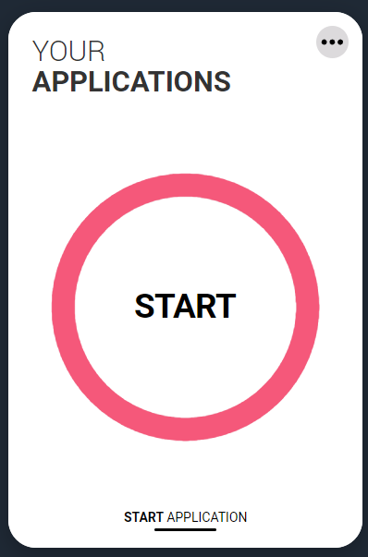
On the Hub page, you'll see a tile that reads 'Your Applications'. It has a large red circle on it, with the word 'START' in capital letters. Click that button to get started on your application.

You'll then see a collection of nine tiles that represent the various sections of YOUR PROFILE.

Your Profile

Most of the sections in YOUR PROFILE are quite straightforward. For example, in the Personal Details section, you are asked to give your name, date of birth and gender. In the Contact Details section, you’re asked for your mobile number, postal address and residency details. See the corresponding sections below for help with each section. If you’re not sure how to answer some of the questions, consult your class tutor or contact SWAP for help. A few things to note:

- You may complete the sections in any order.
- You may pause at any point and log out. Your progress will be saved. You can then log in and resume your application at a later date.
- Before you can submit your application, you must mark each section as complete. You can do so by placing a tick mark in the box at the bottom of each page, as shown in the image below
- In some cases e.g. in the Employment section, you may simply mark the section as complete without entering any information.
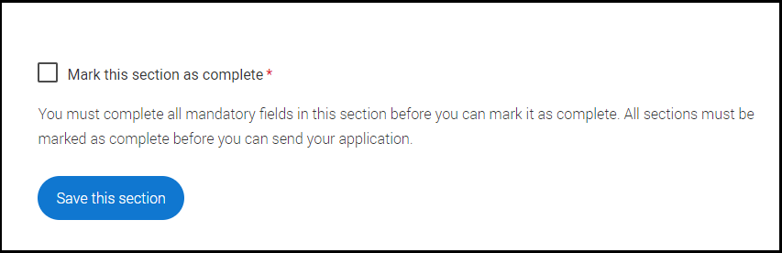
From within each section, you can access the next section by clicking on the name of the section on the left-hand sidebar. Your progress is indicated by the circle icon or (on the Hub page) by a note at the bottom of each tile:

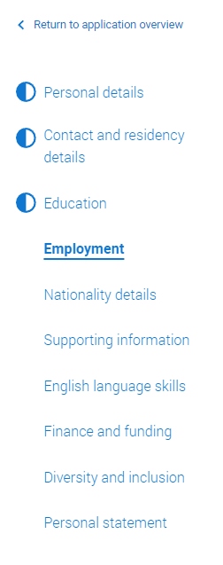
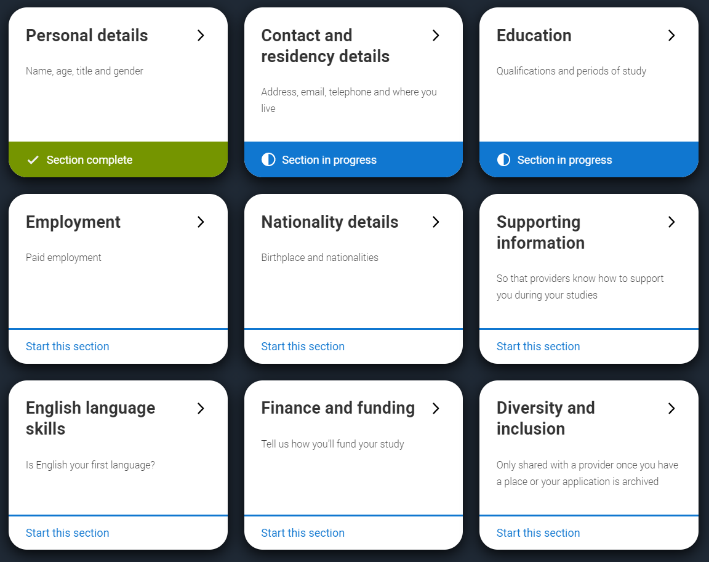

Personal Details

Input your personal details as you wish. Fields marked with a red asterisk (star) are required. Otherwise, you are not required to fill them in and may skip them. Once you’re finished, mark the section as complete and then save it.

To move on to the next section, you may click the ‘Next…’ button in the lower right-hand corner, or choose the next section from the sidebar.

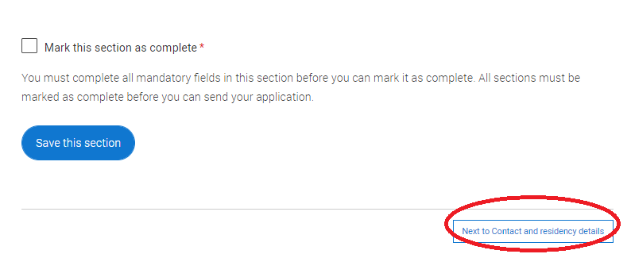

Contact and Residency Details

As above, fields marked with an asterisk are required; otherwise you may leave them blank or fill them in as you wish.

- Your email address cannot be edited directly in this section. Instead, if you need to change your email address or password, click on the upper right-hand corner of the page (where you first signed in) and then choose the page you need from the menu there.

- Input your UK address. Remember that UCAS will use your information to contact you right up through September of next year, so if your address changes before you begin university, you should update it on UCAS.

- Under ‘Residency details’, choose the correct responses from the drop-down menu. Check with your tutor or SWAP if you’re not sure how to answer.

As above, mark as complete and save before moving on to the next section.

Education

Please follow these instructions carefully. Before you begin this section, you will want to have handy the complete list of units you’ll be studying on the SWAP programme this year. In most cases, that will mean a list of 16-21 units, and each one has to be entered individually as directed below. If you fail to enter all of the units or if you enter them incorrectly, you application may be rejected.

Add place of education
Remember that the universities will consider your application based on your SWAP qualification, so the only relevant ‘place of education’ you must enter is ‘Scottish Wider Access Programme, West’. If you wish, you may add other places you’ve attended in the past, but it is not necessary.

- Click on ADD PLACE OF EDUCATION.
- In the first field, begin typing ‘Scottish Wider Access Programme, West’ and you can select it when it pops up.
- The exam centre number is greyed out. Ignore it.
- Start and end dates: enter the month and year you began your SWAP programme and when you will end it. Ordinarily this will be August of the current year and June of the next, although if you are on a ‘January start’ programme your responses will be different.
- Scroll down and indicate FULL TIME under ‘Type of study’.
- In response to the next question (‘Do you, or will you, have any qualifications from this centre’) the answer is YES.
- Click SAVE.

You will see a notification that your Place of Education has been entered successfully and your Place of Education will be displayed on the next page, as in the image below:

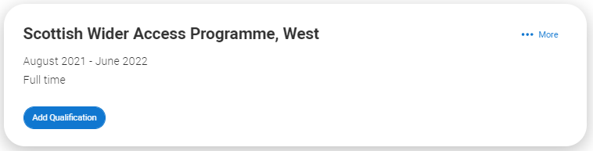

Add Qualification
With your list of units in hand, follow these steps to correctly input your SWAP qualification details:

- Click on ADD QUALIFICATION.

The type of qualification you need to enter is ‘NATIONAL UNITS – SCOTLAND’. You may see that displayed automatically under ‘Qualifications Shortlist’. If not, scroll down and use the ‘search by name’ field to search for ‘National Units-Scotland’. A link will appear below the search box as you type. Click to add it.
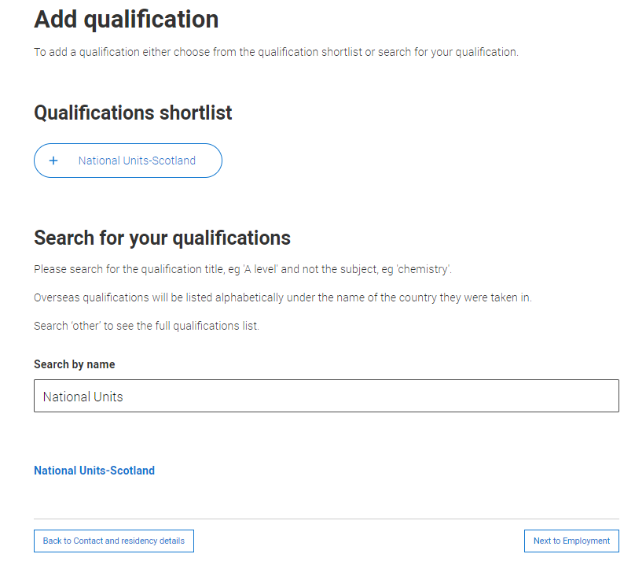

- Click on National Units-Scotland
- In the Add Qualification screen, type in the Title and Unit Code for each, using the list provided by your class tutor. Be consistent in typing the full title followed by the code. For ex: Application of Mathematics – H225 75
- Qualification date will be June of next year.
- Awarding organisation is SQA.
- Level: consult the list given to you by your class tutor.
- Result is PENDING.
- Click SAVE AND ADD ANOTHER to continue adding units until you have entered every unit from your list.
- As you enter units, they will be displayed on the right-hand side of the page. After you finish, carefully compare what you have entered to the list. Make sure you’ve entered every unit correctly before you move on.
Candidate number for Scottish Qualifications (SCN)

After you’ve entered all of your units and saved that section, you may input your Scottish Candidate Number. You can find it on any old SQA certificates you may have from previous study, or you may contact the SQA by telephone on 0345 279 1000 to ask for your number. If you do not have a number or do not wish to include it, you may skip this field (and the same applied to the ULN).

Please state the highest level of qualification you expect to have before you start your course:

Because you are applying to university on the basis of your SWAP qualification, you should select “Below honours degree level qualifications” from the drop-down menu provided.

Triple-check that your units are complete and are listed under the ‘Scottish Wider Access Programme, West’ section, then you may mark the section as complete, save it, and move on to the next part of your application.
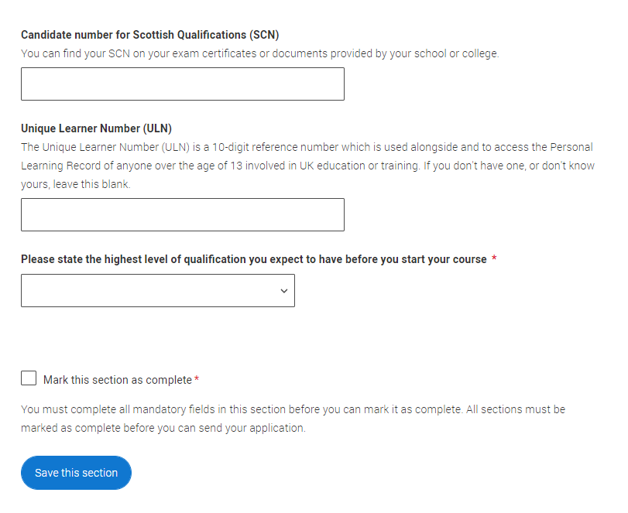

Employment

Follow the prompts to add employers and details of any previous work experience you may have. You are not required to include employment information if it is not relevant to your application or if you have not worked. However, you must mark the section as complete (by ticking the box) and save the section before your application can be considered complete.

Nationality Details

Answer the questions on this page. Note that the prompts may change as you make your selections. Read each question carefully and then mark it as complete, save it, and move on.

Supporting Information

Answer the questions regarding your EU status, as applicable. In response to the question about disabilities, disclose any/all disabilities, impairments or medical conditions that may apply. If you have more than one, you may choose that as an option and then provide further details in the text box below.

NB: Only the university that you eventually choose as your FIRM choice will have access to this information (and they will see it only after you have accepted their offer). At that point, your chosen university will get in touch with you to offer support for making the transition to their institution.

English Language Skills

Read and follow the instructions provided to indicate your level of English language skill. If English is not your first language, you will be offered the chance to input certificate numbers for your proficiency test e.g. TOEFL or IELTS.

Finance and Funding

Read the information provided and then make your selections. In the vast majority of cases, you will select UK, ChI, IoM or EU student finance services. If you’re in doubt, check with your class tutor or SWAP for help.

Under ‘Student support arrangements, select ‘Student AA Scotland’:

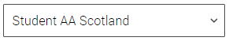

Diversity and Inclusion

This section may take a bit more time to complete.

Choose a response to each of the prompts regarding ethnic origin, religion, etc. Please note that you may opt out of answering some of the questions or you may choose a response such as ‘I prefer not to say’.

Skip the section on ‘Activities in preparation for higher education’.

- Read the Care support information and then answer the question. Please note the FAQ, as it may be useful in helping you decide how to answer. You may be eligible for additional support if you have ever been in care.

- Answer the questions regarding your parents’ education and your own occupational background, if any. If you struggle to find your job title, try inputting the sector e.g. retail or hospitality.

Once you’re finished, mark as complete, save and return to the Hub main page by clicking on ‘Return to application overview’ link in the upper left-hand side of the page.

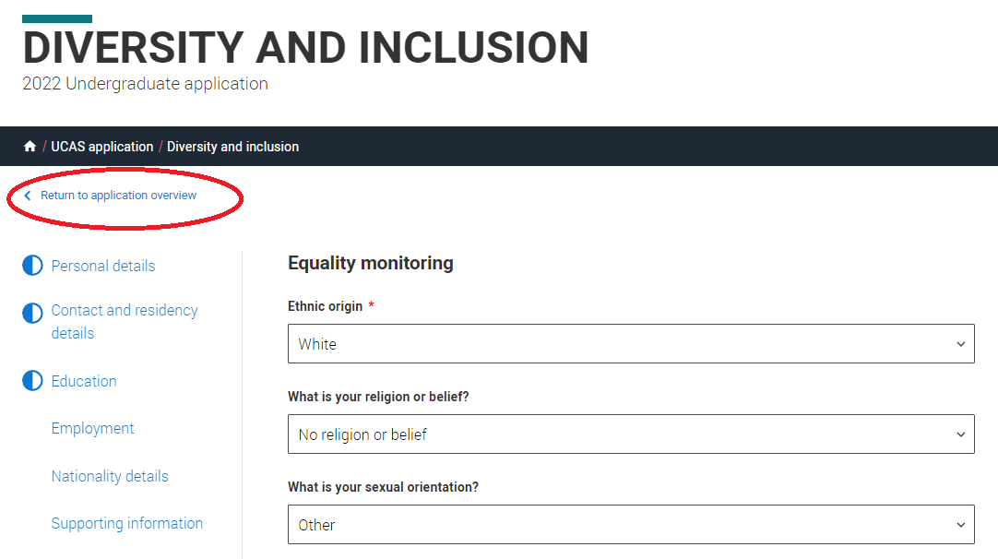
You will then see your Application Status displayed. If you scroll down a bit, you’ll see the section entitled YOUR CHOICES and the button to ‘Add Choice’.

Important information about choices

Your “Choices” are the university courses to which you wish to apply. If you haven’t already done so, download the UCAS Choices Worksheet from Prep for HE to help you gather all of the necessary details before you begin. It never hurts to have an experienced set of eyes to look over your choices, so you should also give a copy of the worksheet to your class tutor before you submit your application, so that s/he can check that you have made sensible choices.


We strongly advise you to apply for more than one partner university. If you do not to use all of your available choices and/or you apply only to one or two universities, you are at greater risk of being in the unfortunate position of having no offers and limited options for progression to university.

Your position re: your choices will depend upon the SWAP Student Agreement you read during induction at the beginning of the year. Refer to your Student Agreement for details. You may access your Student Agreement at any time by revisiting the Prep for HE induction modules.

If you want to apply for more than one course at a particular university you must make a separate entry for each. However, please note that some universities operate a “faculty entry” system whereby the entry requirements are the same for all courses within a faculty, so one choice per university may be sufficient.

In the case of the University of Strathclyde, applicants to Social Science subjects are permitted ONE CHOICE ONLY. Do not apply to more than one Social Science subject at the University of Strathclyde, as all applications will be rejected if you do.

You may enter your courses in any order. They will be arranged alphabetically by default. The fee will be £27.00 for more than one choice.
Research your choices thoroughly and check that you have given the correct course and university codes. If you use the wrong code, your application could be rejected and the decision cannot be reversed. Double-check with your class tutor or the SWAP office if you are unsure.

Add Choices

When you’re ready, click on ‘Add choice’. The form should be completed up to five times (once for each choice). Have the completed UCAS Choices Worksheet handy to help you input the data.

Follow the instructions below:

Search for the name of the university and select it as it comes up.
- Search for the course and select with care from the list that appears. Double-check against the worksheet to be sure you’re inputting the correct choice with the correct course code.
- Choose the Start Date from the drop-down menu.
- Further details: Unless your university has asked you to provide further details in this field, you may skip it.
- Point of entry should be left blank. Read the instructions.
- The question regarding whether you plan to ‘live at home’ is to ascertain whether or not you need information about student accommodation. If you would like to consider moving into student halls of residence, you may select ‘no’. Otherwise, you should select ‘yes’.
- Save
- You may be presented with information about criminal convictions. Read the information provided and tick the box if it applies to you. NB: the box has an asterisk, indicating it is required, but you may save the page without ticking it if you have no criminal convictions to disclose.
Please note that a failure to disclose a conviction (even if the offence was minor or a long time ago) could mean that any offer made by a university may be retracted for non-disclosure. If you have any criminal convictions, read the advice given by UCAS:
https://www.ucas.com/undergraduate/applying-university/criminal-convictions-what-you-need-know
You may also contact your class tutor or SWAP for support, if needed.

After you enter your first choice, you’ll find yourself back on the Hub main page. You can return to the ‘Add Choice’ button and input your second choice, and then repeat the process for up to five choices. Once you’re done and you’ve double-checked it all, you may mark the section as complete.

Your Personal Statement

Your personal statement is your best opportunity to tell the universities and colleges about your motivation, commitment and suitability for your chosen courses. You only get one personal statement, though, which has to apply to all of your choices, so you will need to think carefully about how you phrase things.

Information to help you write your personal statement is available in the Personal Statement section of the UCAS module in Prep for HE. We advise you to complete it before you begin working on your personal statement.

Application Status

After you have completed and ‘marked as complete’ all sections of the application, including your choices and personal statement, your application status will change to reflect your new status and you will be able to progress to the final stage of reviewing and then submitting your application. Click the ‘review and submit’ button to begin.

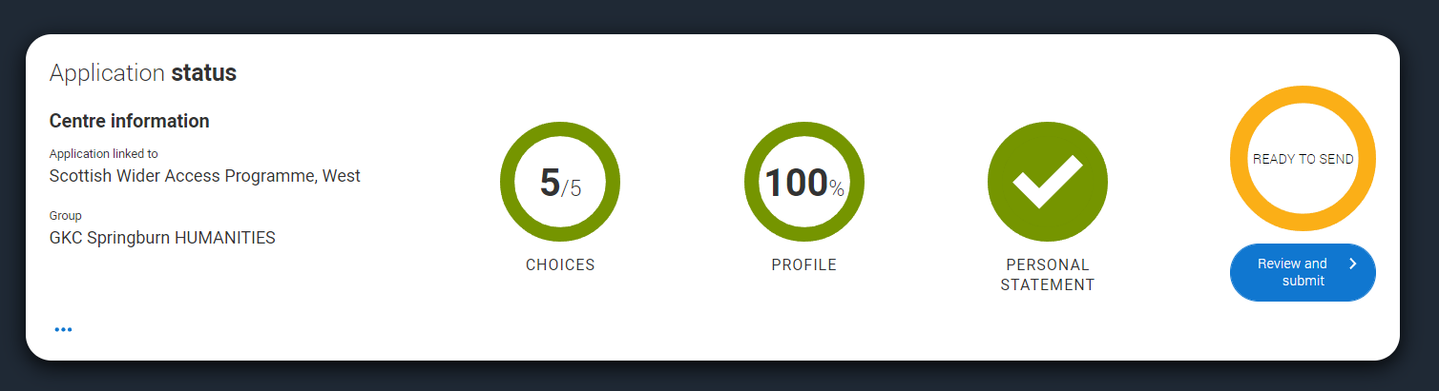

Check Your Application

You will be presented with an overview of your application, all on one page. Carefully check each section and be sure that it is complete and correct. If you need to add or change anything, click the ‘Edit’ link, which you’ll find in the upper right-hand corner of each section. Double-check that your entire personal statement appears as it should and nothing has been cut off at the end. Once you’re satisfied that the application is ready to send, click ‘Accept and proceed’. If you want to return to the main application page, click the ‘Return to application’ link instead

Marketing Preferences

Review the information for each of the marketing options and decide if you wish to opt in or out. Click ‘Accept and proceed’ when you’re done.

Terms and Conditions

It is important that you read the information provided on this page, as it pertains to your future legal contract with any university whose offer you firmly accept. Some of your rights and obligations as an applicant and a student are outlined in this section, so read it carefully and make sure you understand. After you have done so, you can tick the relevant box and then click on ‘Accept and proceed’.

Pay and Submit

The final step you need to take in the process is to pay the amount due and submit your application. However, your application is not formally submitted until the reference has been attached and the application approved by your tutor. You must first pay and submit the form before your referee (usually your class tutor) can attach a reference.

Please note the following:

Your class tutor will provide you with dates that you must strictly adhere to for completion of your application. These dates are normally around the beginning of December. If you miss a college deadline without good cause, your application may be delayed and you may consequently miss the UCAS deadline.

- Keep an eye on your emails, as the college or SWAP may return your application to you for correction if it has not been completed properly. You will then need to make changes and re-send to be checked again. Keep in touch with your tutor.

- On receipt of your application, UCAS will get in touch to confirm they have received it. If you have not have not received acknowledgement from UCAS by the first week of January, please check with your class tutor as a matter of urgency. The hard deadline for UCAS is January 15th and you must not miss it.

What happens after the application is sent away?

Decisions
Universities usually take at least a few weeks (and sometimes several months) to respond, so try to put it out of you mind for a while. Focus on your course work and make sure you pass your units.

Throughout the process, you can login to UCAS to track the progress of your applications online. UCAS may send you further information and advice, which will explain how to respond to offers. Please note: You do not need to make a final decision until you have heard from all of your choices.

If you accept an offer, you are entering into a binding contract with a university, so it’s not a decision to be rushed. Consult with your class tutor for guidance.

Offers
If a university makes an offer, it may be either conditional or unconditional; however, the vast majority of offers made to SWAP students are conditional.

Conditional Offer (C)
This means that the university or college has made you an offer that depends
on certain conditions, usually that you must satisfactorily complete all units of your Access Programme (includes evidence of completion of the Prep for HE unit) and obtain appropriate grades in your profile.

Meeting the conditions
Whatever the conditions, you must meet or exceed them to be eligible to accept the offer. So if, for example, you receive an offer that is conditional upon you passing your SWAP programme and achieving at least ABB on your profile, then that is all you need to do to be eligible to take up your place. Some universities or courses will have higher or lower entry requirements than others, or may set additional conditions e.g. succeeding at interview or achieving a certain grade on your Maths exam at the end of the academic year. Pay close attention to the conditions and speak with your tutor if there’s anything you don’t understand.

Please note:

- The order of profile grades does not matter. For example, if your offer is conditional on achieving ABB in your profile, and your final profile grades are BBA or BAB, you have still met the conditions.

- Profile grades are a minimum. For example, if your offer is conditional on achieving ABB and you achieve AAC on your profile, you will not have met the conditions of your offer, as a ‘C’ grade is below the minimum level for all three grading areas, and the three grades are not ‘averaged’.

Rejection
After reviewing your application, sometimes a university will decide against making you an offer. In that case, you will receive a notification via UCAS that your application has been rejected.

It’s tough to face rejection at any time, but it can be especially difficult if the very first response is a no. If you have followed guidance, then chances are good that you will hold at least a couple of offers by the time the other universities finish reviewing your application, so take heart and speak with your class tutor.

Accepting or replying to offers
After all of your chosen institutions have decided whether or not to offer you a place, UCAS will prompt you to respond to your offers. You must reply to each offer individually, choosing one of the following responses:

- Firm acceptance (F)
- Insurance acceptance (I)
- Decline (D)

Firm acceptance (F)
You can only accept one offer firmly. It is unlikely that any SWAP student will have an unconditional offer; however, if you firmly accept an unconditional offer (UF), you commit yourself to that course. You must turn down all other offers through UCAS and then you won’t deal with UCAS again. Afterwards, you will just be directly in contact with your chosen university or college.

If you firmly accept a conditional offer (CF), you will be guaranteed a place on that course provided you achieve the grades that are needed or also meet any other conditions. If you meet all of the conditions of your ‘Conditional Firm’ offer, you are then committed to the course and you will not be able to go elsewhere.

Insurance acceptance (I)
If you receive two or more offers and you firmly accept a conditional offer, you must also decide whether to accept a second offer as insurance. This is likely to be another conditional offer (CI). If you choose a conditional offer as your insurance, the grades needed for the insurance choice should be lower than the grades needed for your firm choice. That will give you a safer ‘fall-back’ option in case you don’t achieve the grades required for your Firm choice.

Decline (D)
After you have decided on your firm acceptance and insurance acceptance, you must decline (D) all other offers through UCAS. Take your time and make sure you are choosing correctly. If you make a mistake, you have a very brief window of opportunity to get in touch with UCAS to correct it.

Finally

Think carefully before you decide which offers to accept, because once you accept an offer, including an insurance offer; you are committed to that course.

You should feel satisfied that both the course and university are right for you because you will be spending the next several years there. We recommend that, where possible, you attend open days or visits before you make your decision. You can delay your replies to UCAS until after your visits, as long as you reply by the date given by UCAS in their correspondence with you.

If you change your mind after accepting an offer, you may withdraw; however, you will not be able to apply for other courses or go through Clearing in the same year.

If you have any questions about the UCAS application process, making good choices, and/or writing your personal statement that haven’t been covered in the SWAP Prep for HE module, speak with your class tutor in the first instance, or get in touch with the SWAPWest office for support.

SWAPWest
c/o Glasgow Kelvin College
123 Flemington Street
Glasgow G21 4TD
0141 564 7206
Web: www.scottishwideraccess.org
Email: swapwest@scottishwideraccess.org

