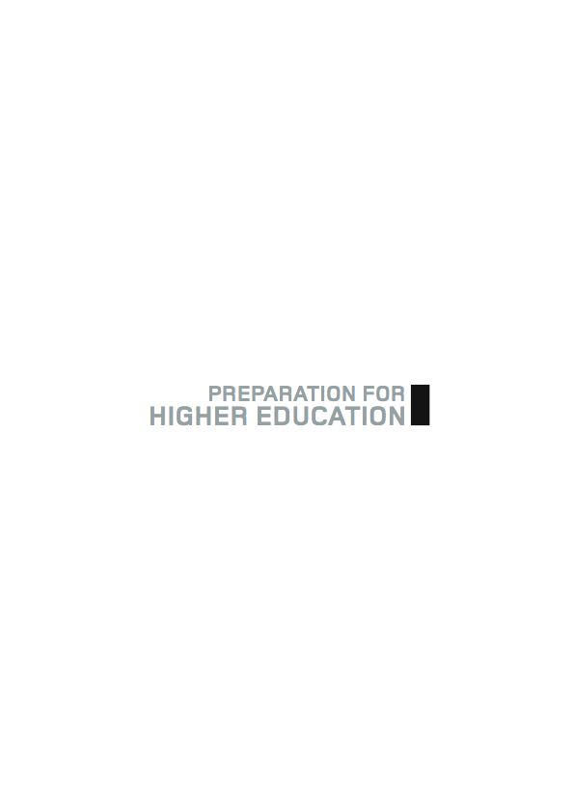

SCOTTISH WIDER ACCESS PROGRAMME (SWAPWEST)

THE PERSONAL STATEMENT
(MEDICAL STUDIES ROUTES)

What is a personal statement?

A personal statement is your opportunity to highlight the qualities you have which will gain you entry to your chosen course at university.

As a SWAP student your life experiences should give you plenty of material to write a positive and engaging statement which will convince the selector that you should have a place.

You still have some time before you complete your SWAP programme so you will need to maximise all your relevant life experiences and link them to your present academic work in college, showing that you have the skills and qualities to stand you in good stead for study in higher education.

You should also think carefully about which of your experiences and achievements will make your application stand out among the many vying for the selectors’ attention.
You are advised to work your way through this booklet and complete all the exercises.

The booklet is an essential part of your SWAP ‘Preparation for Higher Education’. You can work through it on your own, with fellow students or as part of your guidance session with your tutor.

It is most likely you will use a combination of all three.

Where do I start?

The first thing you must do is gather as much information as you can about the degree course on which you’d like to enrol. This may sound simple but many students have a clear idea about the final career they aspire to but do not have enough information about the steps in between. Even though you are set on a medical career, there are still certain steps you must take.

Also, remember that SWAPWest progression is for a place in higher education, not a particular place at a particular institution. The reason for this is very simple – as you go through your SWAP programme you may discover abilities you did not think you had and your choice of route may change. You will be aware by now that places on the medical studies degree are not guaranteed so if, for whatever reason, you do not obtain a place you must have thought through alternatives. You must have a number of back up choices.

For medical students an interview is part of the selection process – a later section of the Preparation for Higher Education will help you with this process. At the moment you have to concentrate on making sure your application is of appropriate quality to let you reach the interview stage.

Have you done the following?:
- Spent some time looking at the websites and reviewing general information about the universities you will apply to.
- Had a detailed look at the information on the faculty.
- Obtained information about the way the course is structured.
- Understood how the assessment system works.
- Thought about all the options open to you.
- Made sure you have a ‘fall back’ position if your first choice turns
out to be unsuccessful.
- Investigated your ‘fall back’ option thoroughly.

Gathering information

Allow sufficient time to prepare your statement. As an Access to Medical Studies student, you will have to submit a UCAS application early in your SWAP programme. It is essential that you are organised.

GATHERING INFORMATION: NOTES

Make a list of all the documents, dates or anything else you need to gather, i.e. dates and details of work experience placements or qualifications gained whilst at work.

Do not rely on your memory for important information – always check your facts, or at least indicate where you have any doubt. Ensure you do this before you start writing even the first draft. There is nothing more annoying than having to break off in the middle to rummage through cupboards for some vital piece of evidence! Even more importantly, it breaks your train of thought.

List of items and important dates

On the following pages there are exercises for you to try.
They are designed to get you thinking about what to include in your personal statement – and what to leave out.

You may want to do the exercises on your own, but working with someone else can be helpful too. Remember to focus on those qualities which will make you stand out as a suitable candidate for Medical Studies.

EXERCISE ONE

Look at the list below. It is not exhaustive but is designed to get you thinking about the various elements you may wish to include in your personal statement or which may support your application. Refer also to the key words and phrases you noted down in the previous exercise.

Mark each item with E = essential, or N = not essential

- evidence of related work experience

- a list of your non-academic achievements

- references from employers

- a brief summary of your core skills

- information about the course you are applying to

- your C.V.

- responsible posts you hold in clubs or societies

- responsible posts you held previously e.g. at school

- evidence of personal strengths e.g. persistence

- examples of any personal difficulties you have overcome

- reasons why you want to enrol on this degree course

- interesting anecdotes about you

- evidence of your maturity

- your longer-term plans

Now compare your answers with those of other students.
Note that there is no definitive list – this is a PERSONAL statement – but on the next page you will find some pointers to help you.

Remember also that you must give examples showing how you can demonstrate your ability / experience of each.

Here are some suggestions for each of the categories above.

1. evidence of related work experience
Any evidence should be recent – you are aiming to show how you have developed and what kind of a person you are now. If you have not had much experience related to medical careers, try to bring out those aspects of your experience which can be transferred. This could include, for example, experience in problem solving.

2. a list of your non-academic achievements
Any such list should refer to recent experiences. The fact that you won the egg-and-spoon race at primary school is not really a good example!
Again you must say how your achievements have helped you develop appropriate skills such as team working.

3. references from employers
These should not be included in any detail except perhaps in the context of point 1 above. The personal statement is primarily an academic statement.

4. a brief summary of your core skills
These can be highlighted in some of the other categories – any core skills you claim have to be substantiated by evidence.

5. information about the course you are applying to
You must find out as much as possible about the course(s) you are applying to. Although several universities may run similar courses, the mode of delivery is not always the same. If a university has a curriculum based on problem solving, for example, it is necessary to demonstrate how you have the skills to cope with this. If the university still uses the traditional lecture format, you need to show how you have the appropriate listening and organisational skills to benefit from this.

6. your C.V.
Your C.V. should always be kept up to date and you should provide a copy to your tutor to help him/her write your reference. This is very important because of the early application required.

7. responsible posts you hold in clubs or societies
These should be referred to in the context of the skills you have. Only put in the most important. If you are a member of a large number of clubs you may have to re-think your priorities if you want to be successful academically. Keep this section short.

8. responsible posts you held previously, e.g. school
These are not important unless you had some outstanding achievement. Where you are now is more important.

9. evidence of personal strengths, e.g. persistence
Note the word here is ‘evidence’. Your mother or your partner believing you would do really well in a medical career is not evidence. Think this one through carefully and if in doubt, incorporate this information into one of the
categories above.

10. examples of any personal difficulties you have overcome
Very important: the saying ‘it’s not the problems you face in life, but the way you deal with them’ is true. If you can demonstrate an ability to cope with difficult situations this will stand you in good stead in the future. You must state clearly why you were not able to take advantage of the opportunities first time around.

11. reasons why you want to enrol on this degree course
You must target the information in this section. Vague aspirations are of no help to the selector.

12. interesting anecdotes about you
Absolutely not – unless they are of relevance to one of the categories above and can be substantiated!

13. evidence of your maturity
As a mature student you have acquired life skills – make use of them and show them off.

14. your longer-term plans
Show that you understand how this degree will help with your longer-term plans.

EXERCISE TWO

There are three blank sections below. Fill in each one with as much information as you can. Do not worry at this stage about being selective – that comes later.

Section One
Why I want to undertake this degree

Notes
- make the introductory sentence short
- try to make your first sentence interesting and personal
- say why you are applying for this course
- show your understanding of the subject
- say why it interests you
- state your career goal

Section Two
My past experiences and how they show my suitability for this degree

Notes
- show evidence of your academic ability
- describe any voluntary work
- highlight appropriate interests
- state relevant work experience
- show the development of your skills in previous employment or study
- include anything which shows you have been able to reflect on and learn from your experience.

Section Three
Other skills/achievements which relate to the profession you want to study

Notes
- write down any responsibilities you hold/have held and how they have helped you
- show evidence of a high level of core skills and how you achieved these
- record any other experiences which have shaped the decision you are now making
- if relevant write down any interesting leisure activities and how they contribute to your development

Once you have completed all three sections, look at the checklist on the next page and delete those items from your lists which are not relevant or add more information if required.

Checklist for Personal Statement

Section One
Is there evidence you can:
- research thoroughly
- be focused
- show commitment to this area
- demonstrate understanding of what is involved
- show knowledge of the subject?

Section Two
Do your statements in this section:
- highlight your maturity and experience
- demonstrate your skills
- show how you can cope with a new environment
- give examples of how you have learned from experience, including voluntary work
- include all relevant work experience?

Section Three
Have you shown the ability in this section to:
- be selective
- highlight recent events
- include any significant responsibilities you have or have recently had
- demonstrate what you have learned in developing core skills?

You should also look back now at your notes from the ‘Gathering Information’ exercises.

The admissions tutor has a limited time to read each applicant’s statement. You must therefore:
- keep to the number of words allowed
- create an interesting opening sentence
- structure your statement carefully
- check and re-check all spelling, grammar and punctuation (don’t rely on the computer spell-check!)
- eliminate unnecessary words
- keep the sentences short: don’t use over-elaborate language.
- ask someone totally unconnected with the course to read it over. If they can understand it then you are on the right lines.
- avoid jargon and clichés.

On this page you will find an example of a personal statement. Read it through and identify both good and bad points. Try to do this as a group/class exercise.

Mock Personal Statement

Read through the following extract from a personal statement and identify
- five points to delete
- five points to retain.

When you have done this try re-writing it in no more than 100 words (remember it is only an extract) and compare your version with the information at the back of the booklet. Again, you should do this as a group or as a class exercise.

Personal Statement (Extract)
As a career, medicine is second to none. The gift of healing the sick is one which everyone admires. I want to be counted among those healers. My previous job was very demanding but although I had financial rewards, I found that at the end of the day I was not satisfied with the way my life was going.

My last project meant that I had to work very long hours with little time for my personal life and although it was completed on time through dedication and my ability to lead a team, I found that there was a certain je ne sais quoi about the whole experience.

I quickly realised that my future did not lie in this direction and spent a lot of time reflecting on possible options. My partner was a great support to me in this and is convinced I will make a great doctor. I realised I needed a challenge – I felt great waves of relief sweep over me as I realised that a challenge would improve my whole life.

I thought back to my time so long ago at school – I was good at science but decided that although I was getting good grades I preferred to get out to work as soon as possible and earn some real money. The company I chose had a good on-the-job training scheme and I chose that company partly because of this on-the-job training scheme. I went on a lot of training courses and managed to get day release eventually and went on to achieve a lot of qualifications which meant that I was promoted very quickly and as a result of all this training I was earning a really good salary for my age, but I found that I had little or no job satisfaction and that all the money did not make up for this.

(314 words)

This statement is not a real one of course! Now try the exercises on this page and the next and compare your version with the notes of guidance at the back of the booklet.

Mock Personal Statement (Extract)

Five points to delete

1.
2.
3.
4
5.

Five points to retain

1.
2.
3.
4.
5.

Other points to note

Revised personal statement in 100 words or less

Your Personal Statement
Look back at all the exercises so far before you begin this section.
If you need information such as dates of previous employment, make sure you have all the information to hand before you start.

You should do at least two drafts of your personal statement. This will be the only opportunity you get to ‘talk’ to the Admissions tutor. Use the first draft process to get all your thoughts on paper and consolidate the notes you’ve made. Don’t be too critical at this point – just get it on the page!

Once you’ve written your first draft you can now edit it, removing unnecessary words or phrases, choosing more appropriate ways of expressing yourself, ensuring that you focus on what really needs to be said.

Your final version will come after at least one more edit.

Leave yourself plenty of time for each of these stages. Don’t forget to go over your work to check for errors of spelling, grammar or punctuation or omitted words.

Remember to keep a copy!

(You may want to look again at the mock personal statement to make sure you have none of the ‘errors’ listed.)

First draft

Second draft

Final Version

Personal Statement Checklist

Finally look back at what you have written and check:

you have written the correct number of words

you have checked and re-checked spelling, punctuation and grammar

you have deleted any unnecessary words or phrases

you have avoided any jargon or clichés

you have focused on essential elements

you have made the most of your experience

you are convincing in your reasoning about your choice of career

you show knowledge of the area you wish to pursue

you highlight anything which makes you stand out as a candidate

you have asked someone external (and with the necessary checking skills) to check it all!

Guidance Notes for Mock Personal Statement

Below are some suggestions for the exercise on Page 11 of the ‘Preparation for Higher Education: Personal Statement’. They are not exhaustive and you may come up with some of your own. The exercise is designed to sharpen your critical faculties when you come to writing your own statement.

Points to delete
1. The first sentence is too general and vague. Start with something about
you. Try to engage the reader.

2. In the second paragraph the writer sounds negative – in a medical career
you will also have long hours!

3. The use of terms such as ‘je ne sais quoi’ is pretentious to say the least!
Keep it simple.

4. A partner’s support may be important but not a reason to study medicine.

5. Lots of repetition in the final paragraph – the bit about ‘job satisfaction’ is a
repeat of what is said at the beginning and yet adds nothing to the
statement.

Points to retain
1. The demands of the previous job and how you coped successfully with this.

2. Your strong interest in medicine as a career and why you think you would
be good

3. Your careful consideration of the options – reflection is an important part of
learning.

4. The identification of undeveloped skills (good at science at school).

5. Your commitment to training and development and your ability to benefit
from this.

Other points to note
1. Always be positive. Show how you can benefit from difficult experience and
cope with problems.
2. Find examples of your ability to work in and/or lead a team.

3. Avoid use of clichés such as ‘great waves of relief . . .’

4. Always ask yourself ‘What does this contribute to the selector’s
understanding of my suitability for this career?’

5. You have been asked to reduce 314 words to 100 – in reality this part
needs to be even shorter. Every word must count.

