

SCOTTISH WIDER ACCESS PROGRAMME (SWAPWEST)

STUDY SKILLS
Memorisation Techniques
Memorisation vs. Learning

If you think back to your school days, you may have formed the impression that learning is mostly about memorising information and being able to recall facts, figures, names and dates for the purpose of passing exams. You may have spent hours attempting to pound information into your brain by sheer volume of repetition and “drilling” yourself with flash cards or similar methods.

Times have changed and it is now generally accepted that rote memorisation is actually one of the poorest and most inefficient ways to learn. True learning happens on a much deeper level, whereas rote memorisation is more superficial and often temporary.

However, there will be times during your university career when you will find it handy to be able to recall a group of facts, a list of terms or a sequence of events. For those times, there are a number of different methods you can use to commit information to memory.


Using Mnemonics and Acronyms

Rhymes

You may have learned this rhyme at school:

‘Thirty days hath September,

April, June and November.

All the rest have thirty-one

Except for February alone,

Which has but twenty-eight days clear

And twenty-nine in each leap year.’

A rhyme is a form of ‘mnemonic’ - a device that can help you recall information by translating into a form that you can more easily recall. In this example, the rhyme helps us to remember which months have 30 days and which have 31 days. You can make up rhymes to help you memorise key bits of information that you will need to recall at a future date.

Music

Think about how you were taught to remember your ABCs. Do you still find yourself occasionally mumbling the tune as you are alphabetising or sorting? For some, music is one of the best ways to remember lists or groups of information. Song lyrics can be much easier to recall than a plain paragraph of text, even if they both contain the same number of words.

Try the example below. This is a piece of text from a document with which you are unlikely to be very familiar: the Constitution of the United States of America. Read it one time and then cover it or hide it from view. On a blank piece of paper, attempt to duplicate the text from memory:

We, the people, in order to form a more perfect union, establish justice and ensure domestic tranquillity, provide for the common defense, promote the general welfare and secure the blessings of liberty to ourselves and our posterity do ordain and establish this Constitution for the United States of America.

How much did you recall?


Now try watching approximately 45 seconds of a video featuring the same words set to music. Listen to it one time and then attempt to jot down the lyrics that you remember. NB: If you are viewing this document on your internet-enabled computer, hold down the CTRL key and click the link. Otherwise, copy and paste the link into your browser.

http://youtu.be/30OyU4O80i4?t=45s

Did you recall a bit more of the text this time? If so, you may benefit by using music to help you memorise key pieces of information that you may need for university course work and exams.

A more familiar tune may work better for you, so try it out next time you’re faced with data that you want to commit to memory. Old nursery songs like “Twinkle, Twinkle Little Star” or “Incy Wincy Spider” may be just the thing to help you through your next exam.

NB: In our exercise, you were asked to read or listen to the words only one time; in practice, however, repetition will help you remember more. For most people, it takes around twelve repetitions to commit information to memory.

Acronyms

Another mnemonic device is the acronym: a word made from the initial letters of other words. For example, if you needed to remember a list of the healthiest fruits, like the one below, you could rearrange them so that their initial letters make a new word or more memorable sequence:

Apples  Raspberries  Pears =  Grapefruits  Apricots  Plums | Grapefruits  Raspberries  Apples =  Pears  Plums  Apricots | ‘GRAPPA’ is a type of Italian liqueur, but even if you didn’t know that, the word ‘grappa’ is easier to recall than the entire list, and the letters in the word ‘grappa’ can prompt your memory when it’s time to recall the items on the list. Try it in the exercise below:
Exercise:

Cover the list of fruits above with your hand or a piece of paper, and see if you can recall the items on the list from memory, thinking of the acronym ‘grappa.’ Write the list below:

______________________________

______________________________

______________________________

______________________________

______________________________

______________________________

How did you do?

If you find it much easier to recall items on a list by using acronyms, you’re not alone. This method is very popular because it is effective for most people. Some words in common usage started out as acronyms. For example, the word ‘laser’ is an acronym for the original moniker: ‘Light Amplification by Stimulated Emission of Radiation’. The word ‘scuba’ is actually an acronym for ‘Self-Contained Underwater Breathing Apparatus!’

Silly sentences

A student who always found it difficult to spell the word ‘psychology’ decided to make up a silly sentence to help her recall the correct spelling. Now, every time she writes the word, she mutters, “Please say you’ll come home...” and adds ‘ology’ to the end of it. P-s-y-c-h-ology. Easy!

You can do the same with words you find difficult to spell or with other lists that you want to be able to recall later. For example, if you need to begin memorising the Periodic Table of the Elements (which is quite a task) you can make up a silly sentence to help you remember the names of the elements, as well as the order in which they appear. Try it with the first ten elements:

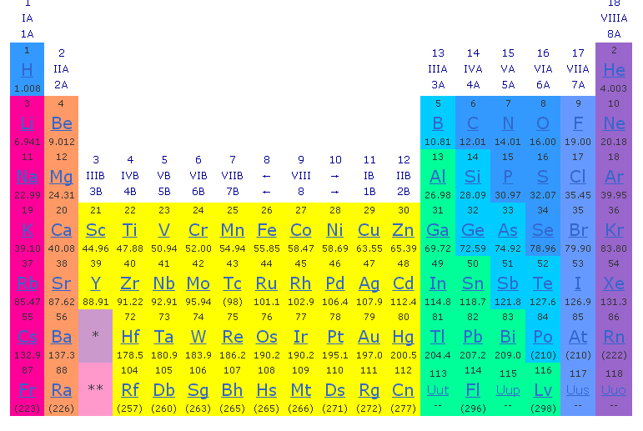
Element | Abbreviation | Words that form a silly sentence
Hydrogen | H
Helium | He
Lithium | Li
Beryllium | Be
Boron | B
Carbon | C
Nitrogen | N
Oxygen | O
Fluorine | F
Neon | Ne
Did you create a sentence that helps you recall the first ten elements? For example, read this sentence:

Ha! He Lies to Beryl, Borrowing her Car Nightly, Often Feeling Nervous.

Can you use that sentence to help you recall the first ten elements without looking at the previous page? You probably will find it easier to use this method if you create your own sentence. Fill in the table below with your own silly sentence and then list the elements without looking at the previous page:

Element | Abbreviation | Silly sentence
 | H
 | He
 | Li
 | Be
 | B
 | C
 | N
 | O
 | F
 | Ne

Did you find it easier than you initially imagined it would be to remember the first ten elements of the Periodic Table? If so, consider using this method to help you recall information for your course. See below for another exercise

Exercise:

Imagine that you are a science student and you need to recall the groupings (taxonomy) of biological organisms: Kingdom, Phylum, Class, Order, Family, Genus and Species. Make up a silly sentence below to help you remember this list and take a few minutes to commit the list to memory, using the sentence as a prompt:

_____________________________________________________________

_____________________________________________________________

Now, think of the silly sentence you just created and list the taxonomy of biological organisms below:

______________________________

______________________________

______________________________

______________________________

______________________________

______________________________

______________________________


How we store information:

The human brain is not like a neat and tidy little file drawer, with everything alphabetised and clearly labelled; it is made up of billions and billions of neurons that are connected together in a vast network that is not unlike a spider’s web in structure.

However, when it comes to memorisation, we tend to try to organise information in a linear style, by making lists and repeatedly reviewing them in an effort to wear a lasting groove in the mind. If you think about it, it makes more sense to commit things to memory in a way that mirrors the structure of the brain. Web-like connections make it easier to recall facts and ideas, so that less rote memorisation is required. In addition, forming new connections in the mind will make those ideas easier to understand, facilitating true learning of the subject matter.

On the following pages, you will find some suggestions for strategies and techniques you can try to help you recall information more effectively.

Use a Simile

A simile is an expression that compares two things. Similes often start with the words, “It is like...”.

For example, when describing a society in which all outsiders eventually assimilate into one social group, you might say, “That society is like a soup or a melting pot.” However, to describe a society where different cultural groups do not blend together but retain their unique attributes, you would need a different simile. Perhaps you would say, “That society is like a salad bowl.” Later on, when you need to recall the features of the two different societies, the images of a bowl of soup and a bowl of salad would come to mind.

Try connecting ideas together by relating them to something you already understand. By relating an abstract or complex idea to a simpler image or commonplace example, you create a new connection in your mental network that will make that abstract or complicated idea easier to recall.

Use Visualisation

You can make abstract or complicated ideas more concrete in your mind by imagining them in a visual format. That is, you can commit information to memory by imagining the information being represented by distinct objects. Try the exercise below with a classmate:

Exercise

Find a partner to work with for this exercise. Tell your partner that s/he needs to remember the following numerical sequence without taking notes: 29325101214 . Read the numbers out only once and then ask your partner to repeat them back to you. How did s/he do?

Now, read out the following “story” and ask your partner to visualise these events happening:

“You have just arrived at the door of No. 29 Main Street. You press the buzzer for flat number 3; the door opens and you climb up some stairs, counting 25 steps as you go. At the top of the stairs is David Cameron, the Prime Minister of the United Kingdom, who lives at No. 10 Downing Street. What is he doing here? He has come to bring you 12 red roses. You take the roses and ask him what they are for. He tells you they are a gift for Valentine’s Day, as today is the 14th of February.”

Now ask your classmate to recall the numerical sequence again. You may find that s/he is better able to recall the numbers correctly by associating them with imagined objects (the door, the buzzer, the steps, David Cameron, the roses, the holiday date).

Teach Your Toy

Another very good way to commit information to memory or to test your understanding of information you have been studying is to try to teach it to someone else. Of course, not everyone will have a partner, parent, child or friend available at all times to listen patiently to a “lesson” but it doesn’t matter. Your “student” can be a cuddly toy, a coffee cup -- or thin air.

A variation on this strategy is to imagine that you’re teaching your subject to an intelligent but uninformed child. If you had to explain your subject to a ten-year-old, how would you do it? This exercise forces you to simplify and to think of concrete examples to explain complicated or abstract ideas. It can also help you identify gaps in your knowledge if you find that you’re faltering at certain points of your “lesson.”

Teach Each Other

Most attempts at memorisation are made in solitude, while you are alone at the library or at home with your books and your notes. However, you can make the process more interesting and more effective by getting together with a few classmates for a brainstorming session. You don’t need to have every fact in front of you; in fact, it’s probably better if you simply start with what you already know and understand well. As each member of the group follows suit, your collective knowledge and understanding of the subject will grow because each of you will have picked up different key points and ideas from lectures, seminars and independent study. By working together, you all get the benefit of several brains forming connections on the same topic. This kind of brainstorming can help you learn faster and pick up on gaps in your knowledge. It can also help with recall, as you may find it easier to remember your classmate explaining and giving examples than you would to recall the same information if you read it in a book.

Group Exercise:

Form small groups with some of your classmates, with the aim of reviewing a specific lesson or topic you have already covered together in one of your classes.

Take turns explaining your own current understanding of the subject to each other. You may wish to use a whiteboard and markers (or pen and paper) to compile your collective understanding in one place.

If you find that several members of the group are struggling with the same concept, ask your tutor for more information, additional reading or exercises that can help you all learn what you need to know.

Memorisation Techniques

As you make the transition to Higher Education, keep in mind that you are still a student, not an expert. Part of the student experience involves practicing new techniques, cultivating new habits and developing new skills. Some things that work very well for you might not work so well for someone else, and vice versa.

Now is the perfect time to try out various techniques for studying, learning and memorising information. Use the techniques that work well for you, and discard the rest. In time, you’ll develop a set of study habits and effective learning skills that suit you best.

