

SCOTTISH WIDER ACCESS PROGRAMME (SWAPWEST)

STUDY SKILLS
Critical Thinking Skills
Critical Thinking

This Preparation for Higher Education session is about...arguing! Well, it aims to help you develop critical thinking skills to help you formulate good arguments. Have you encountered the phrase ‘critical thinking’ before now?

Critical thinking is relevant to all aspects of learning at university level and you must show evidence of critical thinking in your coursework and exams. It can be used in a wide range of subjects from identifying different points of view to problem-solving and reasoning. Demonstration of critical thinking in coursework may make the difference between an ‘A’ and a ‘B’ grade, and it could boost the final classification of your honours degree. This section aims to help you improve your critical thinking skills.

So who in your SWAP class is particularly good at arguing? _______________

List below some of the main skills or characteristics that you think would make someone good in an argument, debate or discussion:

___________________________________________________________________

___________________________________________________________________

___________________________________________________________________

Some skills/characteristics are listed below, but you may not agree with all of them:

- Thinking on your feet - Giving everyone a chance to speak
- Being clever - Listening carefully
- Speaking loudly - Communicating clearly
- Writing detailed notes - Distracting your opponent
- Making people laugh - Being assertive
- Being quick-witted - Not criticising your opponent
- Being focussed - Having a lot of knowledge about the subject
- Being creative - Spotting a weakness in someone else’s argument
- Paying attention - Considering different perspectives
- Speaking softly - Spotting a weakness in your own argument
- Ignoring distractions - Keeping your opponent on the defensive
- Staying calm - Identifying a good argument

Everyone’s list or summary of what makes a person good in an argument or debate is likely to be different; compare your opinion to your classmates’ opinions. As you can see from our list, there are many useful skills that could be cultivated over time. However, you could say that doing well in a debate has three basic parts:

- Thinking up the argument in the first place
- Ensuring your arguments are good ones
- Communicating your points effectively


Brainstorming icebreaker – 101 uses for a paperclip

Our brains can sometimes take a while to create a good point in a debate. We have all left a discussion thinking, ‘I wish I had said this or that’. This exercise might help you with thinking up your arguments by using creative brainstorming.

- First, take one minute (only one minute!) to write down as many uses as you can think of for an ordinary paper clip. Be strict with the time you allow for this, and see how many uses you can come up with.
- Next, write down the following list of objects and think of a use for a paperclip related to this object: map, book, light bulb, computer, radio, tyre, cat and ear. Give yourself only one minute to write down your ideas.
- After doing this exercise, you should see that you can probably think of a use for a paper clip in relation to any object, however bizarre, and could probably think up countless uses for a paper clip. This quick-fire generation of ideas is often referred to as brainstorming.

Brainstorming is a technique that is useful for problem solving and developing new ideas and theories. For example, NASA may have a team of scientists whose job it is to brainstorm what could be done to prevent a meteor that is on a collision course with Earth from colliding with our planet. The best solution to the problem may at first seem bizarre or outrageous. What would you suggest?

The philosophy behind brainstorming is that you should consider any ideas that enter your mind, as they may actually lead somewhere.

If you try to inhibit “absurd” ideas you may also inhibit good ones, or break a train of thought. Sometimes, outrageous breakthrough ideas are required to solve problems and evolve subject areas. Once you write all your ideas down, you can find the good ideas and discard the not-so-good ones. You may, of course, think twice before sharing your bizarre ideas with others until you have developed them into a more palatable form!

Introducing critical thinking

At university, developing good arguments is of huge importance because you will have to put forward your points verbally (in seminar discussions and presentations) and in writing (in exams and essays and reports).

Critical thinking is an important skill to master as a student because it can help you to appreciate the difference between assumptions and evidence and fact (i.e. results discovered through enquiry and research).

Can you think of a situation from the past or present where assumptions were made instead of looking for evidence? Note your suggestion below along with any consequences of the assumptions that were made:

Assumption:

Consequences:

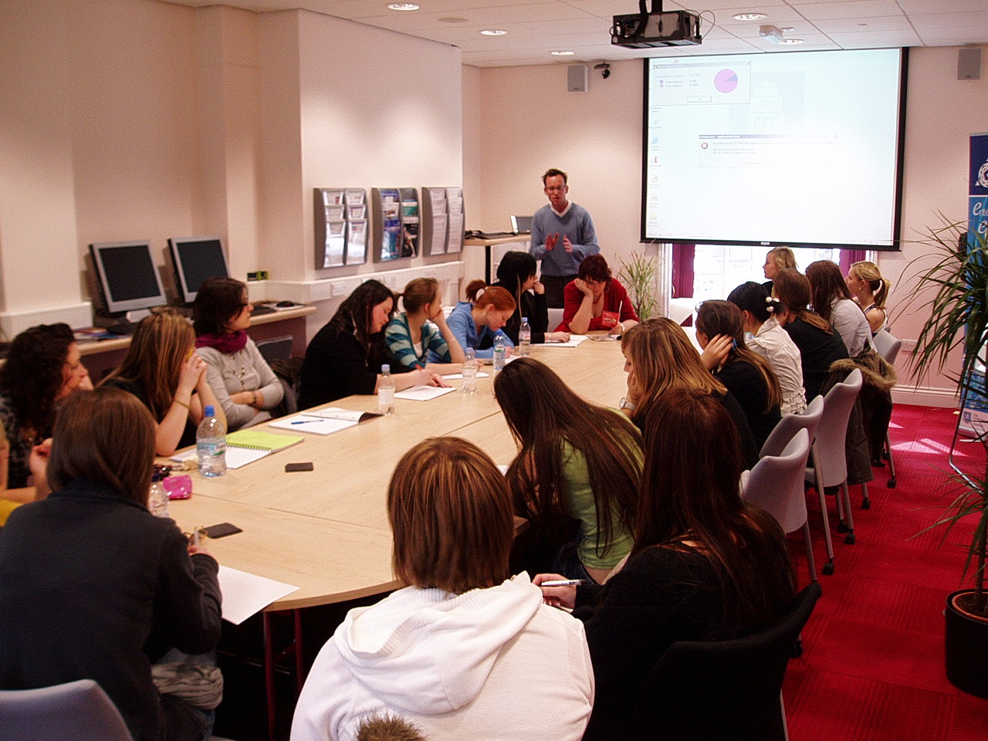
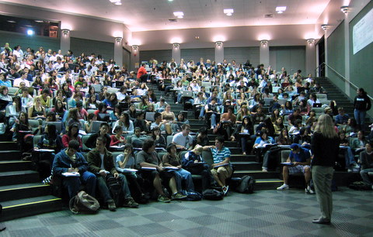
Critical thinking in seminars at university:

a university seminar a (very large) lecture

Critical thinking in seminars:

Seminars differ from lectures as they are small group discussions (with around 10-20 students), based on an academic text, lecture or a pre-set question, and usually lasting an hour. A tutor will be present during seminars, although their role is to facilitate the discussion, rather than to teach. Your performance in seminars will be assessed by the tutor and all members of the seminar group are expected to contribute to the discussion. Assessments are based on evidence of preparation, contribution to the discussion and the strength of your arguments. You must demonstrate excellent critical thinking skills in your points to achieve good grades.
Critical thinking in essays and exams:

Essays will be a large part of your coursework at university because they are useful in allowing you to demonstrate your knowledge and understanding of a subject to your lecturers. You will be set a question and you will have to research the subject by finding relevant books and academic articles to use as evidence. You will then write a concise response to the question, using the evidence you have gathered (e.g. information from books, articles, etc.) to support your answer.

In exams you will also be set a question that you have to answer in writing, although you will have to use the knowledge accrued in your memory to formulate your answer.

If you show that you have critically examined the subjects in your essays and exams, it will contribute towards achieving good grades.

Critical Thinking Exercises:

Besides helping us to appreciate the difference between assumptions and evidence and fact; critical thinking also helps us to analyse a subject from different viewpoints and scrutinise our own opinions.

Critical thinking is a valuable skill to possess in life as well as at university as it allows you to make intelligent, informed decisions and conclusions without prejudice. (e.g. We all know that we can’t believe everything that we read in the papers, but critical thinking skills help us to identify exactly what is “wrong” with what we see, hear or read.)

A short exercise - analyse the following questions:
- Who were the bad guys: the cowboys or the Indians?
- Why was it acceptable to burn witches at the stake in the 1600s?
- Is wind power a good idea for Scotland?

You can briefly think about one or more of these points on your own, or discuss in a group. Note down some of the points you come up with and where you might find evidence or facts to support your arguments.

Notes:

Critical thinking and Irn-Bru
We can use Irn-Bru and Irn-Bru advertising to demonstrate critical thinking.

Who in the group drinks Irn-Bru? What are the good things about Irn-Bru and what are the bad things? Use the table below to generate arguments.

Five positive points about Irn-Bru | Five negative points about Irn-Bru

Taking things further, ask yourself or discuss in your group, what does the name Irn-Bru suggest and what are the advertising companies trying to accomplish with their advertising campaigns? Write down your thoughts and discuss with your classmates. You may start to see things from different perspectives when you use critical thinking.

Finally, ask yourselves the question: should Irn-Bru (and other fizzy drinks) be banned in schools? Mark your position on the decision line and also ask yourself where you can find evidence to support some of your points.

Should Irn-Bru (and other fizzy drinks) be banned in schools?

Strongly FOR ban Sit on the fence Strongly AGAINST ban

Where would you be able to find evidence to support your points? Write your suggestions on the next page:

Example 1: ___________________________________________________________
Example 2: ___________________________________________________________
Example 3: ___________________________________________________________
Example 4: ___________________________________________________________
Example 5: ___________________________________________________________

Decision line – Laika the Space Dog

See also the fact sheet about Laika which is accessible from this page:
http://www.glasgowsciencecentre.org/online/science-in-society.html

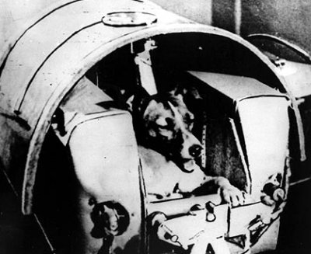
Laika in her capsule Laika commemorated

Laika was the first animal in space. She was a stray dog who was trained and sent into space by Russian scientists in 1957 to assess the effects of space travel on animals, and potentially humans. It is believed that she survived as she orbited the Earth and was euthanased before her oxygen supply ran out. There were, however, claims that Laika died only hours after being launched due to overheating. The experiment proved that a living passenger could survive being launched into orbit. In 2008, Russian officials unveiled a monument of Laika standing on top of a rocket, which now stands outside the research institute in Moscow where her space mission was devised and developed.
Discussion:

In pairs, briefly discuss whether or not you think that this type of research (using animals) is necessary. Consider the following questions, for example:

- Should this experiment have been done?
- How important is space travel/exploration?
- How important are the rights of the animal?
- Is it worth losing the life of a dog for the advancement of science and the human race?
- Is this different to killing animals for meat?
- Do we need to make certain sacrifices for the advancement of science and the human race?

The decision line:

Now talk to your other class members to find out what their opinions are and form a decision line based on whether you agree or disagree that this type of experiment should be done. Inform the group why you placed yourself on the decision line where you did.

Should this type of research on animals, for the advancement of science, take place?

Strongly FOR Sit on the fence Strongly AGAINST

Critical thinking is exactly what the class as a whole have demonstrated in forming the decision line and being able to explain your reasons for taking the positions you did. This should be going on in your own head when formulating arguments at university.

Be critical of your own argument:

When you have identified the arguments in a problem that you have been given and found sufficient supporting material in books, journals and website articles to back it up, it important that you view even this information critically. Try to think of your argument from the position of an opponent – someone who disagrees with you and is seeking to find flaws in your reasoning or evidence – and address those weaknesses yourself. By doing so, you will show a more thorough understanding of the issues than if you had ignored the flaws or weaknesses in your material.
Supporting Evidence

When you are asked to write a report or essay, you will need to find some sources of information to help provide background information and supporting evidence. Ask yourself where you could find high-quality evidence to back up your arguments.

Remember: some sources of information are more credible and reliable than others. It is your job as a student to think critically about your sources and decide which to use and which to discard.

The table below lists some sources that could be used as references in academic writing. Rate them in terms of how reliable the information contained in them is.

Table 1: rate these sources in terms of their reliability
(Google or discuss with your tutor any terms you have not come across before)

Source | Reliability
Source | Very poor | Poor | Average | Good | Very good
Tabloid newspaper
Broadsheet newspaper
Textbook in library
Wikipedia
Journal article
Government article
BBC news online
PhD thesis
Independent web page
Conference paper
Educational publication
Official organisation webpage (e.g. NHS)
Sources of information:
- Your own textbooks
- Library textbooks and library e-resources
- Journal papers
- Internet searches (Google ‘Scholar’ can be useful: http://scholar.google.co.uk/)
- Educational searches (e.g. Intute and Athens)

Choosing your sources:

When you find supporting reading material, think about what the author’s arguments are and the reasons behind them. Is there sufficient evidence to back them up and has the author made any assumptions? What are the alternative points of view to those ideas presented? What conclusion does the author come to and what reasoning does the author use to support this conclusion?

When looking at different sources of information, it is useful to work through each source using a work sheet like this one below. You could try reading an article on a chosen topic and completing a worksheet like this one to assess the credibility of their arguments.
Title:

Author:

Source:

Date published:

Author’s argument/theory:

Reasons for their argument/theory:

What evidence does the author present, it is reliable?:

List any assumptions made and challenge them:

Alternatives:

Critical thinking checklist:

If you are thinking critically, you should be able to:

- State and defend your position
- Provide evidence to support your argument(s)
- Identify multiple viewpoints and show openness to a variety of perspectives
- Assume an opposing position from your own argument and argue objectively and non-defensively from the opposite side
- Present arguments for two or more points of view simultaneously and remain clear in your reasoning in the midst of complexity

Critical thinking also involves:

- Close attention to detail
- An ability to stand back from situations and ask questions
- Weighing up pros and cons
- An ability to form conclusions based on the evidence collected, even if they do not coincide with our pre-existing beliefs

Appendix 1: Interesting experiments on our ability to think independently and critically

The following experiments are well known psychological experiments that assess (i) group pressure on an individual’s opinion and (ii) the effect of an authority figure on obedience when individuals are asked to perform unethical acts.

(i) Asch conformity experiment, from Higher Human Biology, Torrance (2002)

This experiment was carried out to observe the effect of a majority’s opinion on an individual’s opinion, when the majority’s opinion is false. This is commonly referred to as group pressure. Eight people were asked to solve a visual judgement experiment as shown below. However, unknown to the eighth member, the other seven were told in advance to give answer C, the wrong answer. The eighth member could either disagree with the majority or doubt their own judgement enough to conform to group opinion. The experiment was carried out on many subjects and repeated several times with each subject for accuracy.

The experiment: Which line (A, B or C) is equal to line X in length?

The results of the experiment were: 28% held onto their individual, correct opinion during every trial, 45% varied in their responses and 27% gave in to the majority every time. When alone, only one person ever gave the wrong answer.

Important points that emerged from discussion were that many of those who agreed with the majority did so as they genuinely believed that their judgement was wrong (not to end confusion/discomfort and conform). They rather thought that there was something wrong with their eyesight or were experiencing an optical illusion.

The process of a group exerting strong influence on individuals (so they abandon their own view and ideas) is called group pressure. Possibility of this happening with susceptible individuals is increased when the matter in question is an opinion or belief. Critical thinking can help you to ensure your judgement is more reliable and withstand group pressure.
(ii) Milgram experiments

The Milgram experiments on obedience to authority figures were of psychological investigations carried out by Stanley Milgram in1960s. The experiments assessed the willingness of individuals to obey authority when instructed to perform unethical acts. The experiment hoped to explain why Nazi officers could commit mass atrocities in World War II.

In the experiments, volunteer ‘teachers’ were given orders to give electric shocks (of increasing intensity) to learners when they answered questions wrongly. What the teachers didn’t know was that the learners were actors and were not receiving any electric shocks.
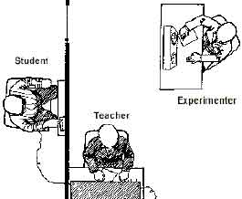 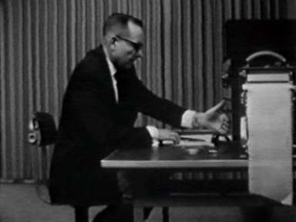The Milgram experiment

In the first experiments, 65 % (26 of 40) of the ‘teachers’ applied the final 450 volt shock, although many were very unwilling.

Milgram's testing indicated that the participants followed the orders of the authority figure, despite their ethical beliefs. The experiments were trialled in many countries, and although the percentages were similar within societies, there were significant variations in different countries worldwide.

The Milgram experiments are considered by some scientists to be unethical and harmful because they may cause psychological damage and cause people to be less trusting in the future. This resulted in more thorough ethical reviews for experiments where human subjects were involved.

Appendix 2: Videos

You can further develop your critical thinking skills by watching the following videos at the links provided.

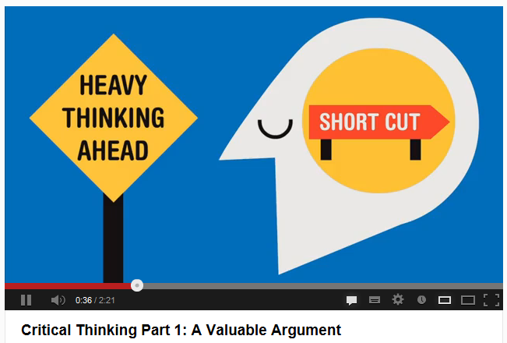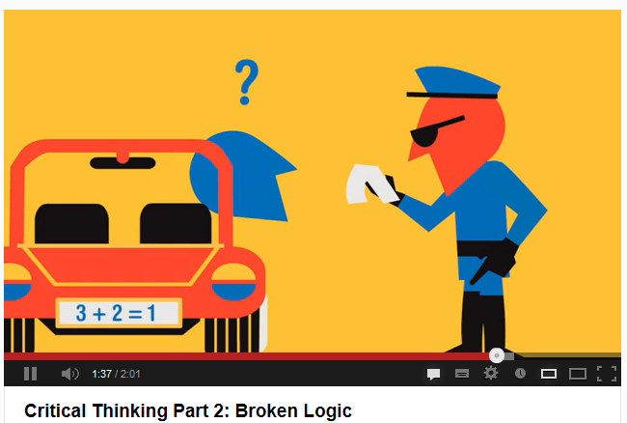

Critical Thinking Part 1: A Valuable Argument: http://www.youtube.com/watch?v=iSZ3BUru59A

Critical Thinking Part 2: Broken Logic: http://www.youtube.com/watch?NR=1&v=VRZk62QNOsM&feature=endscreen

Critical Thinking Part 3: The Man Who Was Made of Straw: http://www.youtube.com/watch?v=kgdDK4XMpm0&feature=relmfu

Critical Thinking Part 4: Getting Personal
http://www.youtube.com/watch?v=W_veZ24nC3g&feature=youtu.be

Full transcripts can be found here: http://technyou.edu.au/fun-stuff/videos/video-transcripts/

