

SCOTTISH WIDER ACCESS PROGRAMME (SWAPWEST)

Study Skills Supplement - Access to Nursing

Anatomy Quiz

Human Body Fact Sheet

Use the information that you will find on the web site "A Look Inside the Human Body" (http://warriors.warren.k12.il.us/dburke/bodyindex.htm) to complete the following questions.

You can also find this site (and many other useful sites) listed on the Guide to Nursing Websites found at http://moodle.gla.ac.uk
- Click on Services
- Then click on Recruitment & International Office
- Click on SWAP then Guide to Nursing websites.
- You can log in as a guest. Simply accept the site policy and ‘continue’.
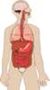 | 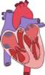 | 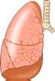 | 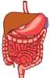 | 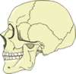
1. What are the four major systems of the human body?

_______________________ ______________________
_______________________ ______________________
Skeletal System
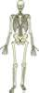
2. What are the 3 major jobs that our skeleton does?
_____________________________________________________________
______________________________________________________________
3. How many bones does a newborn baby have?
____________________
4. How many bones does an adult have?
_____________________
5. Why does a baby have more bones than an adult?

_______________________________________________________
6. Label the unlabelled bones in this skeleton:
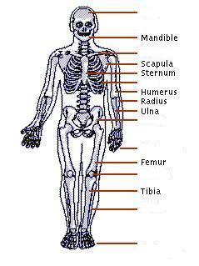

Respiratory System

7. What does the body take in when we breathe?
_______________________________________________________

8. What are the small air balloons in our lungs called?
_______________________________________________________

9. What colour do blood cells turn when they pick up oxygen from the alveoli?
_______________________________________________________

10. What is the name of the muscle that controls the breathing process?
_______________________________________________________

11. What is the highest recorded "sneeze speed"?
_______________________________________________________

12. Label this picture of the Respiratory System.
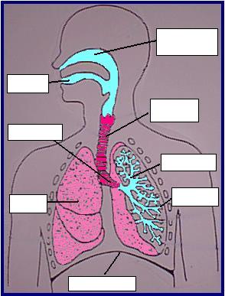
13. Label this picture of an alveolus.
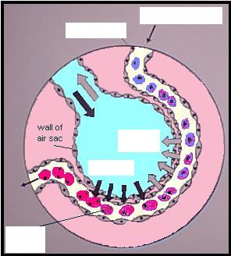
Circulatory System
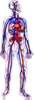

14. Where is the heart positioned?
_______________________________________________________

15. Complete these sentences:
- Blood that is rich in oxygen appears __________________
- Blood that is poor in oxygen appears _________________
- Blood leaving the heart travels in ___________________
- Blood returning to the heart travels in _________________

16. How many blood cells are contained in a droplet of blood?
_______________________________________________________

17. How long do blood cells live?
_______________________________________________________

Digestive System
18. How long is our digestive system?
_______________________________________________________

19. What mixes with the food when it is in the stomach?
_______________________________________________________

20. From the small intestine, food is broken down and goes either into the ___________________ or into the ____________________ ____________________.
21. How much saliva is produced by the body each day?
_______________________________________________________

22. Label this picture of the Digestive System.

