

SCOTTISH WIDER ACCESS PROGRAMME (SWAPWEST)

Study Skills Supplement - Access to Nursing

Case Studies

Time Management

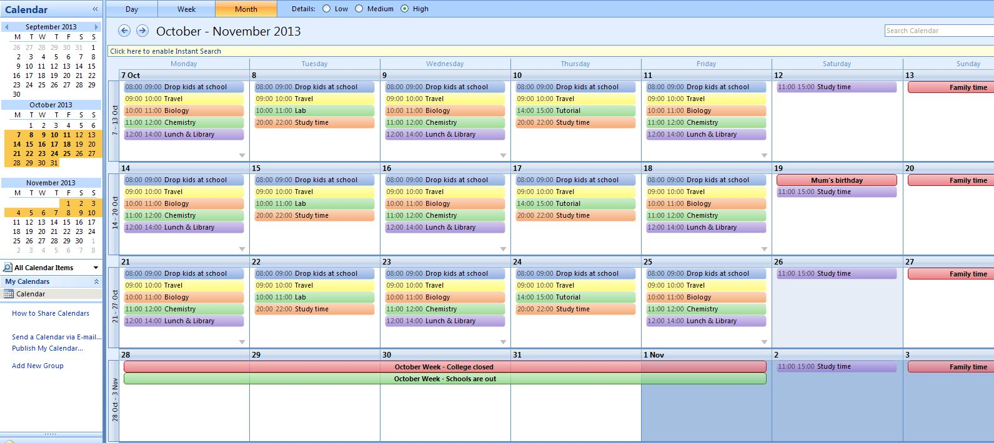
Brian enjoyed his SWAP programme. He found that he was able to keep up with the workload and retain his part-time job without too much difficulty. However, things have changed since he has move on to university. The heavy workload has surprised him and he recently stayed up all night to finish an essay, went to classes at university and then straight on to a night-shift. He was exhausted. He foresees similar times ahead as the deadlines for several pieces of work are approaching.

He has free time during the day but can’t find anywhere suitable and quiet to work on campus. He doesn’t have a laptop. When he does find somewhere to work he spends time responding to emails, all of them important to him: emails about access arrangements for his son, a long-running dispute with a phone operator and from his partner who is facing redundancy at work.

He is tempted to quit his nursing course because he feels he’s taken on too much. On weekends either his son comes to stay or he works extra shifts. His partner is beginning to complain. What can he do?

Nursing Placement



Debbie is in her first year of her nursing diploma. She’s always wanted to be a nurse and now that her two children are both in primary school she feels that the time is right to return to study. She’s a single parent and her mum and sister live close by. She doesn’t have a car.

Debbie loved her Access to Nursing programme where she made some good friends and felt prepared for university study. Her confidence in her academic ability increased. However, she feels she’s had to go it alone. Her mum and sister don’t think this is the right time for her to be studying and have made some ‘comments’ when she’s asked them to look after her kids (although they did help out in the end).

She’s just been given details of her second nursing placement. The first was at a local hospital and 9-5, but this one is two bus rides away and starts at 7 a.m. Her tutors have told her that placements are non-negotiable. She doesn’t know how she can get herself to placement and her kids to school at the same time and is starting to think her mum and sister might be right – perhaps this isn’t the right time in her life to be studying? What should she do?

Study Difficulties



Lynne has always wanted to be a nurse. She worked as an auxiliary in a hospital for several years before some of the nurses on her ward said she would make a good nurse and encouraged her to train. They told her about SWAP.

She enjoyed her SWAP programme but felt she struggled a bit. She was diagnosed as having dyslexia and although college staff gave her lots of support she felt that assignments always took her that bit longer and she always had to work a bit harder than everyone else to keep up.

She recently got a low mark for an assignment and it has knocked her confidence, which was low already. She’s not sure what she should do and imagines that things are only going to get worse. Will they? What should Lynne do?

Nursing Times Student Nurse Blog
Michelle Rowan
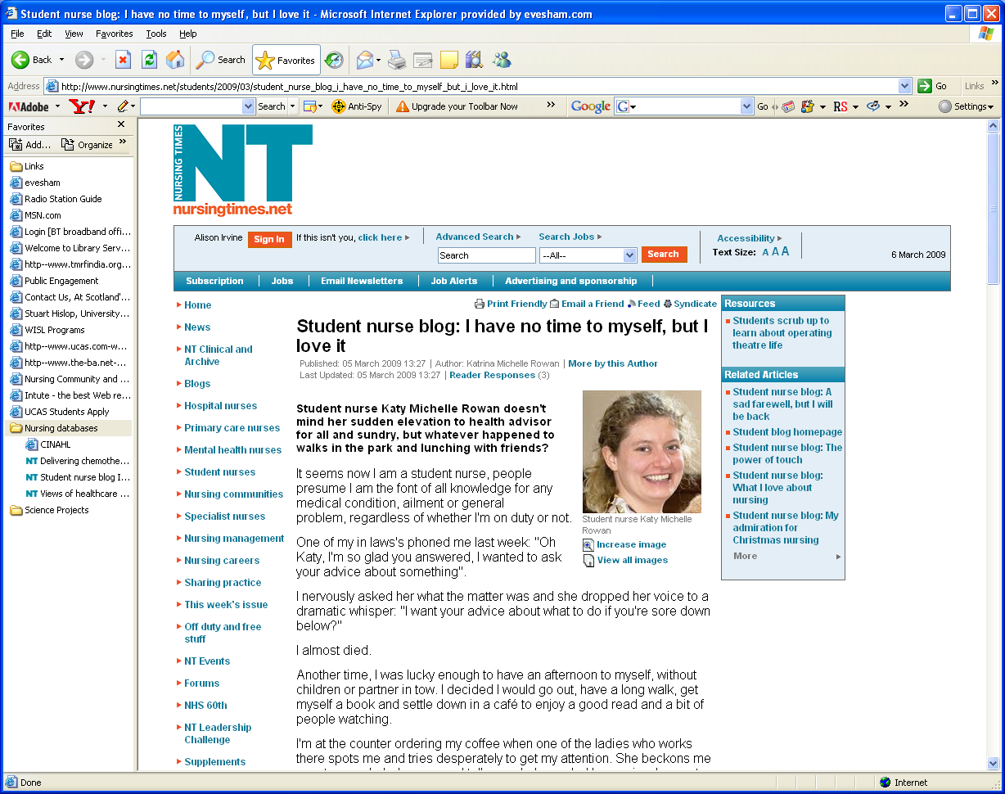
‘I have no time to myself, but I love it’
Every now and then, I find it a real struggle balancing all these different roles. Sometimes I feel like I'm being suffocated with the pressure of placement, home life, university and trying to bring up two kids with only my other half for support.
Occasionally, and I know this is incredibly selfish, I wish I didn't have all these responsibilities.
It gets overwhelming with people relying on me to do the housework, make the dinner, put the kids to bed, write a good essay, read more journals/books or fill in massive loads of paperwork for lecturers or mentors to mark.
I feel like I don't have time for my friends anymore as I'm always busy, on placement or have the kids in tow. In fact I barely have time for ME anymore.
I'm currently on placement at a medical ward. Unfortunately, my kids seem to be conspiring against me to see who can get me up the most times in the night.
Last night my little boy won with a record four times, my little girl almost outdid him by wetting the bed, resulting in a 1a.m. frenzy.
The youngest has also taken to wandering into the bedroom in the early hours and climbing into our bed. It's like sharing with a large, sleep-talking octopus. He wiggles and kicks, robs the entire pillow and will randomly shout ‘mine’ and ‘yoghurt’ at 4 a.m.
Normally I can manage with limited amounts of sleep, but when I am on placement it gets very tough. I have been lucky enough to get a fabulous mentor who enjoys having a student to teach. But after a week, the exhilaration of learning new things wore off and exhaustion took over.
I've been put on night shifts for my final two weeks. I am actually looking forward to this – purely because I will get to have a bed to myself when I come home and I may even get more than four hours of unbroken sleep.
Despite the tiredness, I still love my course. I can't seem to leave the 'nurse' at the hospital as I get waylaid in coffee shops or on Saturday nights for advice.
My friends and I have resorted to meeting up at supermarkets so we can catch up in the coffee shop before they do the shopping and I disappear to work or uni. Gone are the days where we'd meet up and put the world to rights over lunch. I have realised that this is all part of my life now and I enjoy it.
It just takes one person to say just one nice thing and all this pressure is worth it.
It's overwhelming how nursing takes over your life; but I feel like I'm growing every day. I can't wait to meet the person I will become in two years time when I qualify. Hopefully she'll be a good nurse, and maybe even have a bit of time for herself!

If you have any suggestions as to how Michelle could cope better with her life and studies, write them down here.

