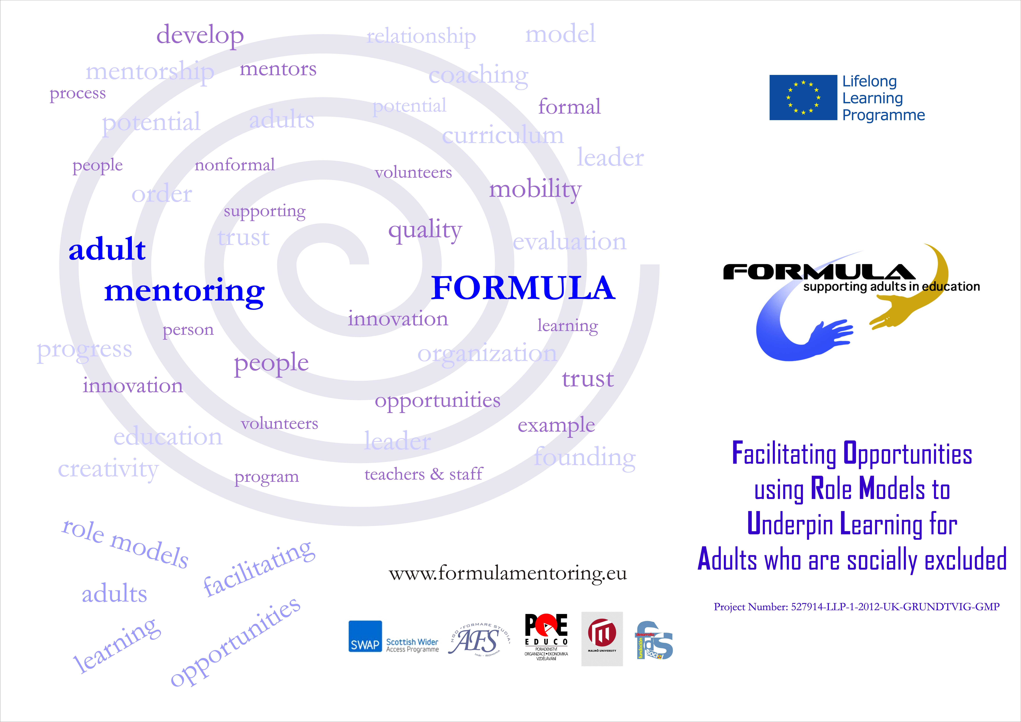


The FORMULA project seeks to address engagement with adult learners from our most socially and economically deprived communities and their progression to “go one step up” with their education, using mentors.

The framework for the project will have two clear strategic outcomes:
- to form a more socially inclusive society during difficult economic conditions by working with adults from our most deprived areas.
- to help our learners to progress to the qualifications they and society need by providing robust guidance frameworks.

The objective of the project is to Facilitate Opportunities for our disadvantaged adult using mentors (Role Models) to Underpin Learning for Adults who are socially excluded.

Four main activities of the project:
1) Each partner will identify and establish an adult peer mentoring network for learners and communities of learners from areas of multiple deprivations.
2) Produce materials and resources to support the mentors involved.
3) Produce materials and resources for adult learning organisations to support volunteer mentors working with adult learners.
4) Develop a European peer mentoring network through the partnership work of the project and the mobility’s to support partner / country networks.

PARTNERS
SWAPWest: Scottish Wider Access Programme (United Kingdom)
SWAPWest is a consortium of establishments, working with Community Education. SWAPWest puts the needs of the adult learners at the core of a wide range of initiatives.
FORMARE STUDIA (Romania)
Formare Studia is a professional training centre. Since 2007, when the organisation was founded, Formare Studia offered 7 training courses to over 2000 adults.
POE EDUCO, spol. s r.o. (Czech Republic)
POE EDUCO, Ltd., based in North Moravia is private organization providing range of education services to adult e. g. professional training and re-qualification of unemployed adult. The company has wide experience in co-operating with Labour Offices from our region and other organisations at a local and regional level.
University of Malmö (Sweden)
Malmö University was founded in 1998 and currently has approximately 20,000 students - it is the ninth largest university in Sweden. The Nightingale Mentoring Scheme began in 1997 in Malmö and cooperated with a number of schools which had large numbers of pupils from very diverse ethnic backgrounds
Foundation for Social Development (Spain)
The Foundation for Social Development (FDS) is a non-profit organization established to promote the development of the population living and working in the rural areas.

