MASTER WEBSITE and FACEBOOK Update

The SWAPWest MASTER Project is about to enter an exciting new phase with the recruitment of learners to test out the Personal, Social and Learning to Learn Competence Tools in novel settings.

The testing will comprise practical workshop sessions for learners and suggestions on how they can improve these key competences. With the Covid-19 situation, these workshops have been designed for on-line delivery to allow the project to continue on schedule. This will be an opportunity for the students to improve and practice their on-line and digital skills which will be essential for them as they continue their studies in the ‘new normal’.

SWAP students will be asked to assist with the project outcomes – useful both to them in their future careers and as an addition to their CVs.

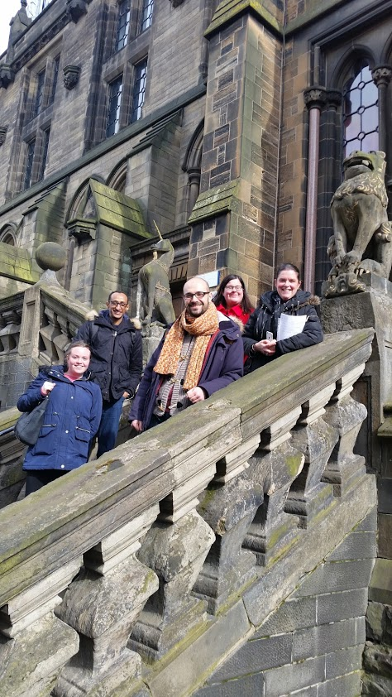

SWAPWest learners visiting the University of Glasgow, 2017