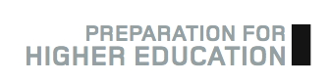
Preparation for Higher Education - How to Complete It

As the title suggests, the ‘Preparation for Higher Education’ (PHE) materials are designed to give you the information, insight and skills you will need to succeed at college or university.

In addition to the academic subjects you will study at college, there are essential ‘study skills’ that every student needs to develop and improve upon in order to do well at university level. Prep for HE will help you to develop those study skills, but it can also help you with some more practical aspects of becoming a university student; things like making the best choices of course and university, writing your Personal Statement and applying to university using the UCAS system. By working your way through the PHE unit, you will also develop your skills in time management and meeting multiple deadlines and juggling multiple responsibilities, all of which are key features of life as a university student.

How to access PHE materials
The most up-to-date version of Preparation for Higher Education materials can be found on the SWAPWest web site [www.scottishwideraccess.org/west/phe]. Simply visit the West section and click on the link marked ‘Prep for HE’. There you will see a list of links to download each of the PHE exercises. Click to download to your own computer or a USB memory stick.

Your college tutor may also make these materials available from your own college web site or VLE (Moodle, Blackboard, etc.)

Methods of Completion

There are three ways you can go about completing your Preparation for Higher Education unit:

1. Paper
You may opt to download the documents to your own computer or memory stick, print them out and complete the exercises by hand. These paper copies can be kept in a binder or folder, which you can later show to your college tutor to provide evidence of completion.

2. Electronic
You may download the documents and save them to your computer or memory stick, as above. Instead of printing them out, however, you could complete the exercises electronically and email them to your tutor. Alternatively, your tutor may ask you to upload the completed exercises to your Virtual Learning Environment (VLE) (e.g. Moodle or Blackboard) to provide evidence of completion.

3. e-Portfolio (Mahara) * Recommended *
You may opt to keep an online portfolio of your work, including completed Prep for HE exercises and a Study Diary (Journal) using Mahara e-portfolio software. One of the main benefits of doing your PHE using Mahara is that, at the end of the year, you can take your work with you; your Mahara portfolio can be ‘exported’ to a USB memory stick. Most universities are adopting Mahara and will expect students to use it, so if you have already used it during your year at college, you will be a bit ahead of the game. See the instructions on the following pages for more information on how to use Mahara to do your PHE. If you need help, contact the SWAPWest office on 0141 564 7206.

PHE is your responsibility

You will find a ‘timeline’ in the section for current students on the SWAPWest web site [www.ScottishWiderAccess.org/west/currentstudents] that will let you know approximately when you should complete each exercise.

SWAP is a programme for adults and, as such, you are expected to take responsibility for completing this section of the programme. Take the time to read each section and complete the exercises that are provided. You can complete the exercises at your own pace and by whichever method you prefer, but it is important that you do complete each section, as doing so will enhance your studies at college and give you the support you need as you progress on to an HN or degree course next year.

Using Mahara for PHE
Mahara is ‘e-portfolio’ software; some have described it as a digital version of a three-ring binder.

Essentially, it is a private online space (i.e. a private web site) where you can collect various bits of work that you have completed, things that interest you or that may enhance your assignments. For example, you could collect newspaper or magazine articles, documents you have created for assignments, images you have downloaded or scanned, photos you have taken at Open Days or Study Skills Days, links to videos you have found online -- or indeed film clips or audio clips that you have created yourself. Later on, Mahara enables you to quickly and easily create a private web page featuring selected items from your collection.

Mahara lends itself to the completion of PHE; you can use its ‘journal’ feature as your PHE ‘Study Diary’ and you can upload electronic versions of completed PHE exercises to your Mahara web pages. At the end of the academic year, you can create a web page showcasing all of these items and share that page with your college tutor to show that you have completed the PHE unit.

If you wish to complete your PHE online using Mahara, follow the steps outlined on the following pages. If you have questions, please contact the SWAPWest team on 0141 564 7206 or by email: swapwest@scottishwideraccess.org

Step 1: Find Mahara on the SWAPWest web site and register as a new user.

- Visit the web site www.scottishwideraccess.org and click on West, then Prep for HE, then SWAP Mahara as shown below:
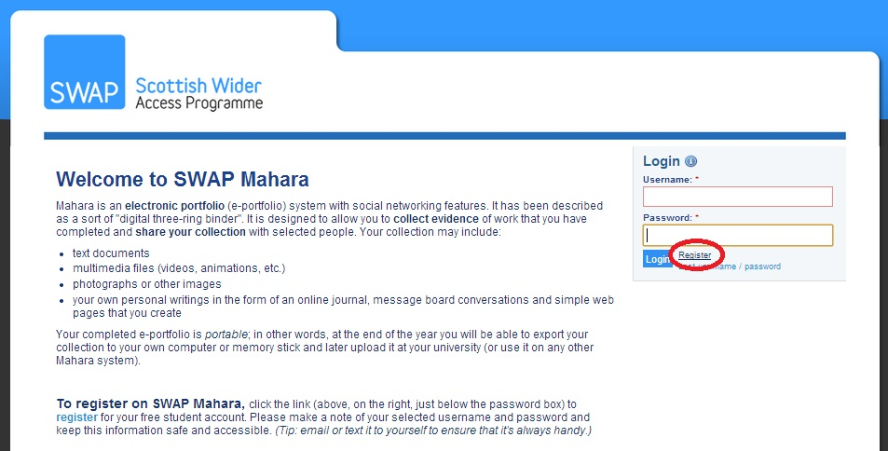
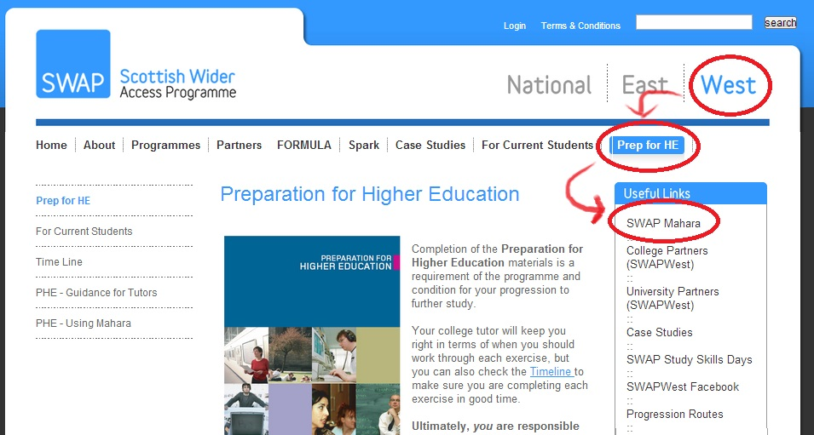
- Click on the link ‘Register,’ as shown below:

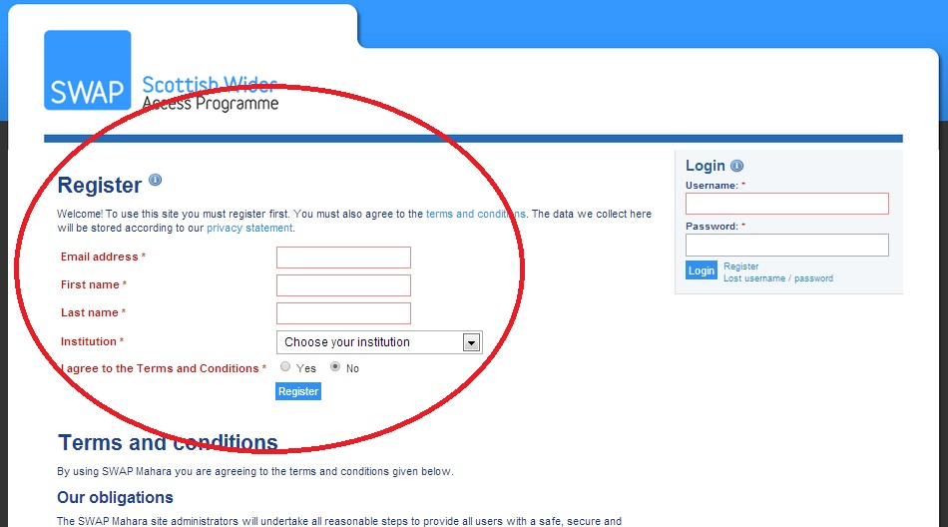
- Fill in the short registration form. Be sure to select your college name from the drop-down menu next to ‘Institution’. You may use any email address you wish but be sure to use one that you have easy access to, as it will be required in order to complete registration.

- When asked to give your reason for registering, give the name of your SWAP ‘Prep for HE’ tutor.

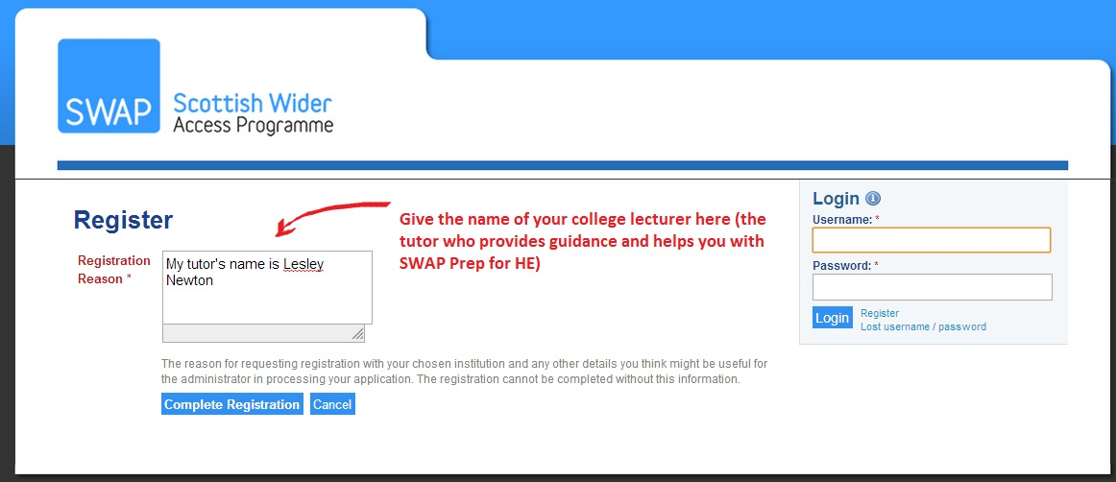
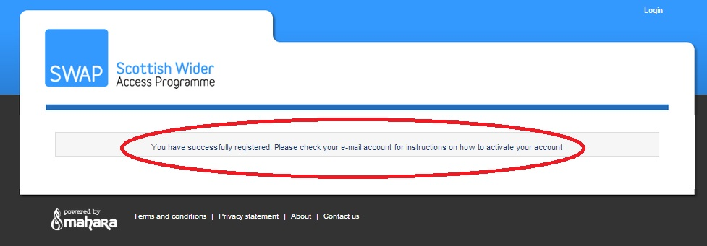
- You will see a confirmation if you have registered successfully. Now you must check your email for instructions on activating your account.

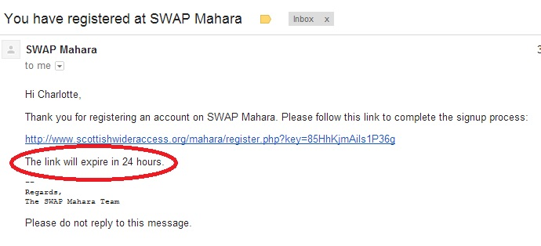
- You have 24 hours to check your email, click the link and confirm your registration. If you fail to confirm within this time period, your registration request will expire and you will have to start over from the beginning.

- Finally, choose your username and password. Be sure to email or text this information to yourself so that you cannot lose it.
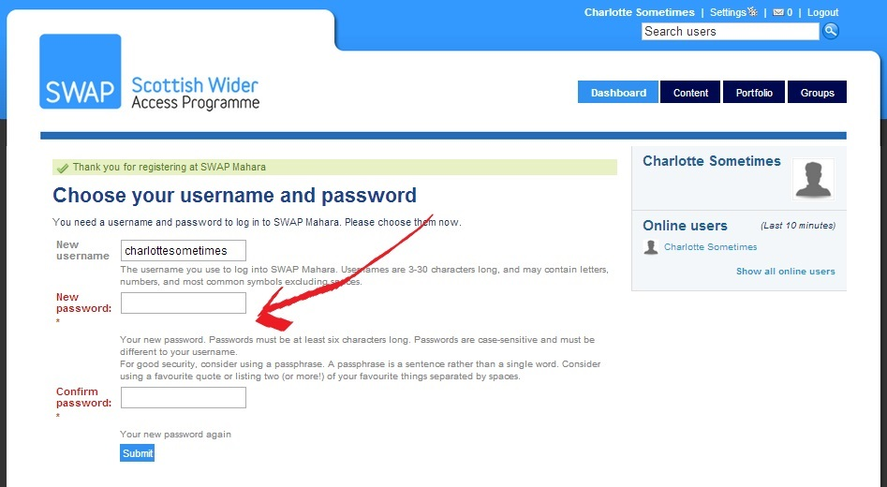

Congratulations! You have registered successfully!

Step 2: Become familiar with the main features of Mahara. Set up your profile. Join groups.

- Read the ‘Welcome to the SWAP Mahara’ information.
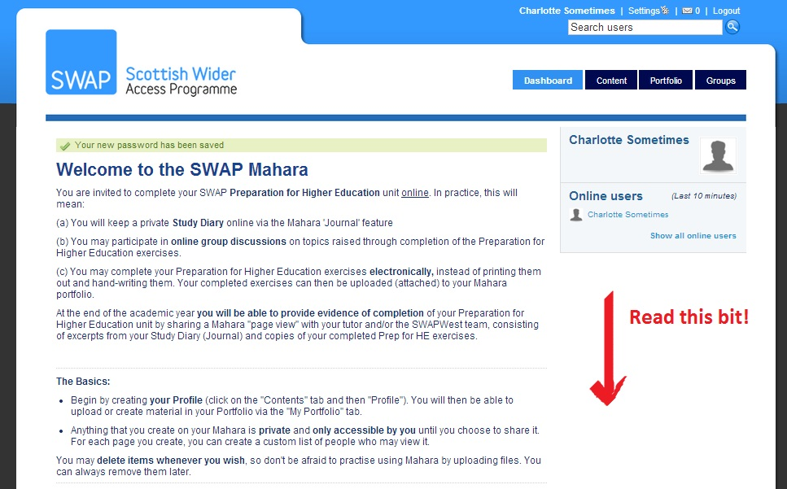
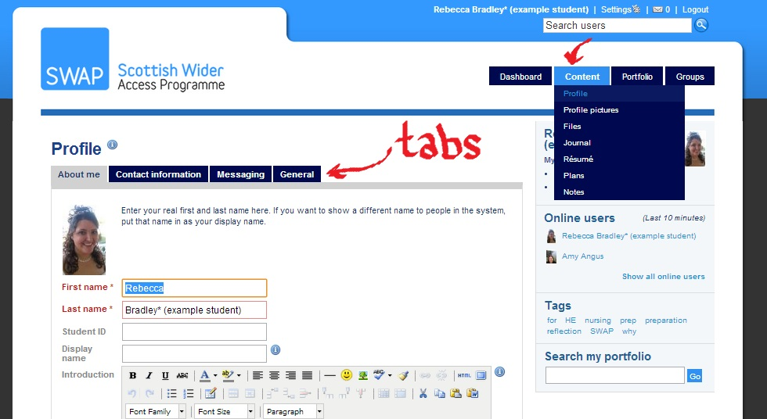
- Set up your profile by filling in the information under each tab, as below:

- Join Groups. Join your own college (class) group (e.g. New College Lanarkshire – Cumbernauld Campus – Humanities). You should also join the Curriculum Group (e.g. SWAP Curriculum Group – Humanities)
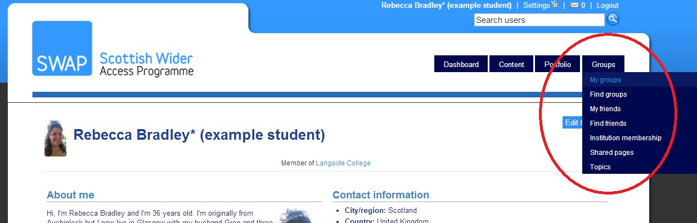
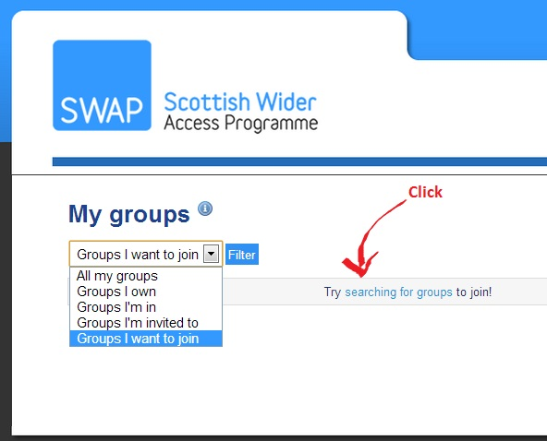

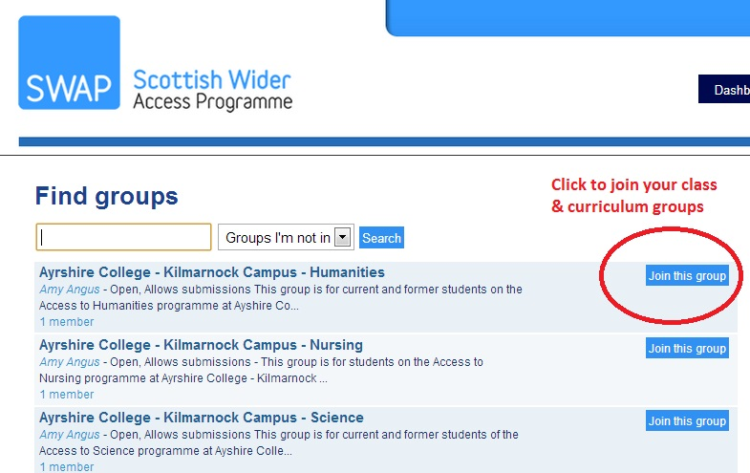

Step 3: Create a page entitled ‘Preparation for Higher Education’, as below:
- Click on ‘Create Page’

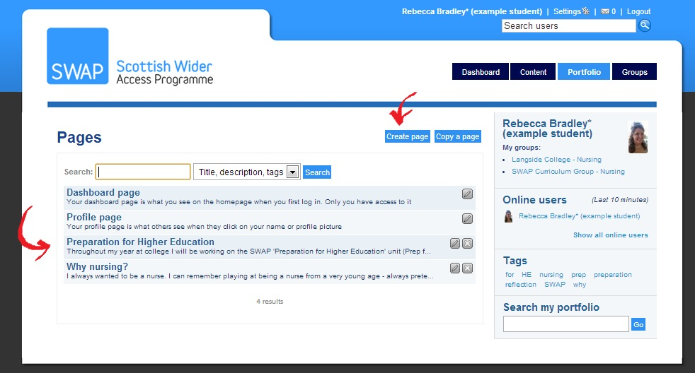

- Title the page. Click the tabs along the top to edit the layout and content.

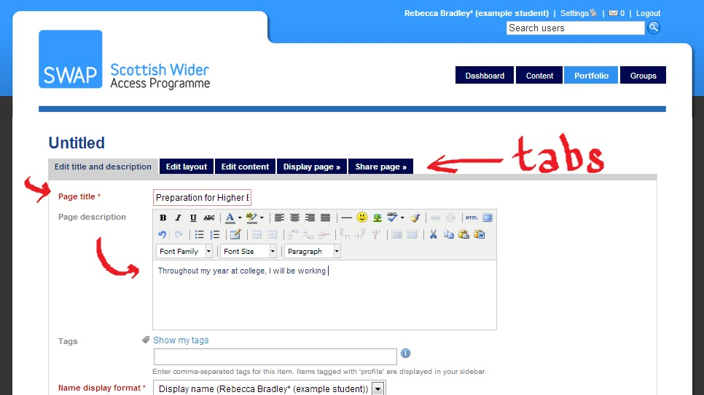

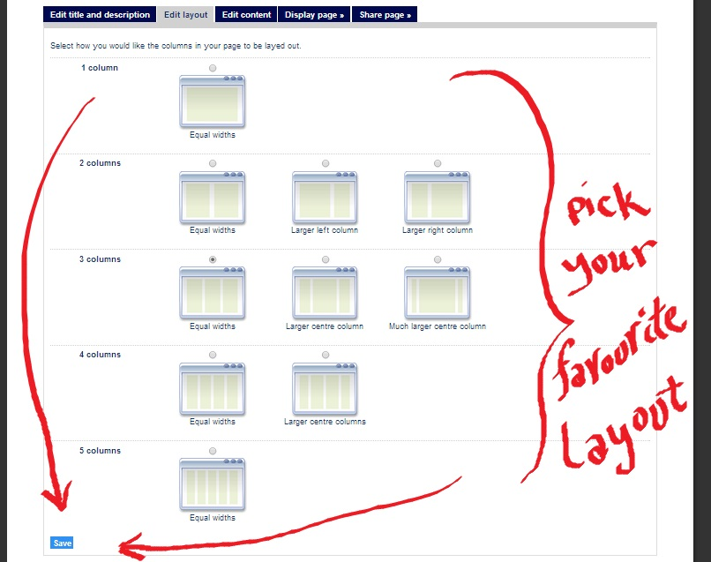

- Drag-and-drop content types to create your page. You can include files (e.g. Word documents, PDF documents, etc.), images and even multimedia content (videos, etc.)
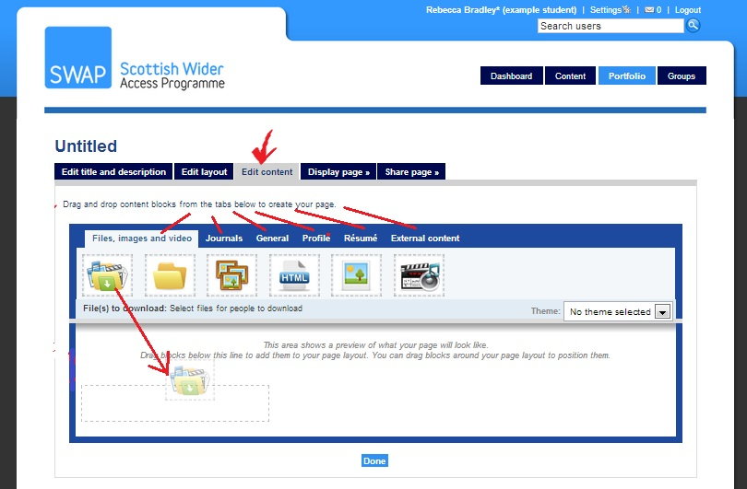

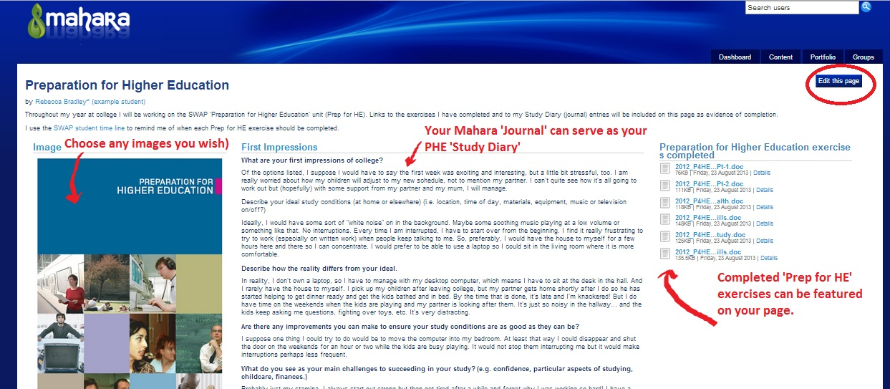
- You can view your completed page as you create it. If you don’t like the way it looks, click on ‘Edit this page’ and change it.

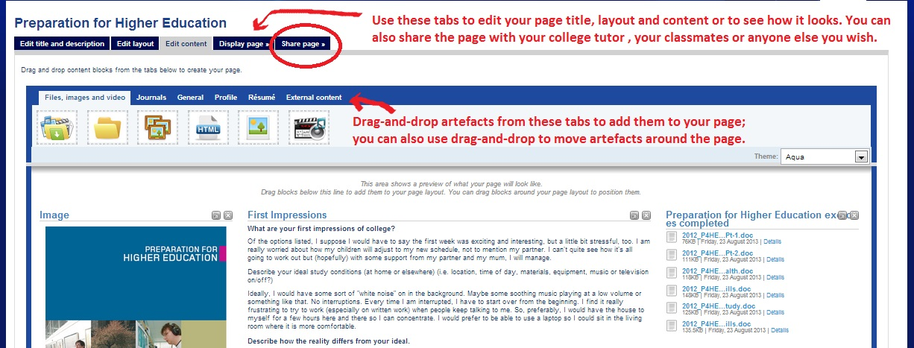

NB: You can download blank copies of the Preparation for Higher Education exercises from the SWAPWest web site, complete them electronically and then upload them to Mahara to be included on your page:

www.scottishwideraccess.org/west/phe

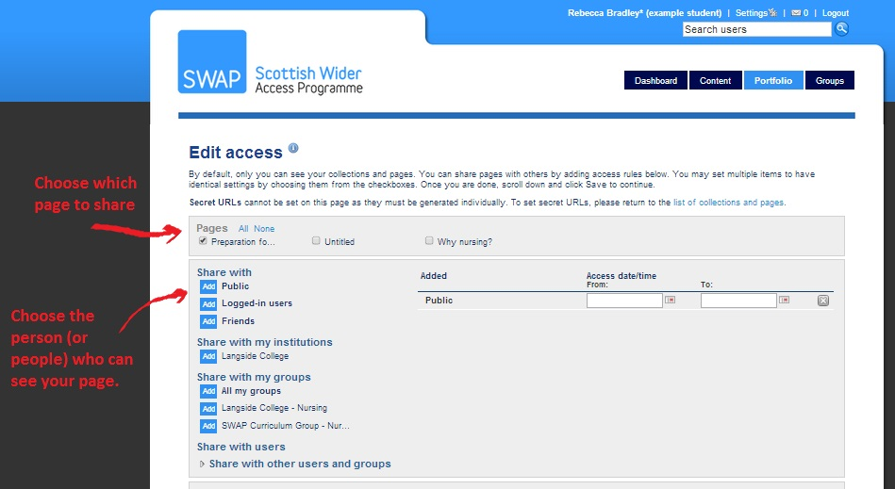
- Finally, when you are ready to show your page to others, click on the ‘Share page’ tab and select the person (or people) who will have permission to view it. By default, your pages are set to ‘private’ (only you can see them) until you change these settings.

- One person you definitely want to ‘share’ your PHE page with is your tutor. You can opt to share your page ONLY with one person, provided s/he is also registered on Mahara. See below:
- Click on ‘Share with Users’
- Select ‘Users’ from the drop-down.
- Type in the first name of the person with whom you want to share your page.
- Click ‘Go’
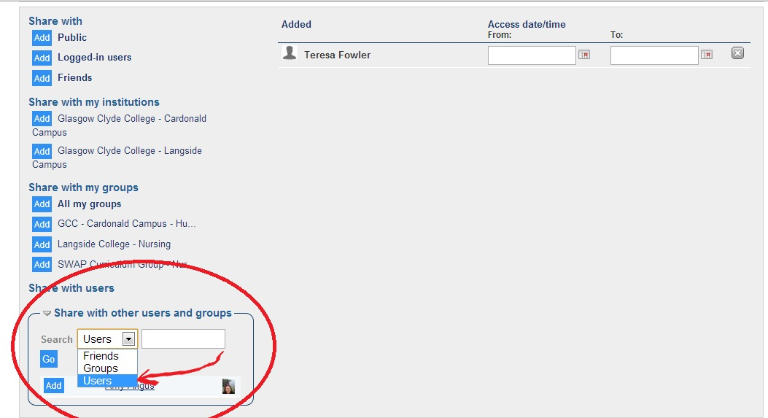
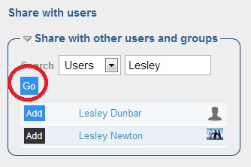
- After clicking ‘Go’ you will see a list of users whose names match your search.
- Click ‘Add’ next to the name of the person you want

If you have any questions about using Mahara to complete your PHE, please contact the SWAPWest office on 0141 564 7206 or email amy.angus@scottishwideraccess.org

