Returning to Education

Session 1 – Worksheet B – Video Introductions
During each session of the “Spark” programme, you may begin by watching a video. The people in the videos are all from the Glasgow area who have returned to education as adults. They talk about why they wanted to go to college, how they did it and what it was like.

Tick the box next to the video introductions that you want to watch (you may watch as many as you like). You can use page two of this worksheet to make notes if you wish.

Jade | 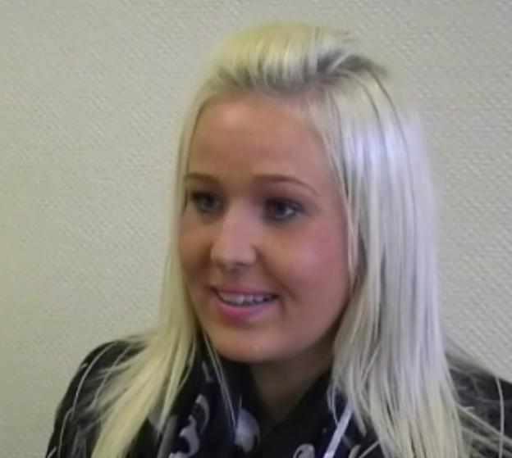 | - Jade, age 25 from Bridgeton  - Single mum of one (age 4)  - “I was so ashamed of my exam results, I was so embarrassed, I was too scared to apply for college. I didn’t think I was good enough.”  - VTCT in Makeup Artistry at Clydebank College
Gary | 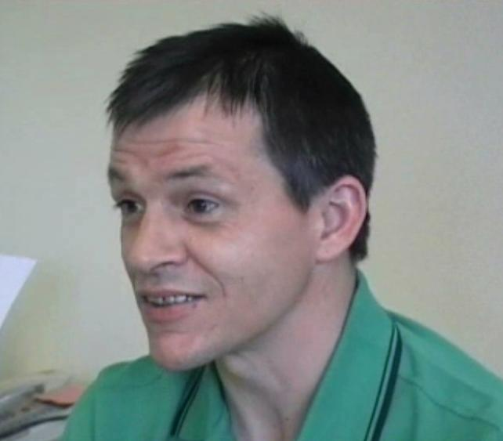 | - Gary, age 42 from Easterhouse  - In recovery from drug addiction  - “Taking drugs became more important than doing well at school. All my dreams of trying to better myself went right out the window.”  - SVQ in Social Care through John Wheatley College
Maria | 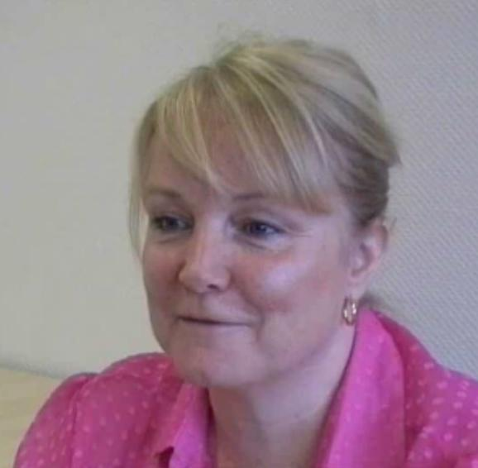 | - Maria, age 52 from Coatbridge  - Married mother of two (ages 24 and 14)  - “I just wanted to be able to write things down – it wasn’t about a career or anything. Once I had done that, then I could start thinking about what else I wanted to do.”  - HNC Social Care at Coatbridge College
Regis | 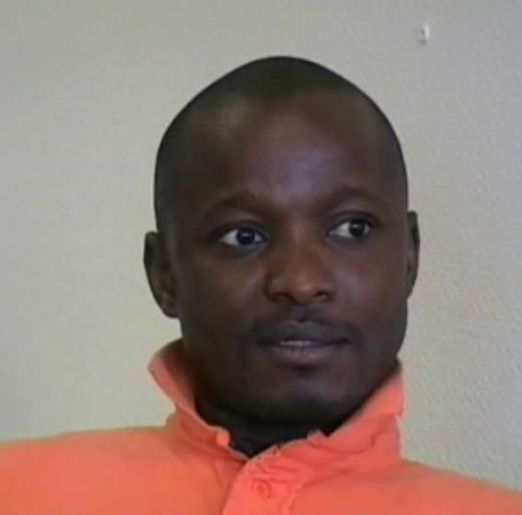 | - Regis, age 38 from the Congo, resident in Glasgow since 2002  - Married father of two young children  - “It is a challenge, but at the end of the day you’re going to be getting something good.”  - HND in Hospitality & Management  - HNC in I.T. and CompTIA A+ Certification at Stow College
Alex | 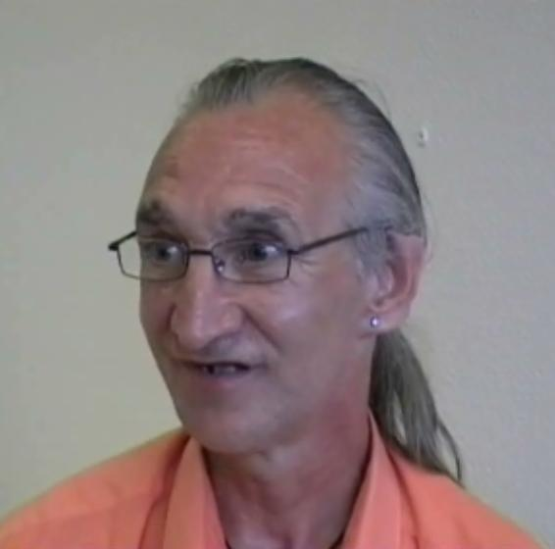 | - Alex, age 45 from Drumchapel  - Single, no children  - “Football, football, football. I was like any young boy that likes his football. I dreamed I was going to play for my team – I never had any other goals!”  - ECDL (European Computer Driving License) at Anniesland College
Jackie | 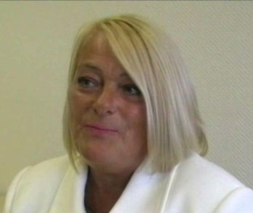 | - Jackie, age 50 from Bridgeton  - Single mum of two (ages 26 and 23)  - “I had no belief in myself. I could go out and help other people but if you asked me to talk in a group, just to say my name, I couldn’t do it.”  - Facilitates the “Steps to Excellence” course in Bridgeton/Dalmarnock

Session 1 – Worksheet B
You can use the spaces below to jot down any thoughts, feelings or ideas that pop into your mind as you watch the videos. These can be questions that you want to ask or just things you want to talk about.
Jade |  | ____________________________________________________________  ____________________________________________________________  ____________________________________________________________
Gary |  | ____________________________________________________________  ____________________________________________________________  ____________________________________________________________
Maria |  | ____________________________________________________________  ____________________________________________________________  ____________________________________________________________
Regis |  | ____________________________________________________________  ____________________________________________________________  ____________________________________________________________
Alex |  | ____________________________________________________________  ____________________________________________________________  ____________________________________________________________
Jackie |  | ____________________________________________________________  ____________________________________________________________  ____________________________________________________________

