**STAY - S**uccessful **T**ransition **A**nd **Y**ou

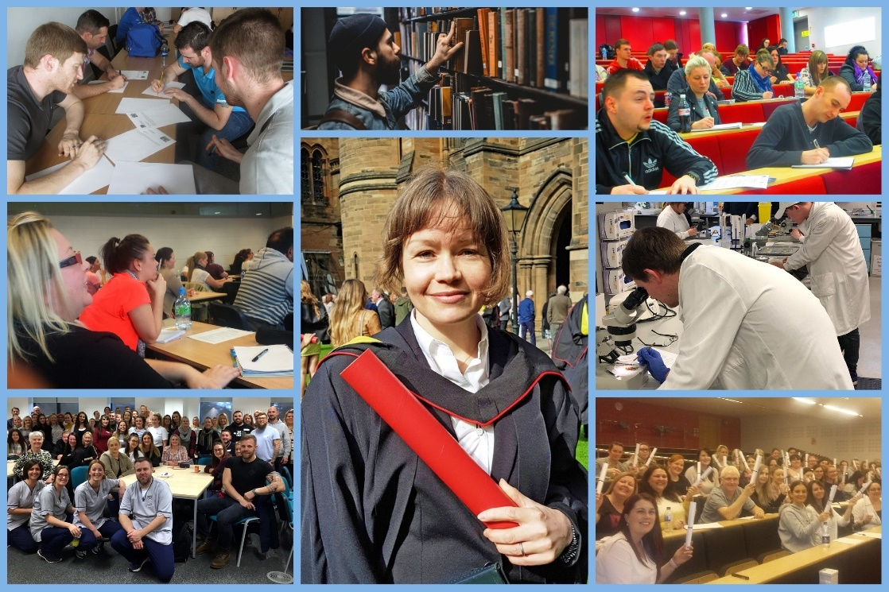

Project Report July 2020

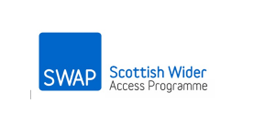

**Contents**

1 Project Description and Rationale 3

1.1 Context 3

1.2 Rationale 3

2 Project Approach and Methodology 3

2.1 Partnership Approach 3

2.2 Strategy 4

3 Project Outcomes 4

4 Evaluation and Analysis 5

4.2 Pilot Group Questionnaire Analysis (SWAP cohort 2018-19) 5

4.3 Pilot Group Focus Group Data 6

4.2 Analysis of STAY online (SWAP cohort 2019-20) 7

5 Follow Up Activities 8

Appendices 9

Appendix I 9

Results of Evaluation data for STAY -delivered online from June 2020 . 9

# Project Description and Rationale

## 1.1 Context

Recent publications from The Commission For Fair Acccess have highlighted the success of Widening Access programmes such as SWAP, in increasing social mobility and in increasing opportunities for HE level study for non traditional students. Identified alongside has been that many students do not "*enjoy the positive reinforcement of families and peers that helps stop more socially privileged students dropping out. Faced with competing social, and maybe financial pressures, they need more resilience to stay the course* ". The '**STAY**' - **S**uccessful **T**ransition **A**nd **Y**ou , project is an initiative which reflects our desire to work in partnership to address retention issues and to actively support and encourage students to be successful within the Higher Education environment as they progress from the Access programmes onto degree and HNC level study.

## 1.2 Rationale

The rationale of the STAY project is to create an approach, methodology and a tool which will build resilience and equip students to ‘stay’ the course of their degree and HNC studies.

The strategy aims to provide progressing students with a practical and relatable guide to expectations of further and higher level study programmes as well as providing effective signposting to transition events and student support services within our partner institutions.

Central to the strategy was the need to create a strong and confident student identity which could be taken forward as students progress to HE level study.

# 2 Project Approach and Methodology

## 2.1 Partnership Approach

STAY adopted a collective approach and as such, extensive scoping out activities were carried out with university partners and students between October 2018 and January 2019. This resulted in the creation of 5 key considerations which would guide development:

1. The need to build resilience.
2. The need to increase knowledge and awareness of support services.
3. The need to develop effective strategies to encourage the seeking of support for success.
4. The need to build confidence by highlighting and promoting existing academic skills and personal attributes.
5. The need to create a strong student identity in which the student sees themselves as part of the HE ‘institution specific’ student community.

## 2.2 Strategy

The core strategy was to create a tool which would build resilience and equip students to ‘stay’ the course of their degree and HNC studies.

The tool had to provide progressing students with practical and relatable guide to expectations of further and higher level study programmes as well as providing signposting to support and academic services within our partner institutions.

Building upon initial Scoping Out work, it was clear that each partner university has a very clear and distinct institutional identity. In order to promote and embed a strong student identity for those progressing from the SWAP Access programmes, the partnership approach provided scope for bespoke collaborative work to be undertaken with respective institutions.

# 3 Project Outcomes

(i) Interative workshops were created aimed at reframing support as a positive learning strategy as a well as consolidating and highlighting core acdemic skills developed across the Access programme of study.

* Support for for Success
* Academic Skills for Success
* HNC Skills for Success.

Workshop sessions were piloted in June - Aug 2019 to selected groups studying a range of SWAP Access courses across 3 different locations. The pilot groups were used to measure the impact and success of new initiatives, activities and materials.

* **Group 1 Social Sciences & Primary Ed - Kelvin College (Easterhouse)**
* **Group 2 Nursing -West College (Clydebank)**
* **Group 3 STEM - Ayrshire College (Kilmarnock)**

(ii) Delivery of a STEM support Day, faciltated by SWAP and hosted by GCU, took place in September 2019. All SWAP students progressing to a STEM based degree course were invited to participate.

(iii) Continued ongoing development of peer networks and communities of learners which promote support and a clearly defined student identity.

(iv) Increased promotion of induction and transition initiatives.

# 4 Evaluation and Analysis

**4.1 Evaluation Strategy**

A core evaluation focus for this project was evidencing the tangible benefit gained by the learners themselves as they embark on the progression to degree and HNC level study. Another key consideration was the need to incorporate the views of our colleges and universities as part of the project’s partnership approach.

* Materials were developed for students to evaluate the workshops sessions upon completion and included space for suggestion on further improvement and development.
* Tutors were also provided with an evaluation questionnaire to gauge the effectiveness of the session as well as incorporating space for feedback on the practical aspects of delivering the workshops as ‘tutor led’ sessions.
* Focus Groups and follow up sessions took place in October 2019 and January 2020 with participants who had taken part in the initial pilot workshop sessions.
* A STAY Seminar was hosted by the University of Glasgow in December 2019 to provide an interactive forum for comment and evaluation by college tutors and representative of the Widening Participation teams from partner universities. Attendees also had the opportunity to pose question to an invited student panel consisting of participants from the initial pilot sessions and focus groups.
* Subsequent advice was sought from our college partners to assist in the development of a bespoke HNC workshop session.

## 4.2 Pilot Group Questionnaire Analysis (SWAP cohort 2018-19)

**The session increased my knowledge of where to access support (93%)**

**Table 1.1: ‘Knowledge of support’ post session**

**The session will actively encourage me to seek help and support(89%)**

**Table 1.2: ‘Encourage the seeking of support’ post session**

**I feel more prepared for university following the session (86%)**

**Table 1.3: ‘Preparedness’ post session**

## 4.3 Pilot Group Focus Group Data

|  |
| --- |
| **The workshops? Did they help?** |
| *I really enjoyed them. They tell you to get all the help you can. I’m not being biased or anything, but I probably would never have gone to Disability or Academic help or anything like that if it wasn’t for you saying this is what you should do, or those videos of that lassie saying that…I might have been in my 3rd year before I’d gone for any help. Sometimes I think it’s just because you’re older, you feel embarrassed, you feel that you’re a dummy.* **Nursing student: UWS**  *Yes, definitely. One of the main things I took from that was to ask for help. If you do have questions, ask. If you need to go somewhere to see someone, just ask. The sessions made me realise there would be other people feeling the same and that I shouldn’t be embarrassed about anything or about getting help. There’s a few times we’ve laughed, me and one of the other girls…we say, of that’s Paula, that’s exactly what she was saying…about study plans and about what’s expected in assessments. Our WhatsApp groups are up and running, just for support and just to vent. So just being there to support each other too.* **Social Sciences student; University of Strathclyde**  *When you are used to getting high marks at college, it was a bit different at university. We had class tests there at Christmas. In my class tests, well in some of them I did really well in,*  *getting around 80%. The rest of them I struggled with, getting around 40 and 50%. The workshops helped me not be so hard on myself. No doubt at all that without the workshops I’d have been in the mindset that there were big chunks of the uni course that I didn’t know anything about going by the marks. But that’s not the case. It would have been easy to spiral downwards. Now I know that I’ve passed, I know that’s ok, I know what’s expected and I know using the feedback what I need to do for the end of the year assessments****.***  *I was prepared for this to happen. And really it was the workshops, that knowing that people like me, from my background and my postcode think about dropping out. That actually kept me going. That gave me the internal drive to stick with it and not give up.***STEM student, University of Strathclyde.** |

**Table 1 – Quotes from STAY Focus Groups (recorded Oct 19 and Jan 2020).**

## 4.2 Analysis of STAY online (SWAP cohort 2019-20)

Due to Covid 19, STAY sessions were adapted to be accessed and delivered online to provide maximum flexibility for students to complete at home. Sessions were made available online from June 2020. The current cohort are continuing to engage with STAY and have been forwarding completed worksheets and feedback across the summer months. An evaluation questionnaire was created for these sessions using Survey Monkey and employed a Likert Scale to measure the impact of undertaking the session. Results can be found in Appendix 1.

Students also were asked to respond to the question ‘How has STAY been of benefit to you?’ 90% of those who responded to this question provided positive comment. Ais provided below.

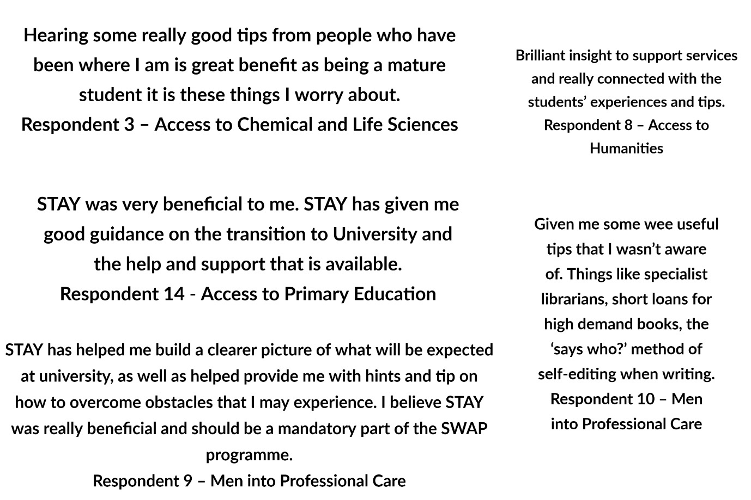

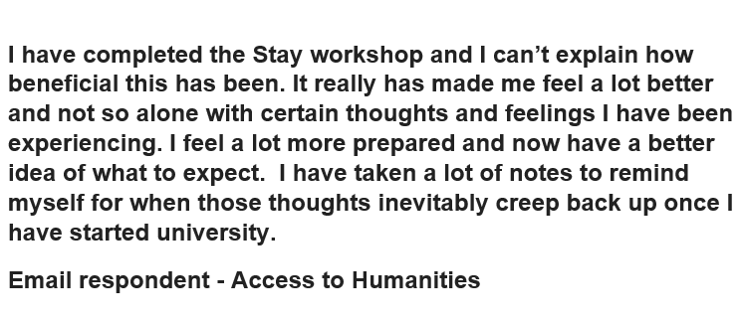

# 5 Follow Up Activities

* SWAP will work in continued partnership with our university partners to actively promote transition and induction events. SWAP will actively collate and disseminate information with progressing students will be guided to respective links and events for induction and transition at partner universities.
* SWAP will seek to work with partners to develop institution specific STAY sessions where applicable.
* SWAP will continue to work with partner universities to encourage the embedding of an institutionally focused student identity by developing ‘ambassador roles’ from within our network of former SWAP students.
* SWAP will facilitate follow up ‘drop in’ student sessions for progressing students in their first year of post SWAP study. The aim of these sessions will be to continue to signpost students to institution specific support services as well as further develop opportunities for peer support via Student Ambassadors and the SWAP Student Network. These sessions are expected to be delivered online and will support the induction and transition work of partners. Bespoke ‘institutional specific’ drop in student sessions are further being developed on request in line with the needs of individual partners.

# Appendices

## Appendix I

### Results of Evaluation data for STAY -delivered online from June 2020 .

Q4

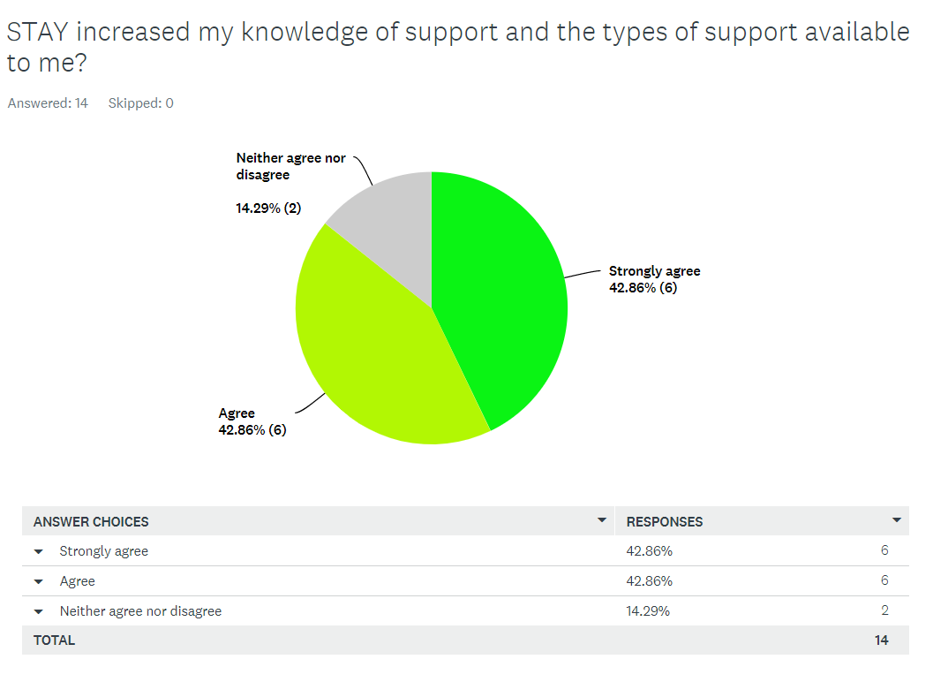

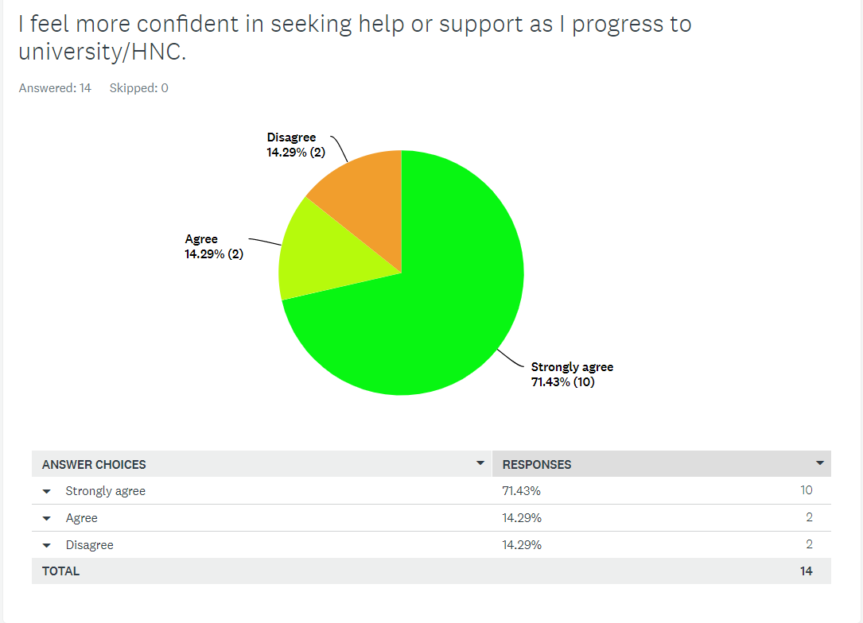Q5

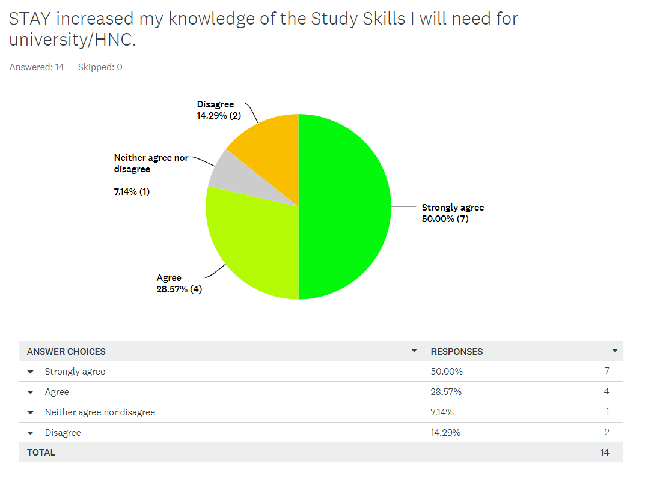Q6

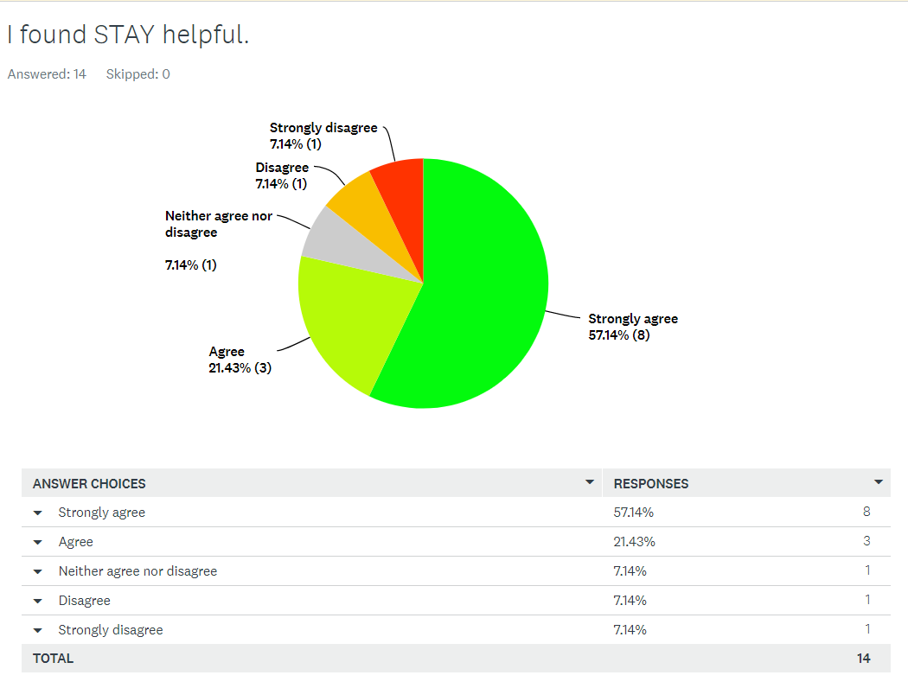Q7

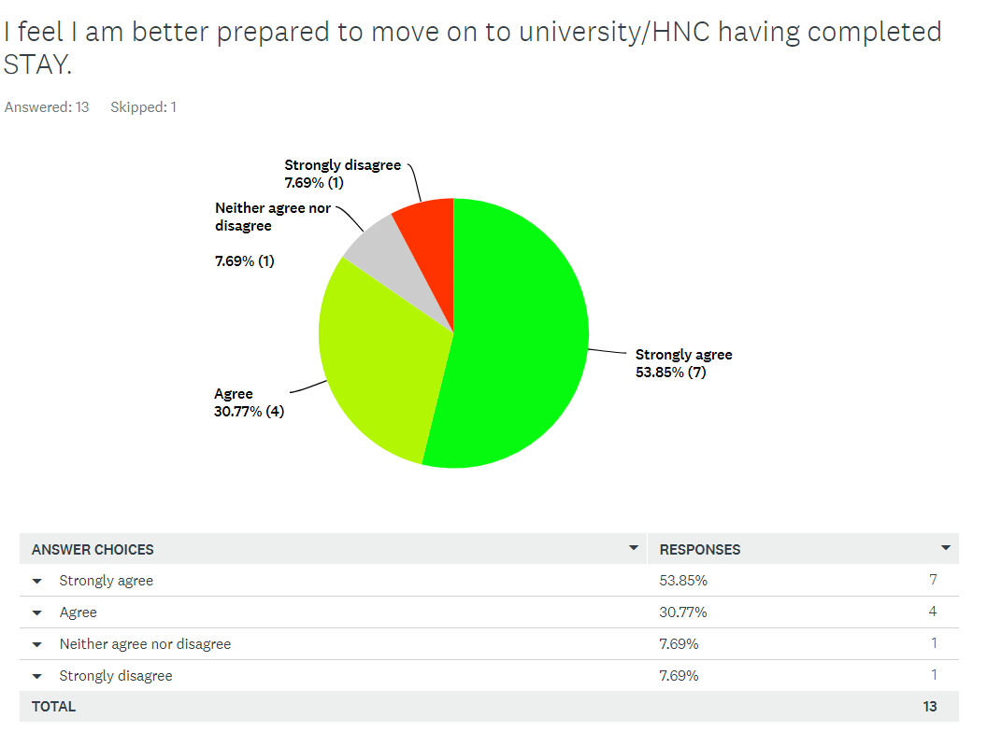Q8