**SWAP**

Student Welcome Pack

2019-20

**Access to Science**

**Including STEM, Allied Health Professions and Life Science (Chemistry & Biology)**

**Welcome to SWAP!**

You have enrolled on an Access programme which is operated by your college in partnership with the **Scottish Wider Access Programme**. The SWAP programme is designed to get you ready to study at the next level, and to give you the qualification you need to apply to HN or university degree courses.

**The SWAP team can be contacted by email –** [**swapwest@scottishwideraccess.org**](mailto:swapwest@scottishwideraccess.org) **or by phone on 0141 564 7206.**

**The programme is designed for** **adults who wish to progress to university or HN** but do not have sufficient qualifications to apply. Since the first SWAP programme in 1987, we have seen over 35,000 students progress to Higher Education. Former SWAP students can now be found working as engineers, environmental scientists, biologists, teachers, nurses, social workers—and in hundreds of other careers fields. Some of your college or university lecturers may even be former SWAP students.

We offer a variety of Access programmes, including Science, Technology, Engineering and Maths (STEM), Life Science, Chemistry & Biology as well as Humanities (Social Sciences), Primary Education, Social Work, Nursing, Allied Health and Medical Studies. Each programme consists of at least **18 academic units**, the SWAP ‘Preparation for Higher Education’ unit (commonly referred to as PHE or **Prep for HE**), and the final **SWAP Student Profile** which will be issued by your college at the end of the year.

SWAP is a national organisation. You have joined **SWAPWest**. Our office is based in Glasgow and we have partnership agreements in place with the colleges and universities in the West of Scotland. Our partner Higher Education Institutions are:

* Glasgow Caledonian University (GCU)
* Scotland’s Rural College (SRUC)
* University of Glasgow
* University of Stirling
* University of Strathclyde
* University of the West of Scotland (UWS)
* Glasgow School of Art
* Royal Conservatoire of Scotland

This pack contains important information about the benefits of SWAP, as well as your responsibilities as a SWAP student. Please read it, paying special attention to the SWAP Student Agreement. Also, it is compulsory that you **register online as a SWAP student**. There are instructions on how to register in this document.

Keep this information handy for future reference and check with your course tutor or SWAPWest if you have any questions.

All the best,

Kenny Anderson (Director) and the SWAPWest team

**REGISTERING AS A SWAP STUDENT**

Registration is **compulsory** so that we can support you as a SWAP student. We need to be able to keep in touch with you, to advise you of university and college information, and to confirm with universities and colleges that you meet SWAP criteria. **When you register, you will be informed of our Data Protection policies.**

**Please register as soon as possible and no later than seven days** after your college SWAP induction talk.



**How to register:**

1. Visit [www.scottishwideraccess.org](http://www.scottishwideraccess.org) and then click ‘**West’**.

2. Click on the links ‘For Current Students’ and ‘New Student Registration’.

3. Next click on ‘Register Now’, complete the form and submit it.

NB: If you experience problems in registering or if you’re not certain your registration has gone through, please don’t register a second time; instead, contact the SWAPWest office be email on swapwest@scottishwideraccess.org for assistance.

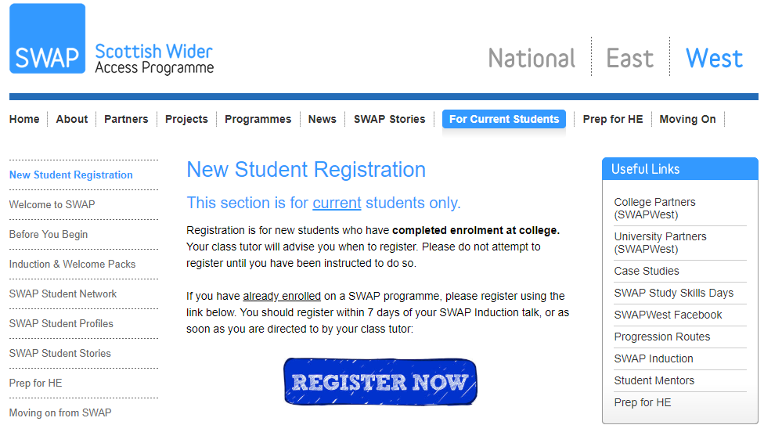

**After registration:**

* Inform your guidance tutor/class tutor that you have completed registration as a SWAP student.

**SWAPWest Student Agreement (Session 2019 – 2020)**

**Access to Science**

The SWAPWest partnership of colleges and universities provides access programmes for adults with no or few qualifications who are looking to return to education. The programme you have enrolled upon is recognised by our partner universities as an agreed entrance qualification for a number of degrees. The agreed degrees are published annually in October and are known as SWAPWest “progression routes”. Due to our unique partnership we can offer places on our progression routes provided **you follow the instructions** required for admission and completion of your programme.

The Student Agreement sets out the specific criteria and requirements that we expect from you to ensure you make the most of the opportunities provided by the SWAP programme.

**Progression from SWAP to university is subject to 4 specific conditions:**

1. **You must complete** **all of the units** of your programme. Non-completion of any of the units means that you will not fully meet the conditions of your offer of a place at university.
2. **Your student profile must meet the requirements** of the university progression route for that degree.
   1. The student profile is an enhanced reference by your college which is given to the university. A sample copy of the profile is available on the SWAPWest web-site. For Science, your subject skills are particularly emphasised but you should also look at the back page as it specifies all of the issues that the college will report on.
   2. **If you do not meet the required profile grades, then you will not be offered a place at university.**
3. **You must complete the Preparation for Higher Education unit.** Materials are available from the SWAPWest web site and/or from your tutor. It is anticipated that you will work through these materials throughout the year. Your college will provide you with support, but **Prep for HE is your responsibility.** You will be asked at the end of the year to provide evidence that you have completed all of the elements of Prep for HE.
4. **You must apply to universities through the** **SWAPWest UCAS School** (using the SWAPWest buzzword), and adhere to the instructions contained in the Prep for HE guides in completing and submitting your UCAS application. Failure to do so may prevent you from progressing to university.

Please note Progression Routes will vary in their requirements. Degree subjects where there are limited places or considerable competition for places will specify this and may require applicants to meet additional conditions, such as attending an interview or achieving % results in units or overall. Please note when these are specified these are on the basis of first assessments.

**Where progression routes highlight that places are competitive then that means that there are limited numbers for these degrees. Good students who do well may not gain places on these degrees so contingency planning is expected from all of our students.** You must research your options thoroughly, and make choices which reflect good contingency planning.

**For entrance to all university degrees you must use a service called UCAS.** UCAS administers entrance to university places.You must apply by 15th January 2019. Any application received after that date does not have to be considered. **It is your responsibility to ensure your application has been sent off properly.**

**You must apply through the SWAPWest UCAS School** so that your application is recognised by the partner institutions. You have an opportunity to make 5 choices*:

* **You must apply to more than one partner institution**. It is recommended that you apply to all five partners if at all feasible. In any case, you should apply to a minimum of three different institutions within our partnership (see p. 2).
* **For highly competitive degrees** you are advised in the strongest possible terms to use all 5 UCAS choices, including at least two backups in courses that are less competitive for entry, such as Sociology, Social Science, or similar. Keep in mind that for such professional qualifications, you may take an undergraduate degree and then progress to a post-graduate qualification in your chosen career field.
  + Students applying to study Primary Education will be required to make 4 back-up choices, reserving the 5th choice for a **single** Primary Education institution, should you be successful in being invited for interview. Full information on the SWAPWest Primary Education process is available at induction.
* **Please note that the University of Strathclyde (Social Sciences)** will not accept applications to more than one degree course per applicant. If you apply to more than one Social Science subject at Strathclyde Uni, all of your applications will be rejected.

In addition, for all choices **your personal statement is extremely important,** and you must follow the Prep for HE guidelines in completing your application.

**Important:** Your final destination after the SWAP programme is very much a personal decision. SWAP programmes will provide you with progression routes to both college courses and universities. Please use the resources in Preparation for HE, and discuss your options with your tutor, the SWAP team or university staff to work out the best option for you.

**Non-SWAP progression route choices**

If you are applying to a university place outwith the published progression routes, either with a Higher Education partner or an institution which is not a partner, then these are regarded as outwith the progression routes. The institutions involved do not have to recognise the SWAP access programme for courses which don’t appear on the published Progression Routes. **You must ensure that you contact SWAP in advance to ensure that the institution will recognise your application. If you do not, then you may waste one of your UCAS choices.** Please email us at [swapwest@scottishwideraccess.org](mailto:swapwest@scottishwideraccess.org), giving your full contact details and listing all of your intended UCAS choices.

**You must respond to offers:**

After you have received your final response from the universities to which you’ve applied, you must return to UCAS and select a FIRM and INSURANCE place. Note that you need to keep in touch with UCAS to ensure you do not miss your deadline date. **You will lose your place at university if you do not confirm your place in time.** Please consider carefully your selection of FIRM and INSURANCE places, as you are contractually bound to meet their requirements. Further information is available in the Preparation for Higher Education materials.

It is important that you take the time to understand how the SWAP progression routes operate so that you can obtain maximum benefit from your Access year and progress to a higher education course suitable for you. If you are uncertain, please contact your tutor or a member of the SWAP team.

**SWAP Students and Disclosure of Criminal Convictions**

If you are a student applying to universities and colleges, you will be asked to disclose whether you have any criminal convictions.

**It is essential that you make an honest declaration, as checks will be carried out. Failure to disclose any details may exclude you from your chosen course.**



For some courses, particularly in teaching, medicine, health, social work and other courses involving work with children or vulnerable adults, you **must** declare any criminal convictions including spent sentences and cautions (including verbal cautions) in your UCAS application. This policy extends to any and all offences, including traffic offences. You should note that, as part of the application process, the university will apply for an ‘enhanced disclosure document’ or the PVG scheme from the Scottish Criminal Record Office ([www.disclosurescotland.co.uk](http://www.disclosurescotland.co.uk)) or the Criminal Records Bureau.

If you are in any doubt over your declaration, please speak with a Higher Education admission tutor in your area of interest.

Kenneth Anderson, Director, SWAPWest.

**Sign the Induction Register:**

By reading the information in this welcome pack and signing the register that will be circulated during your induction meeting with SWAP, you attest that you fully understand the nature of the SWAPWest learner agreement and agree to be bound by its terms.

**Advice from former SWAP Access to Humanities students:**

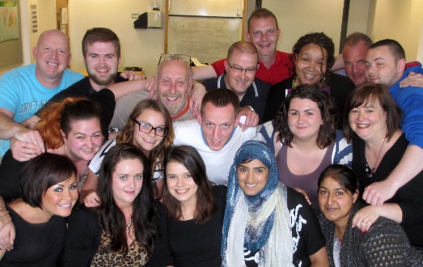“The best advice I can give you is: **don’t panic**! Everything will be fine if you work hard and stay focused. Remember to ask for help; not just from lecturers but from fellow classmates.”

“**Stay organised.** Tidy folder, tidy mind! We lived by that slogan. If you stay organised, you’ll feel on top of the course work and meet all of your deadlines.”

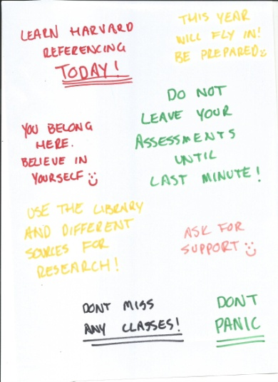

“It may take time to build your academic confidence. **Don’t be hard on yourself**. If you find something difficult or challenging when others don’t seem to be struggling as much, remember that this programme will highlight your strengths *and* your weaknesses. Be open to teamwork and be open to asking for help.”

“You will face challenges and there may be times when you struggle, but **don’t give up.** If my experience is anything to go by, you’ll find a massive amount of support from your classmates, and the tutors will go to great lengths to help you.”



“**Plan ahead.** Break your assignments down to smaller parts to focus better. It can be scary at first. Get to know the lecturers and the facilities.”

“Set aside time for college work, but do have a balance. **It’s important to relax, too**.”

“Read, work hard and ask questions. **Get involved in the process**.”

**PREPARATION FOR HIGHER EDUCATION (Prep for HE):**

To be successful in Higher Education, you must develop and improve skills such as academic writing, critical thinking, note-taking and referencing. The Preparation for Higher Education unit (Prep for HE) is designed to help you do that.

**Prep for HE can help you:**

* Create strategies for more effective learning
* Apply to universities via UCAS and write an impressive Personal Statement
* Develop academic skills and apply critical thinking skills to academic work
* Respond effectively to feedback on course work and assessments
* Develop strategies for managing finances whilst studying full-time

**Where to find Prep for HE:** [www.scottishwideraccess.org/west-prep-for-he](http://www.scottishwideraccess.org/west-prep-for-he)

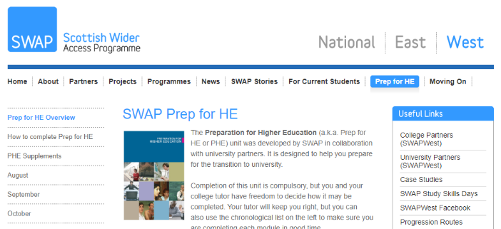

Use the guidance on the SWAPWest web site to help you keep track of which Prep for HE exercises are most useful at key points during the year.

You can start today!

**PREP FOR HE:**

You may find the checklist (overleaf) useful for keeping track of your Prep for HE progress. Please note that although some exercises may be done using the web-based forms that are linked from the SWAP website, others simply require you to download and read through the information, or perhaps organise discussions with classmates around the topics.   
  
Your class tutor may organise activities similar to the ones on our list, but using materials of their own devising or provided by your college’s own academic support team. If so, you may mark the Prep for HE module as ‘complete’ even if you did not use SWAP resources.

**The point is to prepare yourself for the next level of study, so any reasonable means you use to do so may count towards completion of your Prep for HE unit, provided your class tutor is aware of what you’re doing and approves it.**

The timeline we suggest is provided as a guide only; you and your class tutor may find that certain modules are more useful than others at certain times of year, depending upon your programme. Provided you do the work at some point, you are not required to adhere strictly to the suggested timeline. Follow your tutor’s guidance.

Finally, some modules may not apply to you (e.g. you do not need to complete the ‘Science Reports’ module if you are not on an Access to Science/STEM programme). Ask your tutor or SWAP if in any doubt.

**Prep for HE Checklist:**

|  |  |  |  |
| --- | --- | --- | --- |
| **When** | **Module** | **Name** | **Completed √** |
| Sep | PHE01 | Taking Stock – Part 1 |  |
|  | PHE02 | Study Diary (Sep) |  |
|  | PHE03 | How do you study? |  |
| Oct | PHE04 | Study Diary (Oct) |  |
|  | PHE05 | Critical Thinking |  |
|  | PHE06 | Academic Referencing |  |
|  | PHE07 | Taking Stock – Part 2 |  |
| Nov | PHE08 | UCAS Application Guide |  |
|  | PHE08b | Personal Statement |  |
|  | PHE08c | Personal Statement Guidance Notes |  |
|  | PHE08d | Personal Statement (for Medical Studies only) |  |
|  | PHE08e | UCAS Flow Chart |  |
|  | PHE09 | Study Diary (Nov) |  |
|  | PHE10 | Interview Skills *(if applicable)* |  |
|  | PHE11 | Miscellaneous Prep for HE (Autumn) |  |
| Dec | PHE12 | Listening Skills |  |
|  | PHE13 | Academic Reading |  |
| Jan | PHE14 | Memorisation Techniques |  |
|  | PHE15 | Academic Writing |  |
|  | PHE15b | Academic Writing (Science Reports) *(if applicable)* |  |
|  | PHE16 | Study Diary (Jan) |  |
| Feb | PHE17 | Presentation Skills |  |
| Mar | PHE18 | Miscellaneous Prep for HE (Winter) |  |
| Apr | PHE19 | Managing Finances |  |
|  | PHE20 | Study Diary (Apr) |  |
|  | PHE21 | Feedback, Evaluations and Exams |  |
|  | PHE22 | Taking Stock – Part 3 |  |
| May | PHE23 | Study Diary (May) |  |
|  | PHE24 | Miscellaneous Prep for HE (Spring) |  |
| Jun | PHE25 | What Happens Next? |  |

**Checklist for Success in SWAP:**

* I have attended an induction talk from SWAPWest
* I have received a copy of SWAP Student Welcome Pack
* I have read the SWAPWest Student Agreement
* I have registered online as a SWAP student on the SWAP web site (see p. 3)
* I have visited the **Prep for HE** page ([www.scottishwideraccess.org/west-prep-for-he](http://www.scottishwideraccess.org/west-prep-for-he)) and set reminders to complete Prep for HE exercises monthly
* I have read the information provided on the **Student Profiles** web page.



**Top Tips for Success:**

1. Develop study methods and strategies that are effective for you
2. Access additional academic support as soon as you need it; don’t delay
3. Complete Prep for HE exercises regularly throughout the year
4. Respond *positively* to feedback on course work; act on it to improve your skills
5. Offer support when you can give it; ask for support when you need it

**CONTACT US**

Your first point of contact is your course tutor. However, you may contact the SWAPWest office at any time if you have an enquiry or need additional information about the programme or the Prep for HE unit.

|  |  |  |
| --- | --- | --- |
| **Address** |  | Scottish Wider Access Programme (SWAPWest)  c/o Glasgow Kelvin College  facebook.png123 Flemington Street, Room 226  Glasgow G21 4TD |
| **Telephone** |  | 0141 564 7206 |
| **Email** |  | [swapwest@scottishwideraccess.org](mailto:swapwest@scottishwideraccess.org) |
| **Web** |  | [www.scottishwideraccess.org](http://www.scottishwideraccess.org) |
| **Facebook** |  | [www.facebook.com/swapwest](http://www.facebook.com/swapwest) |
| **SWAP Student Mentors** |  | [www.facebook.com/groups/swapmentors](http://www.facebook.com/groups/swapmentors) |

SWAPWest are:

Kenny Anderson (Director)

Amy, Lisa and Paula (Development Officers)

James, Karin and Erica (Admin).