Returning to Education

Session 4 - Worksheet B: Choosing a Subject

NB: This exercise requires a computer and internet connection. Local libraries offer free internet access, and staff there will be able to help you sign up. If you prefer to search for courses offline, you can search the index at the back of your chosen college’s prospectus for specific courses or contact the college’s student advice team for guidance.

Searching for College Courses

1. Using an internet-enabled computer, go to www.myworldofwork.co.uk (or use Google to search the phrase “my world of work”)
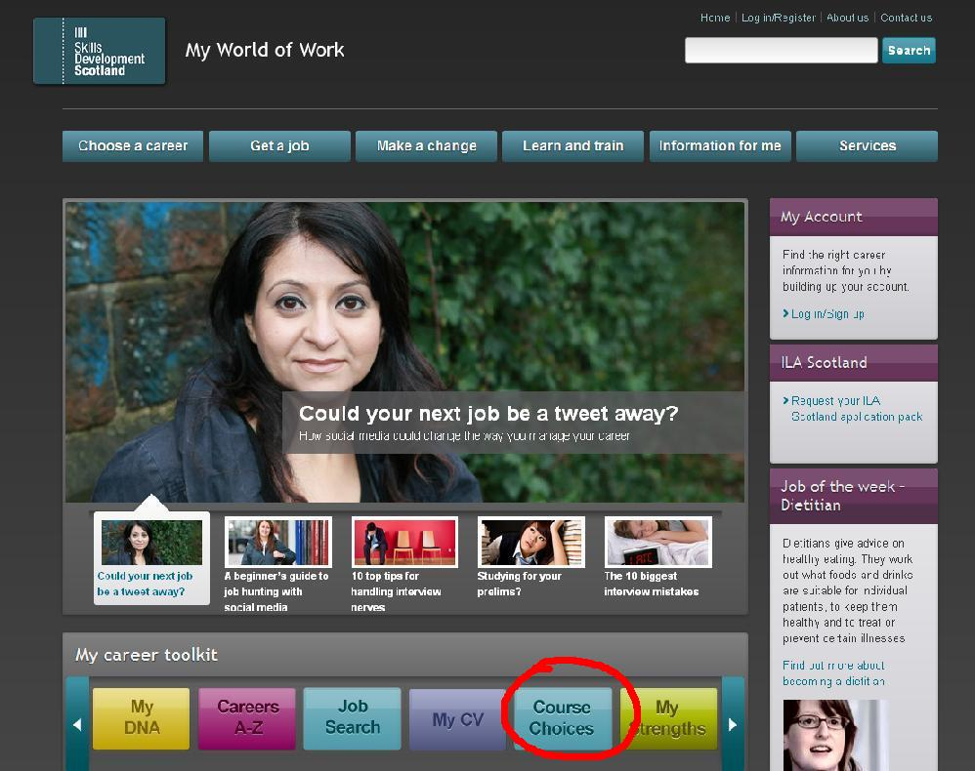

2. From the main page, click on the button [COURSE CHOICES]

3. On the search form, type in one or two words to search for a course. For example “social care”.

4. Choose [General search]

5. Type in your post code.

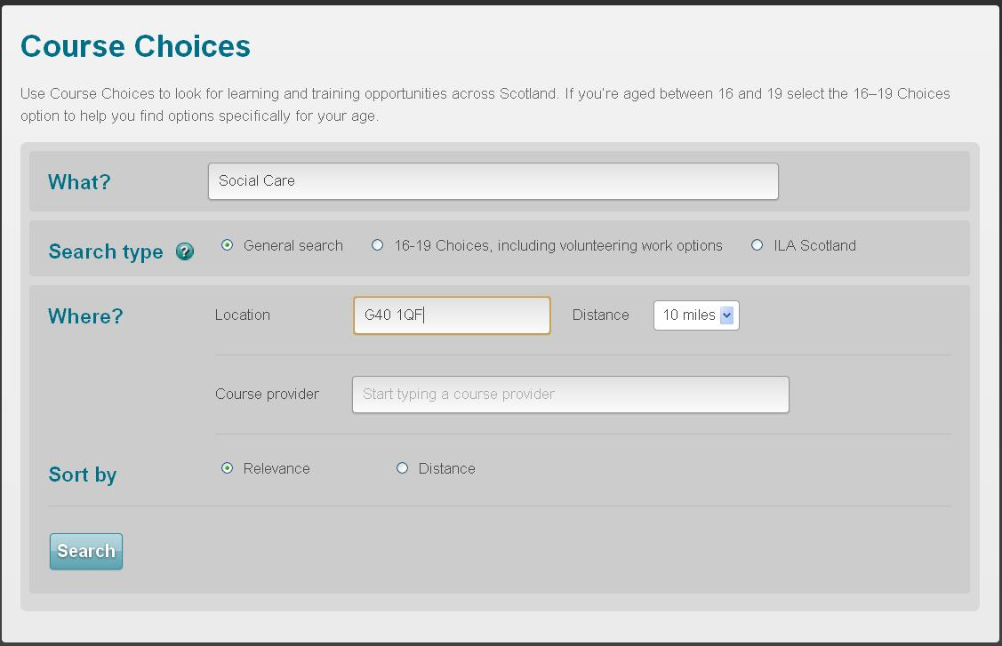
6. [Distance] means “How far from your post code are you willing to travel?”

7. You can skip the course provider field, unless you want to search strictly one college by name. (For example, if the only college you would consider attending is Cumbernauld College, then you could type in “Cumbernauld” to limit your search. Otherwise, leave this field blank.)

8. Click [SEARCH] to run your search.

Search tips:
- If you put in two or more words, it will search for ALL of those words.
- If you don’t get many results, try using a single word or change the search words

Narrowing Your Results
You may get lots of results from your search – perhaps too many! If so, you can narrow your search by using the “Filter search results” fields that appear above the list of results. For example, you could limit your search by qualification level, or you could opt to search for only those courses that are available on a part-time basis.

Your search results are displayed below the “Filter search results” section. In some cases, if you have lots of results, there will be numbers on the right showing multiple pages of results. You can click on these numbers to view pages 2, 3, 4, 5, etc.
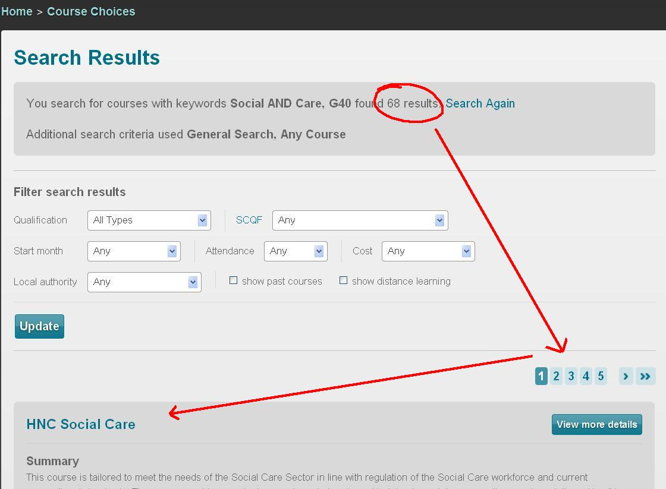

Each result in your list will feature a brief summary about the course which you can read to decide if it’s interesting or not.

When you find a course that looks good, you can get much more detailed information about it by clicking on the link that reads [View more details].

Although most courses are advertised as “full time” some of them will be offered on a part-time infill basis (In other words, if there are places available in the class that aren’t taken up by full-time students, you may be able to attend as a part-timer).
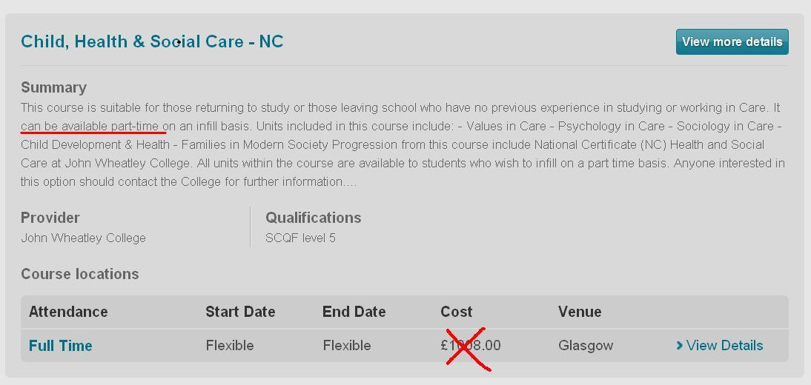
Also, don’t worry if you see a cost associated with the course. Most people will qualify to have their fees waived or paid, and you can also get money from ILA Scotland towards the cost of some courses. (Ask your advisor about ILA Scotland if you don’t already have yours in place.)

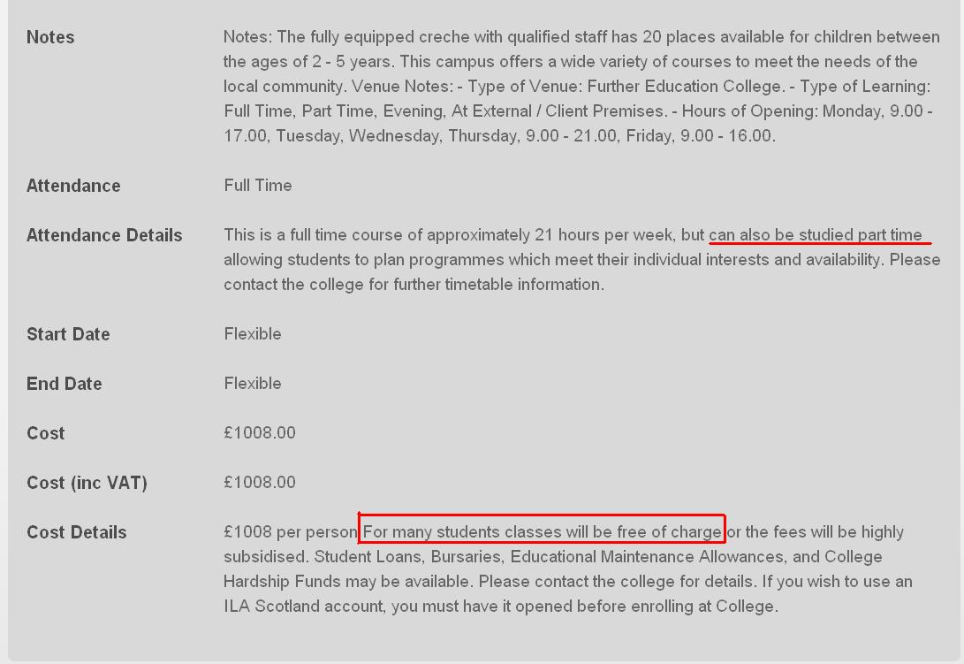
Once you’ve clicked on the [View more details] button, you’ll be presented with much more detailed information about the course, including start and end dates.

If you want to find out more, you can contact the college directly using the details provided on the college contact details handout given to you by your advisor. If you don’t like the look of that course, simply use the [BACK] button on your computer browser to return to your search results and continue reading.

Alternatively, you can return to www.myworldofwork.co.uk and start over, using different search terms.

Searching for ILA Scotland courses
If you haven’t already done it, you should check with your advisor to find out if you are eligible to claim your ILA account. This is a Scottish Government scheme that offers £200 or £500 (depending upon the course level) towards the cost of learning something new.

You may qualify for an ILA Scotland account if you can answer ‘yes’ to the following:

- You are age 16 or older
- You live in Scotland
- You earn £22,000 per year or less (or you are on benefits)

It is worth claiming your ILA Scotland account even if you currently have no idea what to study, because once you do find the course for you, you’ll have to have your ILA account in place before you can enrol. See the example below:

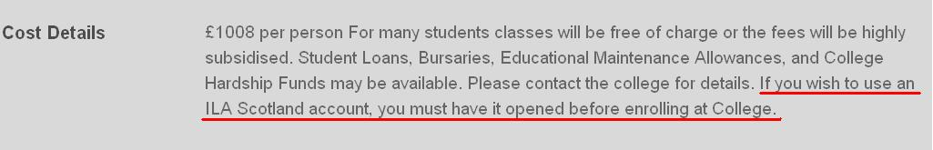

Some facts about the ILA account:

- It is designed to help people on benefits or low-income to pay course fees. Your benefits will not be affected.
- You do not have to know what you want to study before you call to claim your ILA account
- It can take up to 2-3 weeks to get an account in place, so file now
- You have 12 months to use your ILA to pay course fees. If you don’t use your ILA, there is no penalty. Any unused amount will simply expire after one year.
- You can file for an ILA once per year, every year, whether you have claimed an ILA previously or not, regardless of whether or not you used it to pay fees
- If your course fees are more than the amount of your ILA account, you must pay the difference yourself.
  - For example, if you file for an ILA £200 and your course fees are £220, your ILA would cover £200 and you would pay the remaining £20 yourself.
- If your course fees are less than the amount of your ILA account, you can take multiple courses adding up to the amount.
  - For example, if have an ILA £200 account and your course fees are only £80, you would still have £120 left in your account to take another course.

www.ilascotland.org.uk

